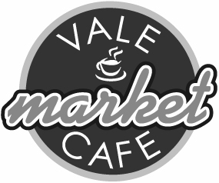
The Vale Market Café
Saturday 9th April 2022
Barnstone Village Hall 10 am – 12 noon
Eat and drink with friends & neighbours
Browse the stalls & purchase locally made
or sourced produce and exchange books
Forthcoming dates 14th May & 11^{t} June 2022

