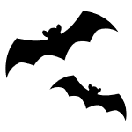

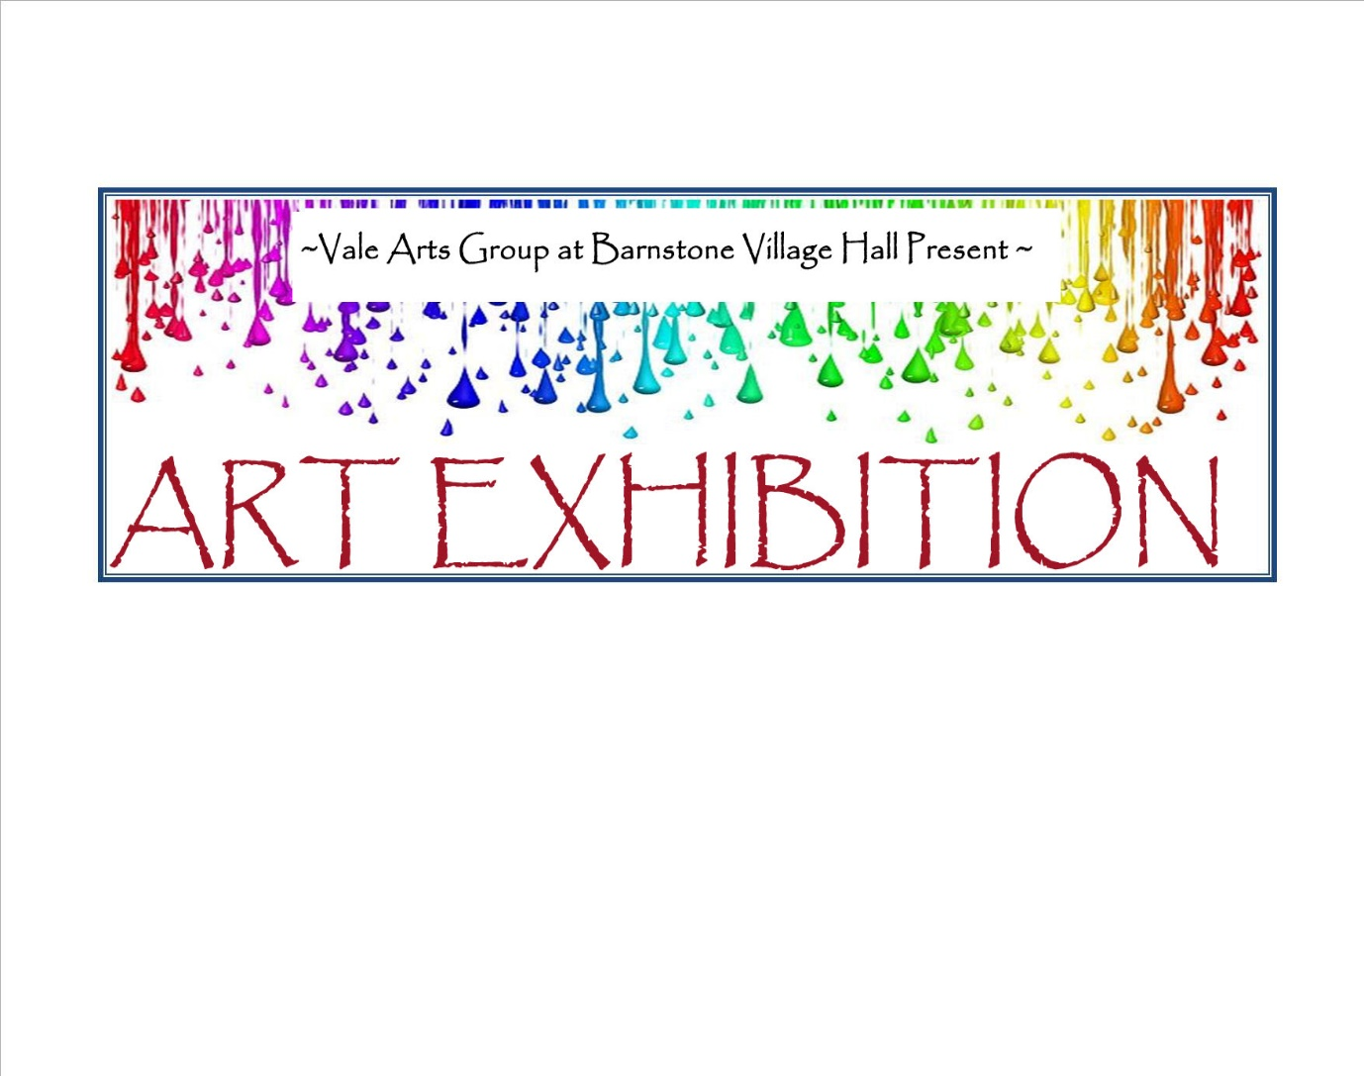

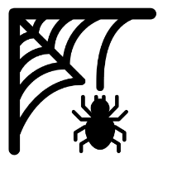**HALLOWEEN**

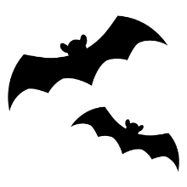

**LANGAR cum BARNSTONE VILLAGE HALL**

**SUNDAY 31ST OCTOBER**

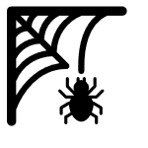**10.00AM TO 1PM**

**Enter- if you dare! DONATION**

**BRING A CARVED PUMPKIN for the COMPETITION at 12 noon**



**REFRESHMENTS - ALL PROCEEDS TO NEW HALL**