Wednesday March 10, 2021

Please remember for all the latest on our services

visit rushcliffe.gov.uk

Please email media@rushcliffe.gov.uk with any enquiries.

Rapid lateral flow tests for households and bubbles of school pupils and staff
Regular lateral flow testing has been outlined for eligible groups and individuals by the Government.
As more pupils and students return to the classroom this week the Government has asked that all adults who live in households with primary school, secondary school and college age children, including childcare and support bubbles, test themselves twice a week.
Many parents will have received a letter from their school asking them to access regular testing.
Around 1 in 3 people with Covid-19 don’t have any symptoms, but can still pass it on. The aim of the rapid testing is to test as many people as possible to help stop the spread of infections – especially as places, such as schools, start to reopen.
To support this, home testing kits (a rapid lateral flow device test) are now available for anyone who is over the age of 18 who lives in the same home as a primary school, secondary school or college age student.
People who are asymptomatic (do not display symptoms of Covid-19) can find out how to get a rapid lateral flow test by visiting: Rapid lateral flow testing for households and bubbles of school pupils and staff - GOV.UK (www.gov.uk)
Find your nearest home test kit collection point.
You will need home testing kits, if you can’t attend a collection point.
You can order home testing kits online through the Government website or by calling 119.

Reporting results
- It is really important that results are reported. People are asked to report results online to NHS Test and Trace or over the phone by calling 119.
If anyone in the household tests positive or gets coronavirus symptoms, they should tell the school and:
- self-isolate immediately
- Get a PCR test at a local test centre to confirm the result. PCR Tests work in a different way to lateral flow device test as the swab kits go to a laboratory. The PCR tests are better at finding very small amounts of the virus, especially early in infection, so these are used primarily in people who have symptoms.
- Follow the stay at home guidance for households with possible coronavirus infection
A negative result means the test did not find signs of coronavirus. But this does not guarantee people do not have coronavirus, so they should keep following all coronavirus advice including:
- regular handwashing
- social distancing
- wearing a face covering where recommended

Community test sites continue – please encourage residents to get regularly tested
We’re continuing to encourage all residents and business owners to take a regular COVID-19 test, if they are not eligible for a lateral flow test, as outlined above.
A full list of asymptomatic test sites is available here: https://bit.ly/3qIoIGo
These include Portland Centre in the Meadows and Clifton Community Centre.

COVID-19 vaccine latest
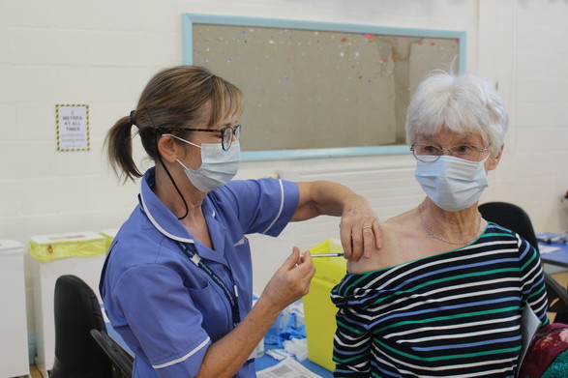
Anyone over 60 is now encouraged to book their COVID-19 vaccine online using the swift queue link or by calling 0115 883 4640 without waiting for a letter to arrive.
Despite current shortages, the NHS CCG have outlined appointment slots are available again from this weekend onwards.
For all enquiries on Vaccination appointments please visit Nottingham and Nottinghamshire’s CCG website.

Register to vote before elections in May
We’re reminding residents to register to vote and ensure their voice is heard ahead of the upcoming Police and Crime Commissioner and County Council elections on Thursday May 6.
In order to vote in these important elections, residents must be on the electoral register. Therefore, we’re encouraging anyone who has not registered at their current address to make sure they are registered in time.
The deadline to register to vote is midnight on Monday, April 19.
This year, residents in Rushcliffe will go to the polls to vote in two different elections and will select:
- County Councillors, who represent their local area and residents, and contribute to the development of policies in areas such as transport, social care and children’s services
- The Police and Crime Commissioner (PCC), who oversees your local police force and ensures they are prioritising what matters to you
Kath Marriott, our Deputy Returning Officer, said: “Make sure you can take part in these elections by registering to vote before the deadline.
“It’s an opportunity to make your voice heard and have a say on who represents you on issues that directly affect day-to-day life here in Rushcliffe.
“If you’re not registered by April 19, you won’t be able to vote.”
Ailsa Irvine, Director of Electoral Administration and Guidance at the Electoral Commission said: “You can’t have your say in these important elections unless you are registered to vote. It’s quick and easy – it takes just five minutes to apply online
“If you have recently turned 18 or moved home, it is particularly important that you act to ensure that you are registered to vote.
“If you were registered to vote in the last election and your details have not changed, you don’t need to take any action. If in doubt, you can check with your local authority on 0115 981 9911.”
Voters have a range of options for casting their ballot – in person, by post or by appointing someone they trust to vote in their place, known as a proxy vote. For those who choose to vote in person, polling stations will be safe places to vote on May 6.
The deadline to apply for a postal vote is 5pm on April 20, and for a proxy vote the deadline is 5pm on April 27.
For information on elections in their area, how to register to vote, or how to apply to vote by post or by proxy, voters can visit the Electoral Commission website. This page will continue to be updated ahead of the polls.

Census letters arriving in the coming days
Households across the Borough are being asked to take part in Census 2021.
This is a once-in-a-decade survey that gives us the most accurate estimate of all the people and households in England and Wales.
It will be the first run predominantly online, with households receiving a letter in the coming days with a unique access code, allowing them to complete the questionnaire on their computers, phones or tablets.
The data will inform not only councils but central government, charities and businesses, when making decisions to put services and funding in the places where they are most needed in the borough. This could mean things like doctors’ surgeries, schools and new transport routes.
Census day will be on Sunday March 21 but households are encouraged to complete the form as soon as it arrives.
It will include questions about your sex, age, work, health, education, household size and ethnicity.
For the first time, there will be a question asking people whether they have served in the armed forces, assisting our Armed Forces Covenant work, as well as voluntary questions for those aged 16 and over on sexual orientation and gender identity.
Results will be available within 12 months, although personal records will be locked away for 100 years, kept safe for future generations.
For more information, visit census.gov.uk.

TV Licencing Phishing Email
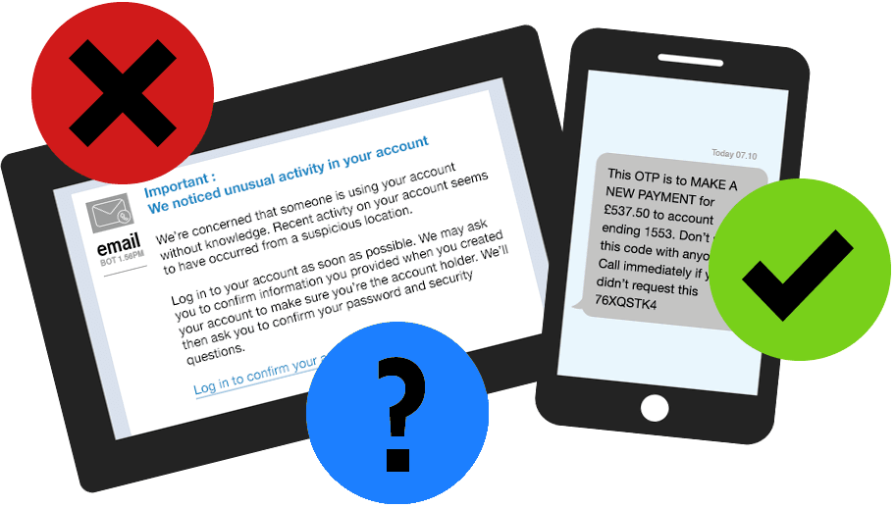
We have received information that emails are being sent to members of the public, falsely purporting to be from TV Licencing.
The email address used is fraudulent and has no connection with TV Licencing.
Official emails from TV Licensing website are sent from donotreply@tvlicensing.co.uk or donotreply@spp.tvlicensing.co.uk and will include the customer name and/or part of the postcode.
As ever, please remind your constituents to take five minutes when confronted with suspicious or unfamiliar communications to evaluate whether the request is genuine.
Residents should never provide personal details to an unknown or untrusted organisation and should check with their provider if they’re uncertain about the validity of an email, call, text or other correspondence.
They should always remember to challenge any communication, with criminals often trying to rush or panic individuals into making a decision.
They should contact their bank immediately if they think they’ve fallen for a scam and report it to Action Fraud.

STEP expression of interest at Ratcliffe on Soar Power Station
Our Cabinet have discussed and passed a recommendation for a non-binding expression of interest for the site of Ratcliffe on Soar Power Station to accommodate a STEP, an ambitious programme to design and build a prototype fusion power plant.
Cabinet discussed this report at their meeting yesterday, March 9, on the proposal that complements other opportunities being progressed for the redevelopment of the site, including the proposals for a Development Corporation and the recently submitted Freeport bid.
STEP is an additional option to be explored with potential to complement the decarbonisation and innovation objectives of the region.
Cabinet discussed its support for this non-binding expression of interest from the current site owners Uniper at the meeting.
Cabinet endorsed, in principle, the submission of the expression of interest for the site as one of several sites being put forward in the East Midlands to the STEP programme.
The site chosen could have global visibility and will form the centre of a programme of activity supporting thousands of high-quality high-tech jobs.
STEP will support economic growth, providing the opportunity to attract £1.5bn of inward investment, and the training of highly skilled engineers. It will also be an integral part of meeting the global net zero challenge.
A Uniper spokesperson said: “Uniper, in conjunction with local stakeholders, including Nottinghamshire County Council, is at the early stages of exploring options to submit part of its Ratcliffe on Soar site to be considered as a possible location for a fusion power station in the next decade or two, as part of the government’s Spherical Tokamak for Energy Production (STEP) programme. This project is one of a range of options being considered for development of the site.”

East Midlands Freeport set for take-off!

Our region received a major economic boost last week with the government’s announcement that it will be one of eight new Freeports in England, creating an estimated 60,000 new skilled jobs for the region.
The news recognises the joint work and efforts by partners from both the public and private sectors and politicians from all parties to deliver an ambitious and innovative project that will transform the region’s social and economic future.
Based around the East Midlands Airport and Gateway Industrial Cluster (EMAGIC) in North West Leicestershire, Uniper’s Ratcliffe-on-Soar power station site here in Rushcliffe and the East Midlands Intermodal Park (EMIP) in South Derbyshire, the Freeport will bring significant investment to develop and drive innovation, alternative energy sources and green technology supporting SME’s and large regional employers, including Rolls-Royce, Toyota, and Alstom (formerly Bombardier).
The East Midlands Freeport bid was submitted by a consortium led by the Local Enterprise Partnerships representing Derby, Derbyshire, Nottingham, Nottinghamshire, Leicester, and Leicestershire. It included private sector businesses and local authorities, with support from universities, business groups, local MP’s and the proposed East Midlands Development Corporation.
The consortium will now work with the government to develop the proposals into an Outline Business Case providing further information on how the Freeport will be delivered.
Our Leader Cllr Simon Robinson, said: “We’re delighted the East Midlands has been chosen for this hugely significant project to offer an environmental and business opportunity that can enhance Rushcliffe as a great place to live and attract high skilled jobs.
“Low carbon and green technology initiatives for the site at Ratcliffe-on-Soar here in the Borough will potentially bring international investment and thousands of employment opportunities, it’s an exciting time for Rushcliffe and the region.”

Top up on the go with electric vehicle charging point now available in Keyworth
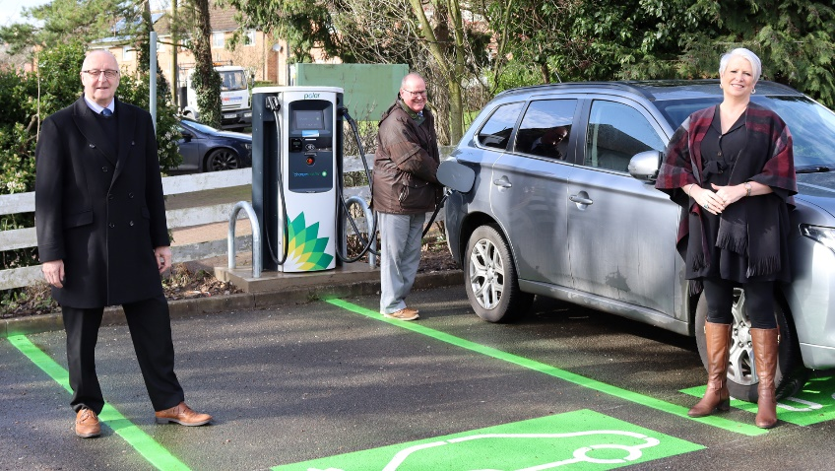
Electric vehicles (EV) owners can now top up on the go, thanks to a new charging point installed at Bunny Lane Car Park in Keyworth, bringing fast, convenient and reliable facilities to drivers wishing to do their bit to help protect the environment.
The new BP Pulse charging point enables EV and hybrid users to quickly charge their vehicles as they visit the village or call by on their way through, with major routes of the A60 and A606 only a short distance away.
This addition to the Borough’s expanding network of electric charging facilities means that users of the car park can now rely on this sustainable source of power in addition to their home charging connections.
Anyone can utilise the new facility, including D2N2 or Charge Your Car (CYC) cardholders, users of the Charge Your Car App, BP Pulse members and guests. The machine also accepts contactless payments to help support efficient top ups.
Our Deputy Leader Councillor Andy Edyvean said: “We’re thrilled to bring public electric charging points to Keyworth and provide the village and surrounding areas with the technology needed to support more environmentally-friendly journeys across our Borough.
“From experience, I know that electric and hybrid vehicles offer a whole host of benefits for the driver, their community and our environment. This infrastructure will help support further residents in making the switch to greener transport.”
Our Cabinet Portfolio Holder for Community and the Environment Councillor Abby Brennan said: “The charging point is an essential part of our work to become Carbon Clever and help reduce the environmental impact of our operations and become carbon-neutral by 2030.
“As a Council, we’re committed to installing more electric charging points across the Borough, to help expand on the existing network that already includes facilities at Rushcliffe Arena in West Bridgford and there should be an update on a site at Radcliffe on Trent soon.
“We very much hope this will further encourage use of electric or hybrid vehicles, confident in the knowledge that these easy-to-use, accessible charging points are becoming ever more commonplace.”
The installation follows the Council’s recent electric vehicles survey, which asked residents what factors might encourage them to own, charge or maintain a battery or plug-in hybrid vehicle.
The authority is now pursuing an ambition programme of electric charging facility installations at locations across the Borough to help further encourage sustainable travel for drivers.
Councillor John Cottee, Borough Councillor for Keyworth and Wolds said: “It’s fantastic to see these developments taking place that will truly enhance the lives of local people and provide nearby residents with further support for sustainable travel.
“I look forward to seeing this new facility used by busy shoppers, visitors and members of our community taking a trip to Keyworth in the months and years ahead.”

Steps for staying safe at Rushcliffe parks, open spaces and play areas

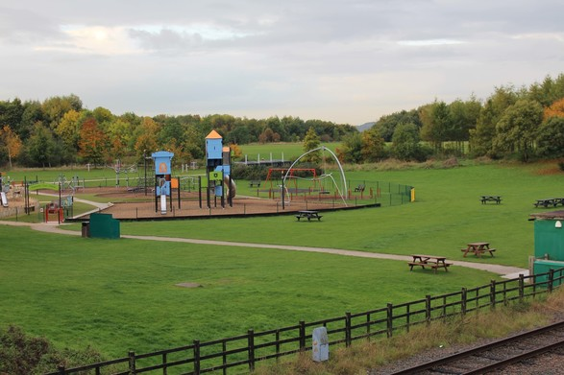
We’re encouraging residents visiting our parks, open spaces and play areas to follow some simple steps to ensure they enjoy a safe trip with their household.
As spring weather arrives, it is anticipated many sites including Rushcliffe Country Park and Bridgford Park will remain very popular, with more people looking to explore the great outdoors during their leisure time.
That’s why we’re asking residents to observe the following steps for staying safe, to ensure everyone can enjoy visiting the locations.
- Follow the on-site signage and remember to socially distance from others at all times
- Wash your hands before and immediately after visiting
- Only one parent or support bubble member should accompany a child at any play area
- No one should visit a site if they feel unwell
- Consider returning at a quieter time should you arrive to find parks or facilities already busy
- Follow current guidance to use open skate parks in line with Skate England advice at https://bit.ly/3r4WQN0
- Outdoor gym equipment remains open in line with the latest government guidance.
If visiting Rushcliffe Country Park, don’t forget its mass of parkland has lots of places to explore in addition to the children’s playground.
Sanitisation of facilities at all play parks takes place routinely and any feedback on the sites is requested to be sent to facilities@rushcliffe.gov.uk

Nottinghamshire authorities top the charts on vital COVID-19 funding stream
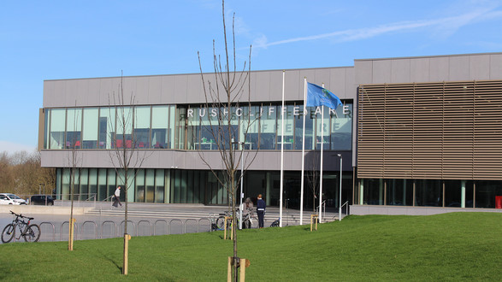
Nottinghamshire is topping the charts for distributing a vital stream of COVID-19 central government grants to local businesses, according to a new report.

We’re amongst eight local authorities in the County responsible for reaching out with the Additional Restrictions Grants (ARG) funding since last October appeared in the top 10% of distributers of Councils nationally following a report by the Department for Business, Energy and Industrial Strategy (BEIS).
It means small and medium size businesses in Notts have now distributed over £12.5 million of funding in data up to January 17 this year.
It follows the work of our revenues and finance teams, alongside fellow local authorities including Ashfield District Council, Bassetlaw District Council, Broxtowe Borough Council, Gedling Borough Council, Mansfield District Council, Newark and Sherwood District Council and Nottingham City Council.
As local authorities, we were able to use the Additional Restrictions Grant until the end of financial year 2021 /2022 following Tier 3 restrictions and closures last year.
Our Leader Cllr Simon Robinson said: “The figures highlight the excellent performance of so many Nottinghamshire councils and is testament to their hard work to reach out with these lifeline grants to thousands of businesses.
“So many have been closed or affected by the pandemic for long periods, it’s heartening here in the County we are leading the way in ensuring those who are eligible have received this funding.
“We understand around the country authorities’ strategies for grants reaching businesses are different and in line with what they feel works best.
“At Rushcliffe, our position from the outset was clear to ensure no time was wasted and the payments being distributed were a priority.
“We recognise businesses need support now as many non-essential retailers prepare to open their doors again safely on April 12 in line with the Prime Minister’s roadmap.
“We know businesses are facing such stark pressures and we’re committed to helping them wherever we can.”

Streetwise praises litter-picking sisters for raising over £2,000 for charity
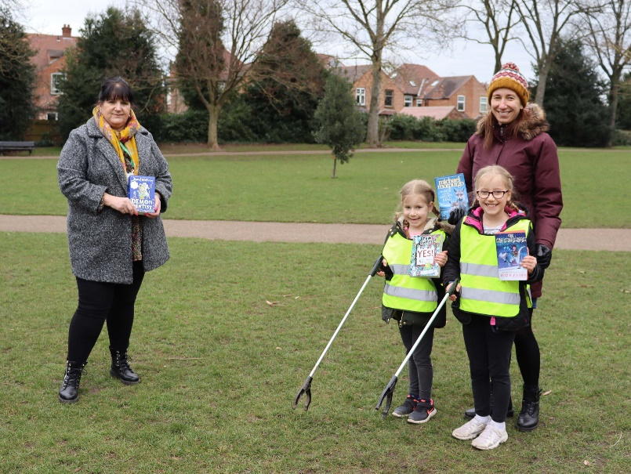
Two litter-picking sisters who completed a ten-day challenge to make their local area litter free whilst also raising money for charity have been praised by our grounds maintenance contractors Streetwise Environmental.

Eight-year-old Alice and six-year-old Emily spent an hour every day of their half-term litter picking in West Bridgford whilst attempting to raise £100 for the Alzheimer’s Society.
Such was the success of their project and the inspiration it brought to others, they raised over twenty times their target, collecting £2,030 for the charity.
Streetwise heard about the sisters’ efforts and have now gifted both Alice and Emily a £20 book voucher each for their work.
Sue Harvey, Business Development Manager at Streetwise met the sisters and their parents, Hannah and Jason, at Bridgford Park in West Bridgford to safely hand over their vouchers and to thank them for their efforts.
Sue said: “It was lovely to meet Emily and Alice and to present them with their book voucher to say thank you for such fabulous work, they’ve made a real impact on the environment in their local community.
“We hope they enjoy reading the books they choose and we’re sure that the money raised will be incredibly useful for such a great cause.”
Hannah added: “We’re really proud of Alice and Emily both for the impact they've had on the community and the phenomenal sum of money they have raised to support dementia sufferers and their families. It goes to show that you really are never too small to make a big difference.
“Charities have struggled during the lockdown, with events being cancelled and charity shops closing, yet at a time when support services are more in demand than ever. The funds raised will have a really meaningful impact.
“The girls are really honoured to have been recognised by Streetwise for their efforts. They both love to read and have missed being able to go into a book shop or our fantastic local library to pick up a book to take home. They are delighted with their book tokens and look forward to spending them when restrictions lift.”
Our Cabinet Portfolio Holder for Community and the Environment Cllr Abby Brennan said: “The work that Emily and Alice have been doing is brilliant and they’ve exceeded their initial target by a huge amount - which is fantastic!
“We’re delighted to be able to help them with their litter picking sessions and that Streetwise were able to give them a token of our appreciation for such great work.
“It’s really inspiring to see young people get involved with efforts to keep their part of the Borough tidy and also raise the profile of a national charity that is close to their family’s hearts.”
Anyone wishing to make their area of Rushcliffe even tidier by litter-picking can contact Streetwise by calling 0115 914 8408 or by emailing.

Reach Rushcliffe funding helps community group go digital
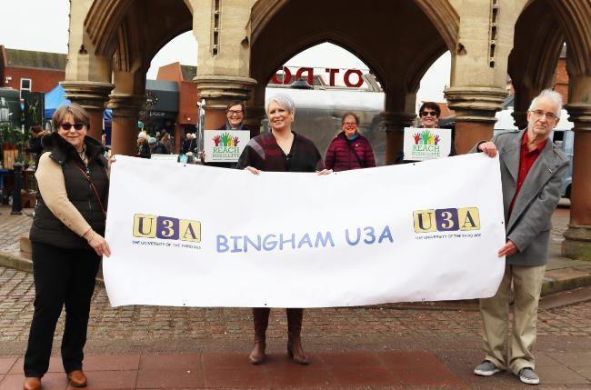
We have provided a community group in Bingham with vital funding through our Reach Rushcliffe project, to help expand their meetings and hold digital get-togethers to keep their members engaged.
Bingham u3a has received funds to assist with their campaign against loneliness and social isolation that it has been spearheading since 2017 in line with our initiative which launched last year.
The group are now set to create an even greater online presence in line with u3a's nationwide ‘Going Forward Together’ project, to increase their membership and hold even more virtual meetings to those online and harder to reach members who may be at risk of social isolation.
The support will also help with training and infrastructure costs of digitising these virtual group get-togethers and the costs of general publicity of the meetings such as banners, newsletters and flyers to reach the new members.
The funding will build on some of the activities that have included members writing and publishing novels and short stories and setting up their own online radio station, radio u3a.
It’s even assisted charity efforts including a 1305-mile tour of Britain, completed by one of the group’s members, all without leaving his back garden, that raised an amazing £715 for the NHS.
Our Portfolio Holder for Community and The Environment Cllr Abby Brennan met with group members and the chairman John Lewis at the Buttercross in Bingham to hear more about how the funding will help them.
Cllr Brennan said: “I’m delighted that Reach Rushcliffe has been able to support another fantastic organisation in their efforts to keep group members engaged, especially those who may not be able to access their services online.
“It’s still set to be an incredibly challenging time for many of our residents as we adapt safely to Central Government’s COVID road map.
“Groups such as this will continue to provide a lifeline and it’s great to see Bingham u3a helping their members keep in touch with creative activities such as their podcast and newsletter.
“We would encourage any organisations also looking to safely reduce social isolation in their part of Rushcliffe to apply for funding through Reach Rushcliffe by visiting our webpage.”
The group are a diverse non-profit independent community group of lively and friendly people who engage in a range of exciting and fun events.
They are part of a worldwide movement that has more than half a million members in the UK with a motto ‘Learn, Laugh, Live’. There are no age rules for those hoping to join and their activities are not academic.
To view more information, residents can visit the Bingham u3a website to view their latest newsletter, visit the Bingham u3a Facebook page and those wishing to join the group can do so by phoning Karen Peters on 01949 875406 or via email.

Residents can get council news direct to their inbox
We’re reminding residents that our email subscription service delivers updates directly to their inboxes.
Residents and businesses can sign up for the updates at: https://bit.ly/RushcliffeSignUp to receive the latest news and information on our services.
This includes updates on council tax, garden waste collections, leisure centres and events when restrictions allow and how to report fly tipping and litter and find out more about planning applications in their neighbourhood.
Our Deputy Leader and Cabinet Portfolio Holder for Business and Economic Growth Cllr Andy Edyvean said: “Thousands of residents have signed up to the service so far so they can stay even more informed with news and updates on our services.
“We know many residents already engage with us on our website at www.rushcliffe.gov.uk and by our ever growing social media channels but as we have increased digital interaction even more so over the last year this is another ideal way they can keep up to speed at the touch of a button.
“We encourage all to subscribe whilst we continue to assess ways to engage hard to reach groups and those who choose to not receive updates digitally.”
Emails are sent using the GovDelivery service, which is used by more than 300 public sector organisations in the UK and Europe, with over 13 million subscribers.

