Thursday, August 27

Remembrance Sunday update
Last year, Group Leaders met to discuss poppy wreaths for Remembrance Day and how the provision of the current plastic tokens of remembrance could be improved to meet the Council’s policy of protecting the environment and furthering sustainability in the Borough.
The Civic Hospitality Panel met this week and agreed that alternatives will be considered, working with the Royal British Legion (RBL) and local florists as necessary.
Any changes to the traditional plastic wreath will be accompanied by a donation to the RBL. You may wish to mention this update to your local parish contacts ahead of commemorations this November.
The Council will also be contacting Parish Clerks to advise them of this proposed change.

Residents reminded to return electoral canvass forms

We’re reminding residents not to lose their voice in local elections by completing their annual canvass form if a reminder letter arrives through the post.

With County Council and Police and Crime Commissioner elections set to take place in the Borough next year, it’s a vital opportunity for residents to make sure they can take part by ensuring their details on the electoral register are correct.

If a reminder form arrives at an address, residents must respond by confirming details online at www.householdresponse.com/rushcliffe.

Alternatively, they can complete the paper form and return it in the post using the pre-paid envelope provided.

The form ensures we can keep the register up to date and identify any residents who could be missing out on the chance to vote. Those wishing to register to vote need to visit www.gov.uk/register-to-vote

Our Electoral Registration Officer Kath Marriott said: “It’s very important that residents respond if they receive a reminder letter, as soon as possible, so we can make sure we have the right details on the electoral register for every address in Rushcliffe.

“To ensure you can have your say at elections taking place next year, simply check the form when it arrives and respond either to state if details remain the same or need updating and make the necessary changes.

“If you’re not currently registered to vote, your name will not appear on the form. If you want to register, the easiest way is online at www.gov.uk/register-to-vote, or we’ll send you information explaining how to do this in the post.

“We’re aware this year’s canvass, which we have to carry out by law, is taking place during a challenging public health situation with COVID-19. We are working to ensure that we take account of public health guidelines, including the continued importance of social distancing.

“Canvassers from our team will be securely visiting addresses where residents haven’t responded from late September so please ensure you play your part and complete the form so we can conduct this exercise as safely as possible.”

Any residents who have any questions can contact our Elections team by emailing elections@rushcliffe.gov.uk or calling 0115 981 9911.

Free bike security marking sessions in Ruddington and Bingham
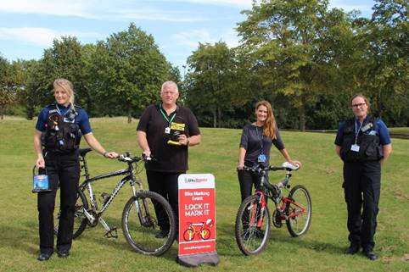
Our popular security bike marking sessions will be hitting the road next month, to create mobile opportunities similar to those usually based at the Arena across the Borough.
Cyclists will now be able to get their bikes security marked and registered with BikeRegister for free at Ruddington Village Market on Saturday September 5 and Bingham Farmers’ Market on September 19, both from 9am to midday.
We have again teamed up with Nottinghamshire Police to host a stall at the events which will also provide advice on crime prevention for burglary and vehicle crime.
Our Cabinet Portfolio Holder for Neighbourhoods Cllr Rob Inglis said: “It’s pleasing to continue our work with Nottinghamshire Police to deliver these important sessions that can make such a big difference in preventing bike, house and vehicle crime in our communities.
“Thank you to co-ordinators at Ruddington Centre Village Partnership for welcoming us aboard to the market and we invite cyclists and residents alike to visit the stall and find out more.”
BikeRegister is the UK’s national cycle database and the preferred bike marking system of Nottinghamshire Police.
Bike marking is a permanent visible deterrent from bike theft and registering a bike makes it traceable and therefore more difficult to sell on. The true owners’ identity is marked and can help cyclists be reunited with their bike if retrieved.
Security of a bike starts with a strong lock and a limited supply of free ‘D’ locks will be available on a first come first served basis at the stalls.

Try a healthier, fresher and more nutritious takeaway in Rushcliffe

Our Environmental Health team are reminding residents of the wide range of healthy options available at local Healthier Options Takeaways (HOT) across the Borough.

Outlets that have achieved a HOT merit offer a variety of food items, which are clearly displayed on their menus to enable customers to make informed choices that will help support a healthy lifestyle.

Our Cabinet Portfolio Holder for Environment and Safety Cllr Rob Inglis said: “The HOT scheme provides a fantastic opportunity for businesses to celebrate all the healthy food options available across their menus.

“Residents can access a wide range of fantastic fresh food in Rushcliffe, so it’s great to be able to access a list of outlets offering healthier choices easily and online.

“If you’re not sure where your local Healthier Options Takeaway is located, simply head to our website and check out what’s available in your area, you might just be surprised by the range of options!”

The reminder comes as the Government launched its new obesity strategy last month to get the nation fit and healthy, protect themselves against COVID-19 and help protect the NHS.

Residents can quickly find a list of participating establishments in their area on our webpage or by looking out for the heart-shaped ‘HOT sticker’ displayed in qualifying venues.

Takeaways that have achieved the merit pledge to offer healthier options to their customers, such as introducing new menu items, improved cooking methods or campaigns that promote nutritious items to customers as they order.

Find a range of further outlets on the County Council website.

Businesses can also find out more about the scheme and how they can get involved by emailing Environmentalhealth@rushcliffe.gov.uk or calling 0115 981 9911.

Don’t forget, you can now get our news direct to your inbox!
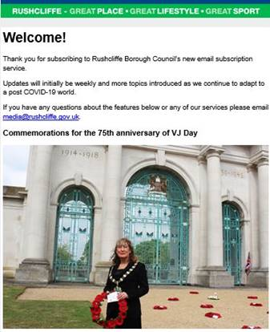
Don’t forget that you can now sign up for our free email subscription service, providing news and updates on our services direct to your inbox.

To sign up now and receive the updates please subscribe here: https://bit.ly/RushcliffeSignUp

Whilst our website and social media pages are still a great place to find all our latest news and updates, these email bulletins are a new no hassle channel that initially will provide a weekly digest on our great services.

Many local authorities use this as another way to connect with residents who are not on social media or may not be in the habit of visiting our website, so we’re taking these further steps to give residents what they want, in the format they wish to receive it as our digital audiences continue to grow.

We’ll be looking to introduce more topics as we continue to adapt to a post COVID-19 world.

New booking system at West Bridgford HWRC from Tuesday

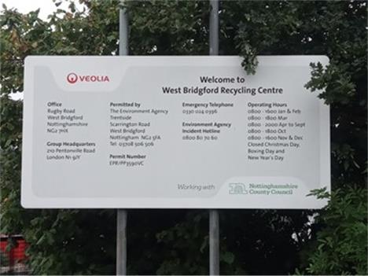
A reminder that a new trial online booking system for the Household Waste and Recycling Centre (HWRC) in West Bridgford will begin on Tuesday, September 1.
The centre on Rugby Road operated by Nottinghamshire County Council will only be accepting pre booked vehicles from next week, with 15-minute time slots available between 8.15am and 7.45pm every day during the summer opening hours. Up to five vehicles will be allowed on site at any one time.
Residents must already be registered to use Nottinghamshire County Council’s recycling centres before booking their timeslot easily through the authority’s website: book to recycle
Sessions can be booked up to two weeks in advance but must be reserved at least 24 hours before visiting the site as no same day slots will be available and visitors to the site will not be permitted entry without an electronic or paper copy of their emailed booking receipt.
For more information or to book a recycling visit over the phone, please contact Nottinghamshire County Council’s customer service centre on 0300 500 8080 between 8am and 6pm Monday to Friday.

Risk management training available next week

A reminder that our virtual risk management training session for members of the Governance Scrutiny Group and all other Councillors is taking place next week on Wednesday, September 2 at 6pm.

The session will be for 45 minutes, with a questions section afterwards.

If you would like to attend, please email democraticservices@rushcliffe.gov.uk

Car sharers reminded to take precautions to stop spread of COVID-19
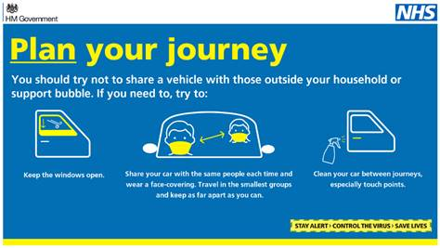
Our Public Health partners are urging people in the City and County to take action to stop the spread of Covid-19, specifically when car sharing.
As well as continuing to wash hands, keeping socially distant and getting a free test for symptoms, people who have to share a car to get to work should be careful to use face coverings and to clean car surfaces at the end of the journey.
Those travelling by car should only do so with people from their household or within their support bubble, or if this is a work requirement. Outside of this, avoiding sharing cars with other people, but if people must then make sure to:
- Share the transport with the same people each time
- Keep to small groups of people at any one time
- Open windows for ventilation
- Clean your car between journeys using standard cleaning products; make sure you clean door handles and other areas that people may touch
- Ask the driver and passengers to wear a face covering.

Emergency fund to help Nottinghamshire groups support residents

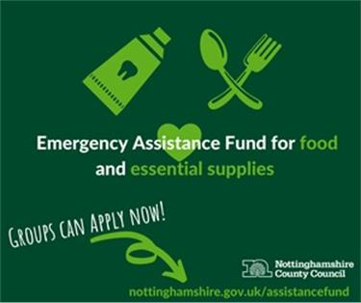
A reminder that the emergency fund to help Nottinghamshire groups support residents who are struggling to afford essentials due to COVID-19 is now available through Nottinghamshire County Council.

The Emergency Assistance Fund offers a share of £858,000 of emergency funding to groups and organisations already helping communities during the crisis.

To apply and find out more, please direct applicants to: Assistance Fund

Compliments
Our housing teams received a message of thanks from the daughter of a resident who was recently found a new home in Radcliffe on Trent.
She said: “A big thank you to you and your team for getting my dad into his new home in Radcliffe, he moved in recently and loves it, he is so happy now.

“Keep up the good work.”

All the latest information for residents is available on the Coronavirus webpages or over the phone on 0115 981 99 11.

_________________________________________________________________________________

Thank you for contacting Rushcliffe Borough Council.

