Langar Cum Barnstone Parish Council

The Parish Council continues to meet monthly, albeit in virtual Zoom meetings. Our latest meeting was on 14 May, at which we were joined by one of our Borough Councillors and both of our County Councillors.
At that meeting, Cllrs. Chris Harper and Nicky Pulford were elected as Chair and Vice-Chair respectively for the coming session.
As in previous meetings all member of the public are welcome, agendas will be displayed on noticeboards and also on the Website and Facebook. If you would like to attend please email the Parish Clerk – Sharon prior to the meeting for a link and password.

Claire Pegg

Happy Retirement to Claire

Claire Pegg, our Parish Clerk for ten years, has retired. I was fortunate that my two years as Chair of the Parish Council coincided with Claire’s final years in post, so I saw at first hand the impeccable job she did for the Parish as a whole. With a wealth and breadth of local knowledge and experience in council matters, she was the perfect person to guide the Council in its affairs. On behalf of all the councillors, past and present, who have had the good fortune to interact with Claire, I wish her a very happy retirement.

Jeffrey Fry

Community cohesion and bread. – Jodi Carter-Davies
Over the first two months of lockdown the Vale Market Café (VMC) delivered over 1600 items of bread to 83 households in Langar and Barnstone, inspired a flour donation and encouraged an explosion of home baking and sour dough experimentation.
I can only just remember back to our last café in March when the implications of the pandemic were starting to impact on our lives. The café advised its vulnerable volunteers to stay at home and hand sanitiser was placed on all the tables. We were all struggling to get hold of basic items like bread, flour, yeast and toilet roll as society panic bought, throwing a spanner in the supply chain. It seems strange that nearly three months on we have achieved so much.
Thanks to a call from John, the VMC’s bread supplier, from Turners Quality Bakers in Cropwell Bishop, the bread delivery scheme was born and Langar and Barnstone residents could get a basic range of baked goods delivered direct to their door. The scheme was conceived on the 19th March and we completed our first delivery on Saturday 21st March, following a leaflet which was included in a mass communication delivered by hand to all households informing parishioners what support was available to them locally.
As a community group we already had the infrastructure in place for the scheme to work. Allowing residents to pay for bread via bacs or cash made life lot a lot easier, except for Robin, our Treasurer, who had to match all the payments! Luckily during this time we have managed to apply for and access online banking which has made life a lot easier and means we have an order and payment system in place should we ever need to set up something again. We have also inspired similar schemes in Nether Broughton, Elston, Shelton and Orston too.
Setting up a specific email address for orders was easy and it has been nice getting to know our non internet connected neighbours over the phone. I have collated all the orders in Robin’s whizzy spreadsheet (although I still manage to get the odd order wrong!) and then Ruth and Steve Brandon at Bottom House Farm in Langar and I alternate making them up for delivery. Ruth’s son Henry has helped deliver in Langar along with Charlie Nicholson on Church Lane and Charlotte and Morgan Mazers, and my youngest son Laurie when I can pry him out of bed!
Other than being able to support a local business that has managed to avoid furloughing staff thanks to the village delivery services both here and on the other side of the A52, we have also forged some fantastic new relationships within our own community. 16 volunteers to date have been involved and most notably Gareth and Josh from Skydive Langar who have helped with the mobile delivery round and alternated with Treena Philpotts and her Son Sam in Barnstone. Gareth at Skydive said “It was a real pleasure for us to play a small part in supporting the local community, and I hope it will be the start of more cooperation in the future. Once the Covid restrictions are relaxed, we would be keen to host an open evening / afternoon at the airfield for locals to come and visit us and see what we get up to, so we can continue to build relationships with the community.”
In addition, through the bread deliveries and flour and yeast donations we have accrued a lump sum which we will be able to put back into our community. Whether it’s a new bench to compliment one of the many walks we have all been on, more dog poo bins or just a community celebration in the autumn it will be good to put something back into the environment which has nurtured us over these past few months. The VMC would welcome other suggestions from the community so please do get in touch.

Please Pick Up After Your Pet!
It doesn't take much to remember that we have many much loved pets in our community. In fact, if you don't watch your step, you are liable to step in one such reminder! Besides being unsightly and smelly, animal waste can be hazardous to the health of our children who play in the community and also to other pets.
Therefore, it is important to remember to immediately clean up after your pet. Please take along a bag with you to pick up waste and then dispose of it properly - there are plenty of dog waste bins in the area and as it is an offence not to do so, you can also be fined.
By taking a few simple steps to clean up after your pet, you can contribute not only to the beauty of our villages, but also towards the elimination of one of the most irritating nuisances in our area.
Please help to make the place cleaner and safer for everyone.
Thank you for your cooperation.

Brownies
Barnstone Brownie Pack is at present on an unlooked-for extended break. I do miss our meetings and we would have enjoyed getting out and about in this lovely weather. I've tried to continue the things that the Brownies would have been involved with the community like decorating the teacup tree, the phone box, the Village Hall, painting stones and doing the planters.
The Brownies have been sent a few activities to do at home, including a gnome to paint. A few other children in the villages have been given one too. When meetings resume, we plan to have a gnome party by the Brownie Bench and invite the other mysterious 'Gnome People' whoever they may be.....
Brown Owl

Vale Market Cafe
It is unlikely that we will be able to open the Vale Market Cafe again until Saturday 12th September, when we will be celebrating our 9th anniversary. We are hoping to contact residents with a flyer before we reopen and hope that all our existing customers will be eager to return and that some new customers, impressed with the Turner's bread they have been having delivered, will also want to give us a try.

Royal British Legion

Granby, Barnstone & District Branch of the Royal British Legion are hoping to be able to provide their Annual Luncheon on Sunday 20th September. Please look out for posters in the Parish. We are awaiting advice from Poppy Appeal Headquarters about doorstep collections during Remembrancetide (late October - early November). We are hoping that the Remembrance Sunday Service and Parade at Langar on Sunday 8th November will still be able to proceed. Again we hope to be able to inform Parishioners about details a little nearer to the date.

Councillor Adrian Bellamy

Gone blonde, but has raised over £1500 for the NHS so far!!!!

D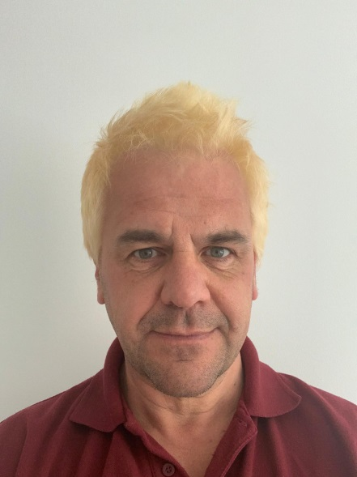

Dove Cottage

Dove cottage day hospice, have 5 shops and a tea room which are all closed at the moment so no income.
I have raised £1000.00 plus by collecting plastic tops used postage stamps and used printer cartridges
Thank you David Williams

VALE ARTS GROUP

VALE ARTS GROUP - Sadly due to a horrible thing called Covid 19, it seems our Langar cum Barnstone Village Festival is not likely to take place! The Group had thoughts of putting on an Exhibition, but ---- not to be daunted we have now set our sights on September. Watch this space for a date!! We hope everyone will keep safe and well until we can get together again. All the Best, Gillian Clarke – Secretary

Project SEAL June Update
Unfortunately Project SEAL has been seriously affected by the lock down measures introduced due to the COVID-19 pandemic. We have been unable to meet as a group or carry out our activities to meet our obligations to engage with the local community as required by the National Lottery Heritage Fund. These were to include working with the pupils at Langar School, giving a brief talk at the Annual Parish Meeting and a display on our findings during the Langar & Barnstone Village Fete.
Fortunately, we have completed the creation of a site archive of the finds and documents relating to St Ethelburga’s and Matt Beresford of MB Archaeology has written the report describing these. Originally all of our work had to be completed by the end of August but the NLHF has given us an extension until December. Whether we will be able to achieve this will depend on any remaining lock down measures.
One area we are keen to investigate are the two fields either side of the St Ethelburga site. The finds and field name evidence suggest that there is significant Romano-British settlement nearby. We made an application to the Nineveh Trust for funding a 3 year project of geophysical surveying and field walking activity but unfortunately we will not be receiving any funding as the trust as allocated all of its budget to COVID-19 research. We cannot carry out these activities without funding so it is possible that Project SEAL may have to cease its activities.
Nigel Wood

