Register to vote by Monday April 17th

Don’t forget also, if you wish to vote in person at a polling station you have to have photo ID.

You will only need to show one form of photo ID. It needs to be the original version and not a photocopy.

Apply to vote by post.
If you can’t get to a polling station on the day

Apply to vote by proxy
Can't get to the polling station on polling day? Ask a trusted person to vote on your behalf and apply for a proxy vote.

Learn more at https://www.electoralcommission.org.uk/i-am-a/voter/voter-id/accepted-forms-photo-id
Or
go to the Rushcliffe Web Site
www.Rushcliffe.gov.uk

Thanks
Cllr. Tina Combellack
Nevile & Langar Ward
Cllr.tcombellack@rushcliffe.gov.uk

Residents can now complete photo ID process to vote at Rushcliffe Customer Service sites

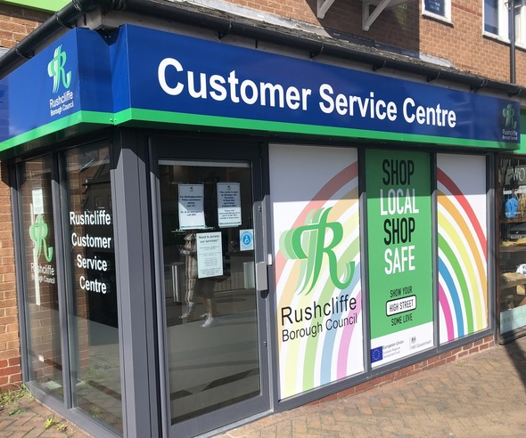

Our Customer Services sites are now available to process Voter Authority Certificates in person that enable residents without photo ID to vote at polling stations at this May’s elections.
We’re aware of the barrier some online forms can present so our Customer Service Centre on Gordon Road in West Bridgford is available during opening hours of Mondays and Thursdays 8.30am-5pm and Fridays 8.30am-4.30pm to help guide residents through the process.
Appointments are also available to complete the process in person at our Customer Service contact points at
Bingham, EastLeake and Cotgrave.
Residents need to have their date of birth and national insurance number to hand and already be registered to vote before they arrive at any site.
They can otherwise apply online for the certificate at
voter-authority-certificate.service.gov.uk
We’re reminding all residents they may already have a form of photo ID that is acceptable. They can use any of the following:
- Passport
- Driving licence (including provisional license)
- Blue badge
- Certain concessionary travel cards
- Identity card with PASS mark (Proof of Age Standards Scheme)
- Biometric Immigration document
- Defence identity card
- Certain national identity cards
For more information on which forms of photo ID will be accepted, visit electoralcommission.org.uk/voterID or
call their helpline on 0800 328 0280.
If voting by post voters do not require photo ID, with other verification checks made to complete this form of voting.
Read more on our website.

