Monday, October 5

Upcoming meetings

Wednesday, October 7: Communities Scrutiny Group will meet at 7pm. The meeting will be live streamed via our YouTube channel for members of the public to listen and view.

Thursday, October 8: Planning Committee will meet at 6.30pm. The meeting will be live streamed via our YouTube channel for members of the public to listen and view.

Deadline approaches for Celebrating Rushcliffe Awards – nominate now!

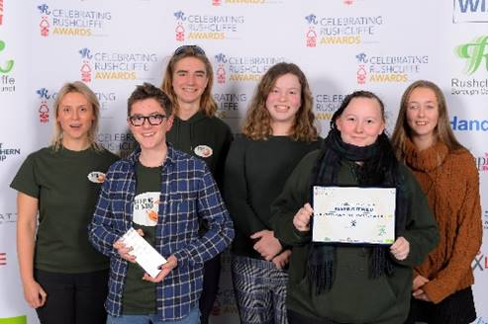
There’s just a few hours left to nominate your deserving groups and individuals for a Celebrating Rushcliffe Award!

Nominations close at midnight tonight (Monday) and take just minutes to complete so please recognise your heroes in your community here.

We know the impact COVID-19 has had on every part of the community and local enterprise but we still wish to ensure so many feel acknowledged for their outstanding contributions this year so please nominate.

Latest COVID-19 update

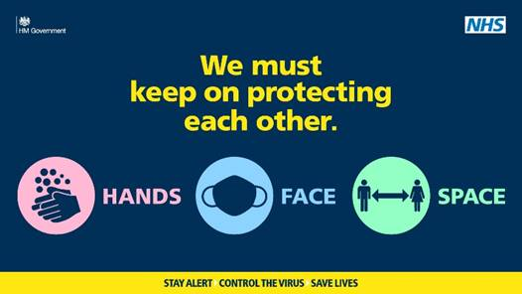
COVID-19 cases continue to rise here in Rushcliffe in line with many areas locally and nationally. It is critical therefore that everybody observes the following key behaviours:

- Adhere to the Rule of Six. This means that you should not meet with people from other households socially in groups of more than six. This will apply indoors and outdoors, including in private homes. Education and work settings are unaffected.

- “Hands, Face, Space” which means:
- Hands - wash your hands frequently for at least 20 seconds
- Face - wear a face covering where required, unless you are exempt
- Space - Maintain social distance of at least 2 metres from anyone you don’t live with or 1 metre plus additional precautions such as extra ventilation, screens or face coverings
- When eating out at a café, pub or restaurant everyone should provide full and accurate contact details of everyone in your group using the NHS COVID-19 app or leaving details with the business.
Our businesses resources page features lots of tools to assist businesses operating securely.
- Avoid car sharing but if doing so keep windows open, stick to small groups and wipe down surfaces.
- If you have COVID symptoms, get a test and self-isolate. Symptoms include a fever, a new continuous cough, or loss of your sense of taste or smell. Call 119 to book your free test or book online via the NHS website.
A reminder, face coverings must be worn in the following locations:

- Customers in private hire vehicles and taxis.
- Customers in hospitality venues, except when seated at a table to eat or drink. Staff in hospitality and retail are required to wear them too.
- Staff working on public transport and taxi drivers.

Have you downloaded the NHS COVID-19 App yet?
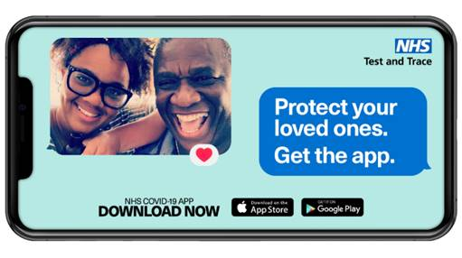
The NHS COVID-19 App is now available and part of the large-scale coronavirus testing and contact tracing programme, NHS Test and Trace, and we are encouraging everyone to download this and play their part to help stop the spread of the virus.

As you may have seen in the media or from a text message to your phone, the app is available to download from the App Store and Google Play. Please visit https://covid19.nhs.uk for more information.

It will be used, alongside traditional contact tracing, to notify users if they come into contact with someone who later tests positive for coronavirus.

The app will advise you to self-isolate if you have been in close contact with a confirmed case. It will also enable you to check symptoms, book a free test if needed and get your test results.

Please adhere to this advice should you receive it in line with red notifications.

Questions on the app and its notifications? Email media@rushcliffe.gov.uk

Cllr Brennan warmly welcomed to Cabinet role

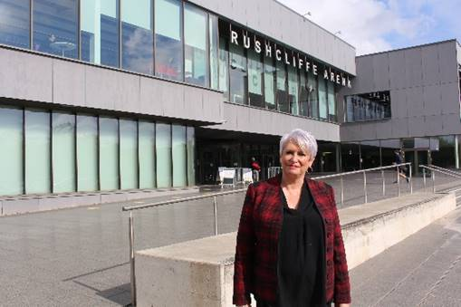
Cllr Abby Brennan has been welcomed to our Cabinet, assuming responsibility for key projects and strategies to benefit the Borough’s community and environmental focuses.
The Radcliffe on Trent ward councillor joins the authority’s executive with a wealth of public and private sector experience having worked for government agencies in the UK and in Europe and also running her own businesses. She was elected to the Council in 2019.
Deputy Chief Executive of the former East Midlands Regional Development Agency, with a career that has also included roles at the European Commission, the United Nations University and with the Civil Service, she hopes this range of different perspectives will help drive forward her portfolio’s priorities.
They will include steering direction on leisure, cultural services and health and wellbeing within the Borough, projects to benefit young people as well as the Council’s progress on energy and carbon reduction and its climate change programme.
Links with Town and Parish Councils and the Armed Forces will also be under her remit.
Cllr Brennan said: “I am delighted to be able to take up this role. The resilience of our local communities has been tested over recent months as the pandemic has impacted them.
“Issues such as health and wellbeing, including mental health, are at the front of our minds. Loneliness and isolation have affected many people, especially the elderly.
“Young people have had their education disrupted and seen many of their opportunities for first and entry level jobs limited by the impact of COVID on industries such as hospitality.
“A key priority for this portfolio moving forward will be to help rebuild that community resilience and to support partners and stakeholders to reach out and support the most effected groups.
“Town and Parish Councils have demonstrated their ability to deliver and support communities on the ground through networks of volunteers and a responsiveness to their local areas. I look forward to working with and strengthening the Borough’s relationship with them.
“The Leisure industry has also felt the impact of the COVID crisis. Leisure Centres are gradually reopening and customer confidence is growing, but it is important that we support this very important sector as we go forward to ensure they can operate on a secure footing.
“Our excellent leisure facilities across the Borough add greatly to our quality of life and are a key priority for us.
“Despite COVID, the Council has made clear its determination to fulfil its environmental goals. This remains a very important priority and we need to plough forward with this work.
“I think lockdown really brought home to many people how important the environment is to us and how our impacts on it can be felt very directly in our personal lives.
“I am pleased that Rushcliffe Borough Council will continue to invest in this agenda, keep it at the forefront of our thinking and recognise the contribution we can make to reducing fossil fuel energy consumption and carbon reduction.
“I also wish to build on the very successful work done to date in supporting our Armed Forces. All parts of the community need to feel involved and supported and we should celebrate the contribution diverse groups make to a strong and resilient community.
“I’m very keen to engage as many local councillors from across the Council in this agenda as possible, local elected representatives know their communities well and understand their needs and challenges.
“As we, hopefully, get on top of this virus we can use the Council’s support systems to help build up our community strengths and be ready to respond if local situations change.
“Finally, our cultural and civic events have had to put on hold for the time being but I’m looking forward to a time, hopefully in the not too far distant future, when we can once again come together to enjoy the range of successful events that the Council puts on across the Borough.”
She assumes the role from Cllr Debbie Mason who stood down from Cabinet at last week’s Full Council meeting after a remarkable 18 years.
Our Leader Cllr Simon Robinson warmly welcomed the new appointment.
He said: “Cllr Brennan brings exceptional insight from her background at such a crucial time for us as we adapt to the challenges COVID is throwing at us and our communities.
“Her focus and drive will be a huge asset to us as a Cabinet and Council as we tackle it head on and ensure we continue to deliver our priorities on the environment, quality of life, efficient services and sustainable growth.”
Claim back energy efficiency improvements costs with Green Homes Grant

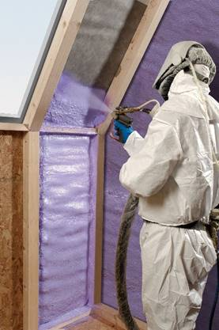
The Green Homes Grant has been announced, giving homeowners vouchers to help cover the cost of energy efficiency improvements to their home such as, loft, wall and floor insulation and low-carbon heating systems.

Those primary improvements can also use the grant for secondary items such as double glazing, as long as it costs no more than the spend on the primary improvement. Funding is not available for gas or oil heating systems.
Apply for a voucher
For most people, the vouchers will be worth about two-thirds of the cost of the work, up to a maximum of £5,000 per household.
So if work is completed which costs £4,500 for example, homeowners can receive a voucher for £3,015 towards the bill.
If in receipt one of the qualifying benefits, a voucher to cover all of the cost of the work up to £10,000 is possible.
Only government approved traders can do this work and homeowners cannot apply for a grant unless a quote is sourced from them.
First please check eligibility, see what improvements could be made to a home and find a list of approved traders to choose from here: https://www.simpleenergyadvice.org.uk/green-homes-grant/questionnaire
Then a voucher can be applied for using this central government website: https://green-homes-grant.service.gov.uk/homeowner-and-landlord-application
Help with applications from the government’s Simple Energy Advice Service is available on 0800 444202.

Please support Mayor’s charities wherever you can

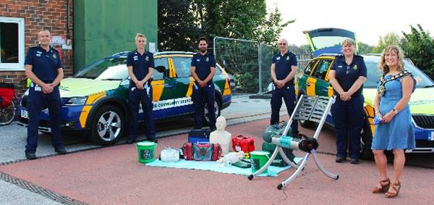
Over the coming weeks we’re featuring our Mayor’s chosen charities across our social media channels to publicise the great work they undertake in the community.

We started with a film here yesterday on Cllr Sue Mallender’s choice of Trent District Community First Responders, who are often the first on the scene when many call 999.

Please donate to their cause and showcase their work to your constituents by signposting them to http://trentcfr.co.uk/support-trent-district-cfr

Great attendance for latest Town and Parish Forum
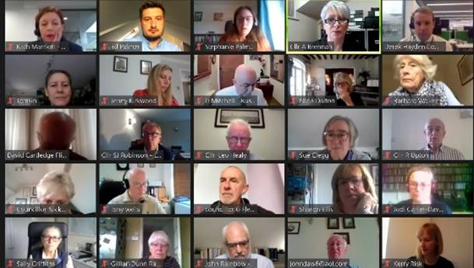
Our Town and Parish Forum took place on Friday as over 60 joined our latest virtual session hosted by our Cabinet Portfolio Holder for Community and The Environment Cllr Abby Brennan.

Topics included an update from Cllr Simon Robinson as Leader, the Queen’s Birthday Honours List and the Government’s proposed reforms to the planning system and housing numbers.

Remembrance Day on Sunday, November 8
We have received feedback from our initial contact with churches across the Borough that some Remembrance Day services are going ahead in line with the current Covid-19 secure guidance.

These will be somewhat different from previous years and will involve services being conducted outside to allow up to 30 attendees. The latest guidance on gatherings in places of worship can be viewed on the Government website.

The Mayor cannot be at every service of Remembrance across the Borough on November 8. Therefore, we are asking fellow Councillors to represent her at a local service where these are being held and where local organisers can accommodate a representative of the Mayor.

Willing Councillors are matched with a location, usually within their ward, and given an environmentally-friendly wreath to lay on behalf of the Mayor.

Please can you inform democraticservices@rushcliffe.gov.uk if you are able to attend a service this year and your preference of church.

The Democratic Services Team are also working on plans for a much-reduced act of remembrance on Armistice Day in West Bridgford. Plans for this will be circulated as soon as they are finalised.

With both of these events, plans are subject to alter in line with any changes to national or local guidance. Councillors flexibility and understanding is appreciated in the event of last-minute changes.

Check your eligibility for this year’s flu vaccination

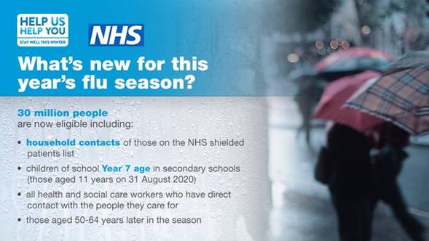
Public Health England are reminding everyone to check if they can get the flu vaccine this autumn, as an estimated 30 million people are eligible for the free vaccination.

There is a particular risk of severe illness from catching flu for:
- older people
- the very young
- pregnant women
- those with underlying disease, such as chronic respiratory or cardiac disease
- those who are immunosuppressed

This year you are also recommended to have the flu vaccine if you are the main carer of an older or disabled person, a household contact of someone on the Shielded Patients List for COVID-19 or a child aged 2 to 11 years old on 31 August 2020.

Flu vaccination is important because:
- if you're at higher risk from coronavirus, you're also more at risk of problems from flu
- if you get flu and coronavirus at the same time, research shows you're more likely to be seriously ill
- it'll help to reduce pressure on the NHS and social care staff who may be dealing with coronavirus

If you've had COVID-19, it's safe to have the flu vaccine. It'll be effective at helping to prevent flu.

Find out more about this year’s flu vaccinations on the NHS website.

Virtual Jobs Fair takes place on Wednesday

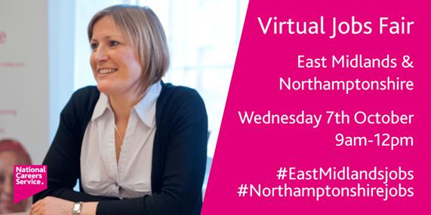
A National Careers Service Virtual Jobs Fair takes place on Wednesday, October 7 from 9am to 12pm, please signpost this to your residents if you can.

Invitees are asked to follow the Fair on twitter on the account @CareersEMids where jobs will be posted continually on the channel and there will also be a live question and answer session with a qualified adviser in each area.

There’s also an Eventbrite registration so residents can see what’s on and get reminders about the event.

The jobs will also be summarised on their Facebook page https://www.facebook.com/CareersEMids

_________________________________________________________________________________

