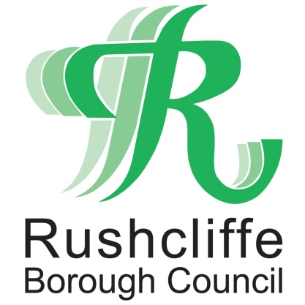 | Press Release

FOR IMMEDIATE RELEASE REF BUSINESS
01.06.20
High street businesses encouraged to share their plans and seek support for reopening
High street businesses are being encouraged to share plans for welcoming customers back to their premises and seek support ahead of reopening, in line with new guidance from Central Government.

Rushcliffe Borough Council has written to businesses in recent weeks to provide useful information on the process and offer advice to any businesses concerned about reopening in a safe and sustainable way as lockdown restrictions ease.

Following updated guidance, all non-essential retail businesses are permitted to open from June 15, with restaurants and cafes advised that they may be able to open from July 4.

Owners are encouraged to inform the authority if they require further support and guidance in order to feel comfortable reopening in the coming weeks.

Currently, business advice for all retailers can be found at www.rushcliffe.gov.uk/businesscoronavirus which hosts a range of resources including signage from the Chartered Institute of Environmental Health and a reopening checklist for food businesses from the Food Standards Agency.

Premises considering how to reopen in line with this guidance have also been invited to email the council and outline any new policies that will help ensure customers can be served safely with appropriate social distancing measures.

The Council is looking to hear more about:

- Name and address of the businesses planning to open
- Date of proposed reopening (should lockdown continue to be eased)
- Policies introduced to ensure customers can be served safely and adhere to social distancing as much as possible, including reference to use of outside space including for queueing and outdoor seating
- Any support or guidance needed from Rushcliffe Borough Council before businesses feel comfortable reopening.

Any businesses with proposed plans to reopen are requested to email econdev@rushcliffe.gov.uk with the above information.

Rushcliffe Borough Council’s Cabinet Portfolio Holder for Business and Transformation, Cllr Andy Edyvean said: “We look forward to hearing from businesses across the Borough on the exciting and innovative ways they intend to welcome customers back to their stores in the coming weeks.

“COVID-19 has impacted everyone and has been particularly challenging for businesses who have had to cease trading during lockdown, which is why we also want to hear about how we can further support our local shopping areas.

“We welcome businesses to share their plans with us so that we can continue to support our local shops, stores and premises wherever possible.”

- ENDS -
NOTE TO EDITORS

For information please contact the Rushcliffe press office on 0115 9148 555 or media@rushcliffe.gov.uk

For the latest news and events, follow @rushcliffe on Twitter or Rushcliffe on Facebook or go to the council's website.

