Thursday, November 5

Meetings

Tuesday, November 10 – Cabinet meeting at 7pm. Visit our website for further details.

Thursday, November 12 – Planning Committee at 6.30pm. Visit our website for further details.

Leader calls for all to stay at home, protect the NHS and save lives

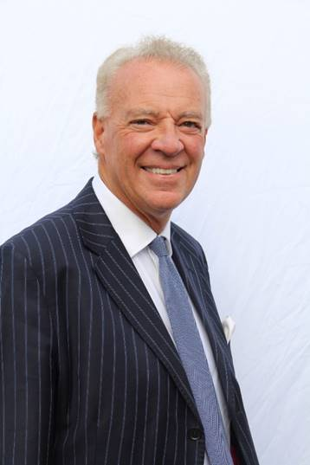
Our Leader Cllr Simon Robinson is calling on the public to do all they can to follow new national restrictions around COVID-19 and continue to play their part by staying at home to protect the NHS and save lives.

Measures for England outlined on Saturday by the Prime Minister have now come into force in an attempt to reduce the number of transmissions and protect the NHS from rising hospital admissions.

Cllr Robinson said: “It’s incredibly important that everybody now complies with these new restrictions.

“I know it’s exceptionally tough on so many of us as residents and business owners but we are in a really serious situation.

“It needs everyone to continue playing their part, starting with staying at home wherever you can and remembering hands, face, space whenever you do leave home for essential reasons.

“I cannot stress enough how important it is as we go forward we all follow these rules to protect each other and get on top of this virus.

“Shop Local Shop Safe at essential outlets and please do keep supporting local traders who are able to continue to operate.

“If you have any questions at all please visit our website www.rushcliffe.gov.uk – it clarifies more on staying at home, meeting others safely, the latest for our businesses and venues and possible financial support, going to work safely and childcare and children’s activities.

“There’s also information available for anyone who needs support with social isolation, mental health or anyone suffering domestic abuse, we understand the pressures so many of us can face at home.

“These measures are very much about protecting everybody in our communities with these huge sacrifices we have to make.

“I’m disappointed we’re in this again after all we did earlier this year but we are where we are and we’ve got to make that commitment and get on top of this pandemic.

“Let me absolutely stress too, a priority is to get that financial support into eligible business bank accounts as soon as possible.

“So as soon as we’ve received the final guidance from government on the business grants packages, we’ll publish the details and then we’ll contact businesses to make sure we can get that vital money out to them.

“Stay safe, continue to look after one another and please follow the rules so we can look forward to a brighter Christmas and 2021.”

Latest COVID-19 update

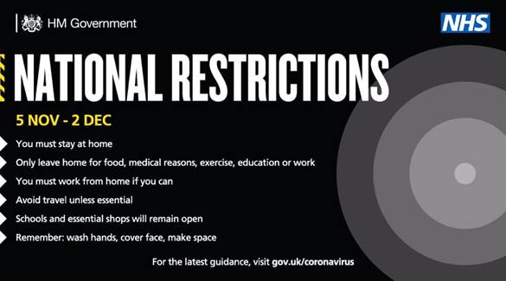
Along with the rest of England, Rushcliffe is now under national COVID-19 measures.

The current national advice is:

Stay at home

This means you must not leave or be outside of your home except for specific purposes. These include:

- for childcare or education, where this is not provided online
- for work purposes, where your place of work remains open and where you cannot work from home (including if your job involves working in other people’s homes)
- to exercise outdoors or visit an outdoor public place - with the people you live with, with your support bubble or, when on your own, with one person from another household
- for any medical concerns, reasons, appointments and emergencies, or to avoid or escape risk of injury or harm - such as domestic abuse
- shopping for basic necessities, for example food and medicine, which should be as infrequent as possible
- to visit members of your support bubble or provide care for vulnerable people, or as a volunteer

Stay safe outside the home

You should minimise time spent outside your home and when around other people ensure that you are two metres apart from anyone not in your household or support bubble.

Remember - ‘Hands. Face. Space’:

- hands – wash your hands regularly and for 20 seconds
- face – wear a face covering in indoor settings where social distancing may be difficult, and where you will come into contact with people you do not normally meet
- space – stay 2 metres apart from people you do not live with where possible, or 1 metre with extra precautions in place (such as wearing face coverings or increasing ventilation indoors)

Meeting with family and friends

You must not meet socially indoors with family or friends unless they are part of your household or support bubble.

You can exercise or visit outdoor public places with the people you live with, your support bubble, or one person from another household (children under school age and those dependent on round-the-clock care, such as those with severe disabilities will not count.)

Outdoor public places include:

- parks and the countryside,
- public gardens and allotments
- playgrounds

You cannot meet in a private garden.

Businesses and venues

To reduce social contact, the Government has ordered certain businesses and venues to close.

These include all non-essential retail. They can remain open for delivery to customers and click-and-collect. Hospitality venues like restaurants, bars and pubs must close, but can still provide takeaway and delivery services.

Our leisure centres and gyms and golf course at Edwalton are closed.

All indoor and outdoor leisure facilities have closed. A full list is here.

Public buildings and parks

Our Council owned playgrounds will remain open.

All of our community venues are closed.

Public buildings across the Borough are allowed to remain open for specific exempt activities, like childcare and support groups.

Business support

Please reassure your constituents that we will be sharing details of a support package for businesses as soon as possible.

Further information for employers is available at:

- Coronavirus Job Retention Scheme
- New Style Employment and Support Allowance

Residents urged to stay safe this Bonfire Night

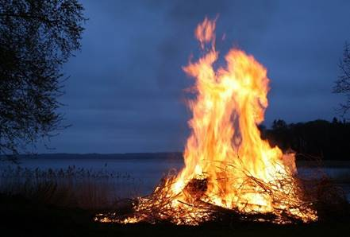
We’re appealing to those residents taking part in Bonfire Night celebrations to stay safe, follow their local COVID-19 restrictions and be mindful of their community when celebrating at home.

As new national measures come into force today, we’re urging neighbours to be considerate and help support each other as everyone celebrates slightly differently this year.

This includes not mixing indoors or in private gardens with other households and remembering Hands, Face, Space at all times.

Residents are also being asked to take care and consider the impact garden fireworks or bonfires could have on their surroundings before incorporating them into their celebrations and to notify neighbours of their plans.

Earlier this year, our Communities Scrutiny group recommended the discontinuation of loud fireworks at Council events in the interests of wildlife, pets, the elderly and those with disabilities.

Anyone setting off fireworks from their property should ensure they have all the proper tools, space and knowledge to do so and should consult with their neighbours to ensure this will not cause unnecessary distress to those nearby.

Low noise fireworks offer a quieter alternative for those wishing to enjoy a garden display full of vivid colours, whilst causing minimal disruption and concern to local neighbours, pets and wildlife.

Recognising Remembrance Day safely

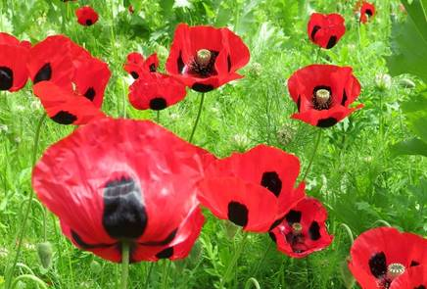
The Government have now shared guidance on preparations for Remembrance Sunday.

Please find a brief overview of the information below, or visit the Government website for full details on what events can take place, who can attend and how risks of transmission can be reduced.

What can a Remembrance Sunday event involve?

Local events should:
- be outdoors, as transmission risks are significantly reduced
- be short and focussed on wreath laying, with a reduced march past or parade only if social distancing can be maintained
- take advantage of opportunities for wreath layers to represent wider groups
- any small, military bands should observe social distancing. Buglers can perform outdoors at Remembrance Sunday events
- keep numbers to a minimum, focussing attendance on those wishing to lay wreaths (more information on who can attend below)
- take reasonable steps to minimise wider public viewing. The public can only attend the event with their own household or those in their support bubble, or individually with one other person from outside their household
- observe social distancing at all times

Limited communal singing, involving the national anthem and one additional song, is permitted outside for Remembrance Sunday, if additional mitigations are put in place.

Who can attend a Remembrance Sunday event?

Event organisers should keep numbers of those participating in the event to a minimum.

Attendees should observe social distancing at all times. Attendees should also take advantage of opportunities for wreath layers to represent wider groups.

For the avoidance of doubt, the following people are legally permitted to attend events to commemorate Remembrance Sunday as participants.
- people attending as part of their work (such as local councillors, local faith leaders, the local MP)
- people attending in a voluntary capacity on behalf of a recognised organisation
- members of the armed forces
- veterans of the armed forces, and/or their representatives or carers
Members of the public are legally permitted to stop and watch the event as spectators, but event organisers should take reasonable steps to discourage the public from attending events, and be mindful of the risk that such events pose, especially to veterans who are often elderly.

Councillors attending a Service of Remembrance are also reminded to collect their wreaths from Rushcliffe Arena in Committee Room 1 by tomorrow, November 6.

Our website also features ideas from the Royal British Legion on how to safely honour those who served and sacrificed in the line of duty at www.rushcliffe.gov.uk/remembrance

Shortlisted nominees announced for the Celebrating Rushcliffe Awards

The shortlisted nominees for this year’s Celebrating Rushcliffe Awards have been announced!

The awards this year are celebrating our wonderful volunteers, businesses and environmentalists, clubs, organisations, and the best of the health and wellbeing and food and drink sectors across the Borough, mindful of the impact COVID-19 has had on every part of the community and local enterprise.

Over 30 groups and individuals have been shortlisted for this year’s accolades and all will in due course be invited to a virtual ceremony taking place over three nights from December 1 to 3 to showcase their achievements.

Visit our website to view the list of all our shortlisted nominees.

Our Portfolio Holder for Community and the Environment Cllr Abby Brennan said: “Congratulations to our shortlisted nominees, whether volunteer, business owner or community hero, they are all making a difference to people’s lives.

“All are hugely deserving of recognition for the roles they are playing in our communities in such incredibly tough times. We can’t wait to feature their stories and celebrate their achievements.

“Thank you to everyone who nominated a group, business or individual. Everyone put forward for an award from the nominations process is being acknowledged by us to say thank you for their continued efforts in the Borough.”

Media partner West Bridgford Wire Editor Pat Gamble congratulated all those shortlisted.

He said: “It’s a great achievement for everyone to have reached this stage of being shortlisted, with so many groups and individuals worthy of recognition in a year that has seen so many help others.

“There are countless outstanding and inspirational stories in Rushcliffe since COVID has arrived and I am sure the ceremonies will highlight their impact whilst also focussing on those who have soldiered on safely in their industry or field.

“There will also be a Special Recognition award this year for an individual or group who has devoted so much to help people in one of our communities.”

Community support service receives crucial funding from Reach Rushcliffe

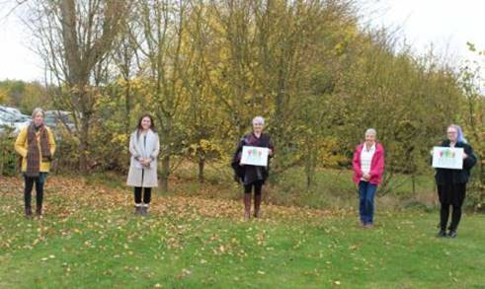
A community service that provides support to elderly and vulnerable residents has received vital funding from Reach Rushcliffe.

Rushcliffe Community and Voluntary Service (RCVS) received funds as part of the Rushcliffe Borough Council initiative aimed at tackling social isolation and loneliness.

The charity will now further develop their befriending phone service across South Nottinghamshire to reach out to those in need.

RCVS will also recruit, support and provide training to volunteers who will support elderly and vulnerable people with regular friendly phone calls that are expected to assist residents in the coming months.
Our Cabinet Portfolio Holder for Community and the Environment Cllr Abby Brennan met with RCVS Chief Executive Carolyn Perry and the project’s volunteers to find out more about the role they are playing at such a crucial time ahead of the next national lockdown.

Cllr Brennan said: “A friendly voice on the end of a phone can be a lifeline to those who are at risk of being socially isolated or vulnerable, especially with further lockdown restrictions now upon us.

“Rushcliffe Community and Voluntary Service provide such vital support, we’re delighted Reach Rushcliffe can make a direct impact on the team reaching out to vulnerable residents across the Borough.

“We hope their calls and contact can truly make a difference this winter as we all adapt to the challenges COVID-19 is posing.”

Carolyn added: “We are so pleased to have received funding through Reach Rushcliffe which means we can expand our telephone befriending service and allocate more volunteers to help those at risk.

“With new measures announced we expect to see an increase in demand for our services from those who are struggling or may be at risk of being isolated from their community.

“Not only will the befriending service reduce loneliness in residents, the one to one support provided will also help to improve their self-esteem and confidence whilst reducing the pressure on our emergency services.”

Anyone wishing to access their services can call 0115 969 9060 or visit their website.

Items for Scrutiny

The next Corporate Overview Group is on Tuesday, December 15. Each meeting of the Group considers items for scrutiny as submitted by Councillors and officers.

The deadline for submitting items for consideration is Friday, November 27. Items for consideration must be submitted using the Scrutiny Matrix which is available on the Extranet.

If you would like to discuss a topic before completing the matrix, please contact Service Manager – Finance and Corporate Services Charlotte Caven-Atack at CCaven-Atack@rushcliffe.gov.uk

Reviewing the Ward Boundaries in Rushcliffe

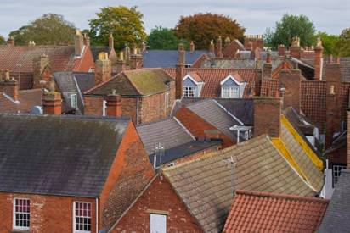
A reminder to please complete the Local Government Boundary Commission for England (LGBCE) survey as soon as possible to help with the commissions’ review into electoral inequalities in Rushcliffe.

The review has been triggered by the LGBCE and will run from August 2020 to Summer 2022. There are two phases to the project.

The first phase requires the Council to publish a written submission and provide the LGBCE with evidence to support the submission alongside detailed data about the local area and electorate. This submission details the number of Councillors the Council feels the Borough needs to represent its electorate.

The second phase of the project involves the LGBCE consulting on the wards those councillors represent before submitting a final decision to Parliament.

The new arrangements, if there are any changes, will come into force at the next Borough Council elections in May 2023.

Work has already started on pulling together the evidence required to draft the submission from the Council. A key part of that evidence is a Councillor Workload Survey. This seeks to find out how much time you spend being a Councillor and how that time is split between representing your community, working on behalf of your residents, and acting as a Council, reading reports and attending meetings.

The survey will also look at other roles you may have within the public sector, whether you work or have retired, and there will be an opportunity to feed back to us about how you feel about the size and nature of your ward.

All comments are anonymous and confidential and will help to contribute towards this important piece of work shaping the future of representation within the Borough. The draft submission will be considered by Cabinet in the new year.

If you have any questions or comments about the survey or wider review, please contact Charlotte Caven-Atack at CCaven-Atack@rushcliffe.gov.uk

