

**Monday, November 30**

**Upcoming meetings**

**Thursday, December 3:** Full Council meeting at 7pm.   
View more details [on our website](https://democracy.rushcliffe.gov.uk/ieListDocuments.aspx?CId=145&MId=952). The meeting will be live streamed on YouTube for the public to listen and view via our [YouTube channel](https://www.youtube.com/user/RushcliffeBC).

**Move into Tier 3 COVID-19 restrictions from Wednesday**

Rushcliffe and Nottinghamshire will enter Tier 3 for restrictions from Wednesday 2 December.

The move is part of the Government’s Winter Plan to reduce the spread of the virus following the end of the four-week national lockdown.

All of the restrictions and current Government advice can be viewed at [www.rushcliffe.gov.uk/coronavirus](http://www.rushcliffe.gov.uk/coronavirus) and for any questions please email [media@rushcliffe.gov.uk](mailto:media@rushcliffe.gov.uk)

**Cropwell Bishop pub closed after flouting COVID rules**

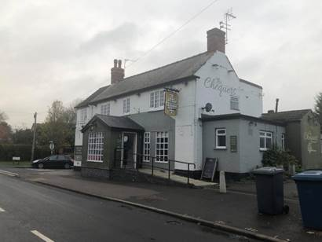We have temporarily closed a pub after a group of people were reported to be drinking alcohol inside - despite national COVID lockdown laws which ban pubs from serving indoors.

Nottinghamshire Police officers supported us as our Environmental Health team and Licensing teams witnessed a gathering at Chequers pub in Cropwell Bishop on Friday (November 27) evening.

They observed the premises from a distance and noticed people entering the pub.

Some left with boxes of food, as they were offering a takeaway service, which is allowed under current restrictions, but it was clear that there less were leaving the pub than entering.

Officers then entered the premises and witnessed a group of men drinking alcohol, prompting a call to Police.

Management at the premises claimed the individuals were customers using the takeaway service who did not wish to wait outside in the cold for their food.

Details of people inside were taken and the pub was today given a prohibition order and a fine of £1,000, in line with central government guidelines.

Our Cabinet Portfolio Holder for Neighbourhoods, Cllr Rob Inglis said: “We know how tough it is for businesses currently but the current COVID restrictions are in place to protect everyone and ultimately save lives.

"We always look to advise and educate business owners as to their responsibilities with any licence but there was a blatant disregard for its rules in this case and we take any breach very seriously to protect consumers.

“Overall compliance from businesses across Rushcliffe has been high and we thank them for playing their part and adapting brilliantly in so many cases.

“We understand the current financial climate for businesses and will now work with the owners in this case to draw up steps they can take to trade safely in future.

“All food and drink must be taken away from the premises with no indoor or outdoor seating available and customers are advised to not congregate inside or outside the business within guidelines outlined by central government.”

Rushcliffe Inspector Craig Berry said: "Officers from the local council and Nottinghamshire Police were called to a pub in Cropwell Bishop on Friday night following numerous calls from members of the public after reports that the premises were open and serving alcohol.

"Through joint enforcement work from the police and the local council we attended today (30 November 2020) and worked in a partnership approach to prevent further breaches of the legislation.

"The bar was issued with a prohibition notice and a fixed penalty notice by licensing officers.

"We are pleased with the partnership approach and will not tolerate flouting the COVID-19 legislation and we will take positive action.

 “We will investigate any reports of licensed premises and pubs that are reported of being open and in breach of the Governments COVID-19 regulations.

"Appropriate actions will be taken, this being a good example of partnership work with the local authority."

**Celebrating Rushcliffe Awards are online tomorrow, Wednesday and Friday**

Our Celebrating Rushcliffe Awards are almost here with virtual ceremonies across three evenings this week each at 7.30pm on Tuesday, Wednesday and Friday on our You Tube channel 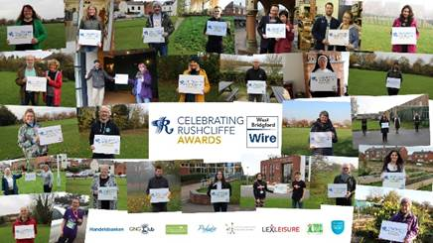<http://www.youtube.com/user/RushcliffeBC>

The accolades will showcase some of the Borough’s wonderful volunteers, businesses and environmentalists, clubs, organisations, and the best of its health and wellbeing and food and drink sectors, mindful of the impact COVID-19 has had on every part of the community and local enterprise.

Over 30 groups and individuals have been shortlisted for this year’s accolades and a full shortlist is available [here](https://www.rushcliffe.gov.uk/aboutus/newsandpublications/latestnews/stories/name,55212,en.php). Good luck to all!

### 

### The festive season has arrived in West Bridgford!

### cid:image009.png@01D6C738.16C05DD0

Brothers and local schoolchildren Rowan and Orion joined our Mayor Cllr Sue Mallender and our Cabinet Portfolio Holder for Community and the Environment Cllr Abby Brennan on Saturday (November 28) to turn on the West Bridgford Christmas lights!

In line with current COVID restrictions there was no wider event this year but the lights soon brought some festive feeling to Central Avenue, Gordon Road and Bridgford Road that includes a sparkling 20 foot Christmas tree.

Madam Mayor said: “We know it’s so unfortunate we cannot switch on the lights in the usual fashion this year but we hope they can still bring some Christmas sparkle to us all.

“Please shop locally this yuletide and shop safely, all local businesses really need your help.”

**Local Testing COVID site being built at Arena car park**

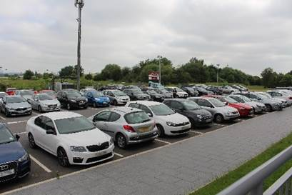The staff section of the car park at Rushcliffe Arena, the area furthest away from the building, is now being converted by our partners at the NHS into a Local Testing COVID Site.

Following discussions on where we could assist with the further role out of testing in the Borough, the Mobile Testing Unit that has been in place at times in recent months on the same site will now be switched to this larger facility.

It will have no effect on current staff or Arena user car parking with sufficient space for all, in line with current staff working practices and is expected to be in place for around three months.

In similar fashion to the mobile unit, the new facility will not be a walk-on site with all testing taking place via [appointment](https://www.nhs.uk/conditions/coronavirus-covid-19/testing-and-tracing/) through the NHS’s current channels or by calling 119.

**Free trees now being delivered to residents’ doors**

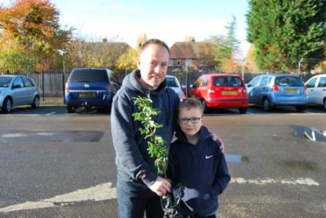Nearly 2,000 free trees are now being delivered to our residents, town and parish councils and groups for their homes and communities who applied earlier this year!

It means a staggering 7,500 trees will have been distributed by us by the end of the year since the start of the campaign in 2018.

The crab apple and hazel trees are now being delivered to each applicant’s doors in the Borough in line with safe COVID practices, avoiding the need for residents to collect the items from central locations amid the current restrictions.

It’s part of our strategy to provide sustainable environments in line with the Borough’s significant housing and employment growth in the next decade.

Look out for more on this later this week. In the meantime please email [media@rushcliffe.gov.uk](mailto:media@rushcliffe.gov.uk) with any questions.

**Christmas festivities begin in Bingham**

Bingham Community Events team have put together a festive video instead of their usual lights switch-on celebrations.

It highlights local businesses, residents and groups who have supported their neighbours and vulnerable people throughout this year and COVID restrictions.

This includes the Bingham Helping Hands Group, Cotgrave Community Kitchen, Summer in the Square and Bingham Market.

Watch the video on their [Facebook page.](https://www.facebook.com/Binghamcommunityevents/videos/1079397865822087)

**Interactive dashboard for COVID-19 cases in Nottingham and Nottinghamshire**

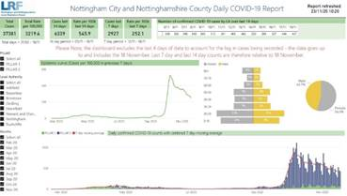An [interactive dashboard providing data on COVID-19 cases in Nottingham and Nottinghamshire](https://app.powerbi.com/view?r=eyJrIjoiMWViOGNkYjUtYTExMi00NzBlLTk4MmEtYzRjYmFhMTY5NjUwIiwidCI6IjZlNWEzN2JiLWE5NjEtNGU0Zi1iYWFlLTI3OThhMjI0NWYzMCIsImMiOjh9) is available for residents to access online.

The Nottingham City and Nottinghamshire County Daily COVID-19 Report summarises the information from the surveillance system which is used to monitor cases across the area.

This will remain a reliable resource for anyone seeking data on the latest COVID-19 cases across the city and county, with the dashboard set to be updated by 12pm each day.

A link to the online resource is also available [on the Coronavirus pages of our website](https://www.rushcliffe.gov.uk/environmentandwaste/emergencyplanning/coronavirus/#d.en.52852).

**Early December Pay Date**

A reminder that due to December payday being on the December 18, the cut-off date for Finance to receive any mileage and expense claims, whether submitted in person or online, is Sunday, December 6.

This is to enable the team to process and submit all claims in time for the pay run. Any claims received or authorised after this date will be paid at the next pay window in January.

A copy of the Travel Expenses Form is available via the Extranet, by clicking ‘Democratic Services’, then ‘Useful Forms’.

**Free online workshops available on-demand for high street businesses**

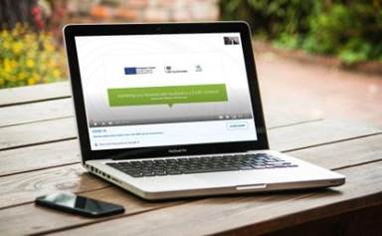A programme of free online workshops delivered by business experts are now available on-demand to help high street businesses reopen or continue to trade securely and successfully during COVID-19.

The recorded sessions are taken from our business support programme which used funding from the European Regional Development Fund to help local businesses recover and operate safely during the pandemic.

A range of topics are available to provide advice and guidance to local businesses, including insights into shopper psychology, driving retail delivery and creating a post-lockdown marketing plan.

All these sessions and more can be accessed by emailing our Economic Development team at [econdev@rushcliffe.gov.uk](mailto:econdev@rushcliffe.gov.uk)

The workshops are delivered by expert business consultancy firms Shamshad Walker Marketing and Grounded Places, both of which boast extensive experience in guiding and advising businesses to maximise their success.

Businesses seeking further advice on any matter can find out more [on our business pages.](http://www.rushcliffe.gov.uk/businesscoronavirus)

**Volunteers needed to sustain vital community support**

Rushcliffe Community and Voluntary Service (RCVS) is stepping up its urgent appeal for more volunteers, to counter the impact of COVID-19 in Nottinghamshire.

Almost 800 vulnerable people have been supported by RCVS since the coronavirus lockdown started in March.

Services include helping with shopping or collecting prescriptions, transport for those who would otherwise be stuck at home, housekeeping, and telephone befriending to counter social isolation.

Almost 5,900 individual pieces of support have been provided in the Borough, Gedling and Broxtowe.

However, around 100 more volunteers are needed to meet ongoing demand. This is because two thirds of the 145 successfully recruited by RCVS earlier in the pandemic are no longer available.

As a result, the charity’s voluntary transport scheme is providing essential journeys only, and there’s a waiting list for the telephone befriending service.

Anyone interested in volunteering should call RCVS on 0115 969 9060 or email [volunteer@rushcliffecvs.org.uk](mailto:volunteer@rushcliffecvs.org.uk).

**All the latest information for residents is available on the** [**Coronavirus webpages**](http://www.rushcliffe.gov.uk/coronavirus) **or over the phone on 0115 981 99 11.**