

Monday, September 28

**Upcoming meetings**

**Monday, September 28:** [Standards Committee](https://democracy.rushcliffe.gov.uk/ieListDocuments.aspx?CId=138&MId=927) will meet this evening at 7pm.

**Tuesday, September 29:** [Governance Scrutiny Group](https://democracy.rushcliffe.gov.uk/ieListDocuments.aspx?CId=272&MId=923) will meet at 7pm. The meeting will be live streamed [via our YouTube channel](https://www.youtube.com/user/RushcliffeBC) for the public to listen and view.

**Check your eligibility for this year’s flu vaccination**

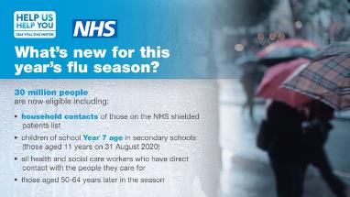Public Health England are reminding everyone to check if they can get the flu vaccine this autumn, as an estimated 30 million people are eligible for the free vaccination.

There is a particular risk of severe illness from catching flu for:

* older people
* the very young
* pregnant women
* those with underlying disease, such as chronic respiratory or cardiac disease
* those who are immunosuppressed

This year you are also recommended to have the flu vaccine if you are the main carer of an older or disabled person, a household contact of someone on the Shielded Patients List for COVID-19 or a child aged 2 to 11 years old on 31 August 2020.

Flu vaccination is important because:

* if you're at higher risk from coronavirus, you're also more at risk of problems from flu
* if you get flu and coronavirus at the same time, research shows you're more likely to be seriously ill
* it'll help to reduce pressure on the NHS and social care staff who may be dealing with coronavirus

If you've had COVID-19, it's safe to have the flu vaccine. It'll be effective at helping to prevent flu.

Find out more about this year’s flu vaccinations [on the NHS website](https://www.nhs.uk/conditions/vaccinations/flu-influenza-vaccine/).

**Discuss your health and care priorities at ‘Community Voices’ event**

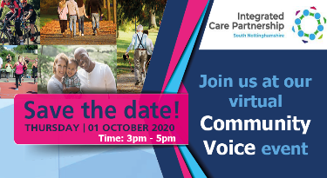A local GP is inviting South Nottinghamshire residents to discuss their health and care priorities at a ‘Community Voices’ event.

Dr Nicole Atkinson, Clinical Lead for South Nottinghamshire Integrated Care Partnership (ICP) covering Broxtowe, Gedling, Hucknall and Rushcliffe, is inviting residents to have their say.

The event, which will take place on Zoom between 3pm and 5pm on Thursday 1 October, will be led by Dr Atkinson, who also works as a GP in Eastwood.

The South Nottinghamshire ICP works across health and care organisations, local councils and communities to support the integration of services and help local people live happier, healthier lives.

Interested residents and health and care workers in the area can [sign up via the eventbrite page](https://www.eventbrite.co.uk/e/south-nottinghamshire-community-voices-tickets-115704079015).

**Cllr Debbie Mason steps down from our Cabinet**

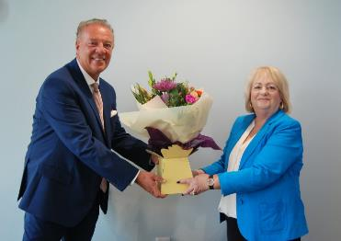Our Deputy Leader Cllr Debbie Mason stood down from our Cabinet on Thursday September 24 after a remarkable 18 years serving in the executive.

Cllr Simon Robinson presented her with flowers as a small token of appreciation for her wonderful service representing the people of the Borough.

**FREE course to support women in business and boost entrepreneurship**

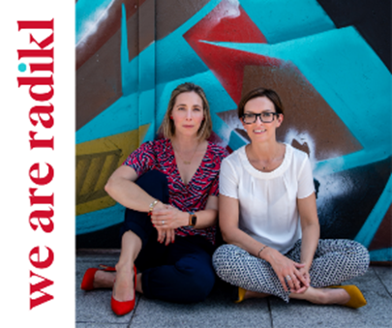A free six-week online course is available to women looking to start a business, thanks to an exciting new partnership between Inspire Learning and We Are Radikl.

The course, entitled, ‘How to start your business – a short course for women’ has been specifically developed for women looking to start their own business and begins on Wednesday, October 7 at 9.15am.

The Covid-19 pandemic has seen a rise in entrepreneurship, with one in four women now starting their own business.

This brand new course is a must for any women who have been made redundant or who face redundancy, or who want to use time on furlough to finally work towards their dream of running a business.

It’s also ideal for any women who have started their own business in the last six and might be looking for help to move things in the right direction.

Created and delivered by women for women, the course will address economic recovery, fuel confidence, build business ‘know how’, help women build connections, and inspire the creation of businesses they’ve dreamt about.

To find out more or sign up, please visit [www.inspireculture.org.uk/learning](http://www.inspireculture.org.uk/learning) or call Inspire Learning on 01623 677 200.

**Businesses can now visit our website to download their NHS QR poster**

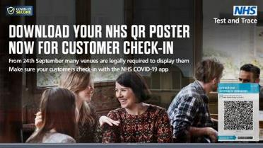Businesses and other public settings where people meet socially including hospitality, close contact and leisure venues across Rushcliffe can now visit our website and download their NHS QR poster to help them collect customer contact details and support NHS Test and Trace.

[Our businesses recourses page](https://www.rushcliffe.gov.uk/business/coronavirus-businesssupport/resourcesandguidance/#d.en.53515) features lots of tools to assist businesses operating securely, including a link explaining how they can get a QR code for their venue, which can be displayed on posters to help customers check-in with the NHS COVID-19 app.

The data collection programme is now law, whether through using a designated QR code with a smart phone, or recorded in writing.

Details must be stored for 21 days and shared with NHS Test and Trace if requested. Businesses can now be fined if they fail to take specified steps to collect contact information or taking bookings for groups of more than six.

Businesses and organisations had been advised to collect and share data earlier this year, with many effectively doing so.

The contact details being recorded at each site should include:

* name of each person in the party
* contact number
* date of visit
* arrival time
* departure time, if possible

We’re joining Nottinghamshire County Council in asking residents to play their part and ensure a member of staff at each premise always asks for details, or if they are not requested, to inform us by emailing: [envhealth@rushcliffe.gov.uk](mailto:envhealth@rushcliffe.gov.uk)

**The Great British September Clean continues in East Leake!**

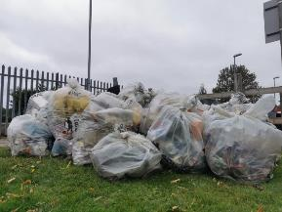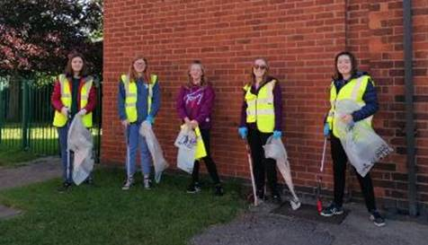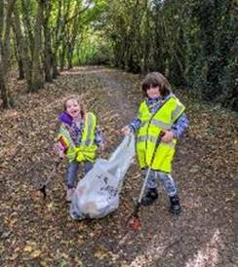Residents in East Leake joined the Great British September Clean over the weekend and collected a staggering 54 bags of rubbish as part of the Parish Council’s annual litter pick.

Thanks to help from over 50 residents, students from East Leake Academy and the local 5th Leake Brownies, the local efforts saw a phenomenal volume of waste collected from locations around the village.

All this month community groups, residents and volunteers have taken part in the Great British September Clean to help keep their local spaces looking clean, tidy and welcoming.

We’re still encouraging groups or volunteers to let us know about any plans they have to celebrate the eco-friendly call to action so we can support their efforts through our partnership with Streetwise who can supply equipment to assist efforts.

Please email [media@rushcliffe.gov.uk](mailto:media@rushcliffe.gov.uk) and share details of any upcoming litter picks or environmental activities taking place in your ward.

**Just two days left to apply for free trees!**

Rushcliffe based residents, town and parish councils and groups have just two days left to apply for their free trees before the deadline.

Households can [apply for up to two trees online](https://www.surveymonkey.co.uk/r/Tree_Scheme_2020) by submitting an application before Wednesday, September 30.

Over 5,700 trees have been distributed since the start of the campaign in 2018 and crab apple and hazel trees are again available without charge.

It’s part of our strategy to provide sustainable environments in line with our significant housing and employment growth in the next decade.

Successful applicants will be able to collect the trees from us in the Autumn adhering to Covid-19 controls and social distancing and will be contacted directly as to when dates will be available.

The crab apple, or Malus Sylvestris, can grow to 12 metres and suit areas of partial shade, whilst hazel trees, or Corylus Avellane, are shade tolerant and can also reach up to 12 metres.

We are also offering to supply and plant up to 10 trees per community group or parish this autumn and winter, on land identified by Parish Councils with the owner’s permission.

Residents can find out more information on these locations by [contacting our media team.](mailto:media@rushcliffe.gov.uk)

**Just a week left to nominate for the Celebrating Rushcliffe Awards!**

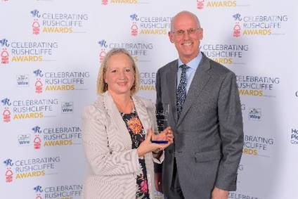There’s just a week left for residents and groups across the Borough to acknowledge their unsung community, business and health heroes in our community accolades, the Celebrating Rushcliffe Awards.

In conjunction with media partner West Bridgford Wire, we want to celebrate the Borough’s wonderful volunteers, businesses, clubs, organisations, environmentalists and the best of our health and wellbeing and food and drink sectors, mindful of the impact COVID-19 has had on every part of the community and local enterprise.

Nominations for the 10 awards are now open [at this link](https://www.surveymonkey.co.uk/r/CRAs2020) until Monday October 5, they include:

* **Volunteer of the Year**
* **Business of the Year**
* **Young Person/Group of the Year**
* **Community Group of the Year**
* **Get Active Award**
* **Food and Drink Establishment of the Year**
* **Health and Well-Being Award**
* **Environmental Group or Project of the Year**
* **Young Environmentalist of the Year**
* **The Pride of Rushcliffe Award**

**Are you signed up for our free email subscription service?**

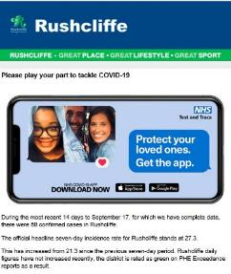Don’t forget to sign up for our free email subscription service, providing news and updates on our services direct to your inbox.

To sign up now and receive the updates please subscribe here: <https://bit.ly/RushcliffeSignUp>

Whilst our website and social media pages remain a great place to find all our latest news and updates, these email bulletins are a new no hassle channel that initially will provide a weekly digest on our great services.

**All the latest information for residents is available on the** [**Coronavirus webpages**](http://www.rushcliffe.gov.uk/coronavirus) **or over the phone on 0115 981 99 11.**

_________________________________________________________________________________

Thank you for contacting Rushcliffe Borough Council.

Please give feedback on your correspondence with us today here: <https://www.surveymonkey.co.uk/r/9LC6CXL>

Follow us on Twitter <https://twitter.com/Rushcliffe>

Like us on Facebook - <https://www.facebook.com/rushcliffeborough>

Connect with us on LinkedIn - [www.linkedin.com/company/rushcliffe-borough-council/](http://www.linkedin.com/company/rushcliffe-borough-council/)

Sign up to receive our business newsletter - <http://eepurl.com/dbczkn>

Call us on 0115 981 9911 (8.30am to 5pm, Monday to Friday), email [customerservices@rushcliffe.gov.uk](mailto:customerservices@rushcliffe.gov.uk) or visit [www.rushcliffe.gov.uk](http://www.rushcliffe.gov.uk)

[](www.arba.org.uk)

Rushcliffe Borough Council  
Finalist, Local Authority of the Year 2019



