

Monday, November 23

**Upcoming meetings**

**Tuesday, November 24:** Governance Scrutiny Group will meet virtually at 7pm.   
View more details [on our website](https://democracy.rushcliffe.gov.uk/ieListDocuments.aspx?CId=272&MId=924). The meeting will be live streamed on YouTube for the public to listen and view via our [YouTube channel](https://www.youtube.com/user/RushcliffeBC).

**Over £1.2m of COVID-19 business grants now distributed**

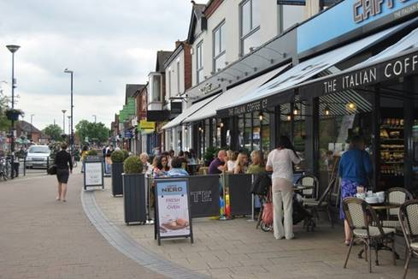Over 300 local eligible businesses have now accessed the discretionary Local Business Support Grant Scheme, meaning over £1.2m distributed for the vital support.

All the information can be found at [rushcliffe.gov.uk/businesscoronavirus](http://www.rushcliffe.gov.uk/businesscoronavirus) and information on other business support activities.

Grants continue to be processed as quickly as possible with business owners asked to ensure all supporting documents are included with any application.

We’ve been working with fellow Nottinghamshire Councils to create a consistent scheme across the County seeking to support those in the non-essential retail, hospitality, leisure and accommodation sectors and those who directly supply them.

**Latest COVID-19 update**

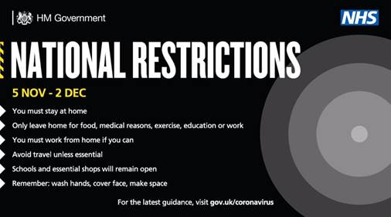Along with the rest of England, Rushcliffe remains under [national COVID-19 measures](https://www.gov.uk/guidance/new-national-restrictions-from-5-november).

Please visit our website for further information on the current national advice and encourage residents to stay at home unless they need to leave for any of the specific purposes outlined on the [Government website](http://www.gov.uk/coronavirus).

It’s important that everyone also follows ‘Hands. Face. Space.’

* **Hands** – wash your hands regularly and for 20 seconds
  + **Face** – wear a face covering in indoor settings where social distancing may be difficult, and where you will come into contact with people you do not normally meet
* **Space** – stay 2 metres apart from people you do not live with where possible, or 1 metre with extra precautions in place (such as wearing face coverings or increasing ventilation indoors)

**Interactive dashboard for COVID-19 cases in Nottingham and Nottinghamshire**

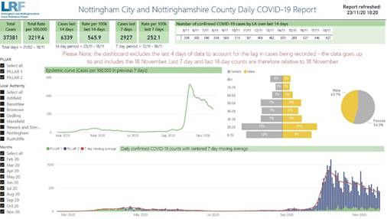A new, [interactive dashboard providing data on COVID-19 cases in Nottingham and Nottinghamshire](https://app.powerbi.com/view?r=eyJrIjoiMWViOGNkYjUtYTExMi00NzBlLTk4MmEtYzRjYmFhMTY5NjUwIiwidCI6IjZlNWEzN2JiLWE5NjEtNGU0Zi1iYWFlLTI3OThhMjI0NWYzMCIsImMiOjh9) is now available for residents to access online.

The Nottingham City and Nottinghamshire County Daily COVID-19 Report summarises the information from the surveillance system which is used to monitor cases across the area.

This will remain a reliable resource for anyone seeking data on the latest COVID-19 cases across the city and county, with the dashboard set to be updated by 12pm each day.

A link to the online resource is also available [on the Coronavirus pages of our website](https://www.rushcliffe.gov.uk/environmentandwaste/emergencyplanning/coronavirus/#d.en.52852).

**Please continue to signpost residents to be tested**

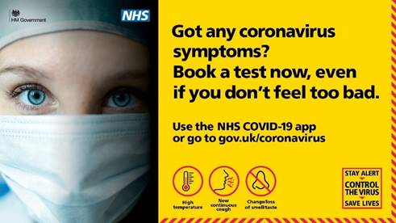Please continue to signpost residents to be tested for COVID-19 should they show symptoms.

This includes: Sneezing face

* new continuous cough
* high temperature
* change in sense of smell or taste

They can find out how to get a test at <http://nhs.uk/coronavirus> or by calling 119.

**Business owners’ chance to pitch business questions to MP and Deputy Leader**

Business owners are invited to join a Federation of Small Businesses (FSB) networking and question and answer session with our local MP Ruth Edwards and our Deputy Leader Cllr Andy Edyvean tomorrow, Tuesday November 24 from 2pm to 3pm.

The roundtable virtual event will be chaired by Michael Weedon, FSB Policy Representative for the East Midlands and Chair of its High Streets and Retail Unit.

A wide range of topics will be discussed from COVID-19 business support to local issues around town centres, the environment and infrastructure including digital.

Open to FSB members and other small businesses who live or work here in the Borough, all wishing to attend are invited to book here <https://bit.ly/32XNOXX>

**Celebrating Rushcliffe Awards invitations now arriving**

The countdown is on to this year’s Celebrating Rushcliffe Awards with invitations now arriving with all councillors, shortlisted nominees and sponsors to virtually join this year’s ceremonies.

All the details and shortlisted nominees can be found at <https://bit.ly/3kJAqg3> and each ceremony will be held on our YouTube channel at [www.youtube.com/user/RushcliffeBC](http://www.youtube.com/user/RushcliffeBC) on the evenings of December 1, 2 and 4, starting at 7.30pm.

Each will take around 30 minutes with three categories featured on each evening.

If you have any questions, please email our Community Development team [communitydevelopment@rushcliffe.gov.uk](mailto:communitydevelopment@rushcliffe.gov.uk) and we look forward to you joining the celebrations.

**Free online workshops available on-demand for high street businesses**

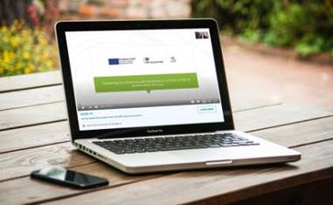A programme of free online workshops delivered by business experts are now available on-demand to help high street businesses reopen or continue to trade securely and successfully during COVID-19.

The recorded sessions are taken from our business support programme which used funding from the European Regional Development Fund to help local businesses recover and operate safely during the pandemic.

A range of topics are available to provide advice and guidance to local businesses, including insights into shopper psychology, driving retail delivery and creating a post-lockdown marketing plan.

All these sessions and more can be accessed by emailing our Economic Development team at [econdev@rushcliffe.gov.uk](mailto:econdev@rushcliffe.gov.uk)

The workshops are delivered by expert business consultancy firms Shamshad Walker Marketing and Grounded Places, both of which boast extensive experience in guiding and advising businesses to maximise their success.

Businesses seeking further advice on any matter can find out more [on our business pages.](http://www.rushcliffe.gov.uk/businesscoronavirus)

**West Bridgford Christmas Lights will return!**

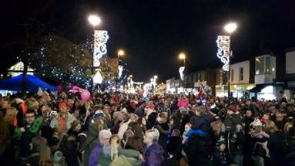Our annual Christmas Lights Switch On event in West Bridgford may sadly be cancelled this year as we continue to follow national COVID restrictions, but we are still looking to install lights and features very soon to bring some festive cheer to residents.

We are not set to advertise when the final touches will be installed and ready to light up Central Avenue and the surrounding area to avoid this news prompting gatherings in the town centre.

We know how popular the lights are year in year out and how tough it is for so many residents in the current climate, so we are aiming again that the features will still give shoppers visiting essential outlets and passers by a festive feel in the run up to yuletide.

**Volunteers needed to sustain vital community support**

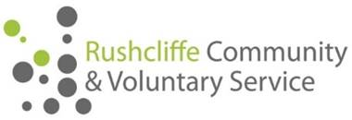Rushcliffe Community and Voluntary Service (RCVS) is stepping up its urgent appeal for more volunteers, to counter the impact of COVID-19 in Nottinghamshire.

Almost 800 vulnerable people have been supported by RCVS since the coronavirus lockdown started in March.

Services include helping with shopping or collecting prescriptions, transport for those who would otherwise be stuck at home, housekeeping, and telephone befriending to counter social isolation.

Almost 5,900 individual pieces of support have been provided in the Borough, Gedling and Broxtowe.

However, around 100 more volunteers are needed to meet ongoing demand. This is because two thirds of the 145 successfully recruited by RCVS earlier in the pandemic are no longer available.

As a result, the charity’s voluntary transport scheme is providing essential journeys only, and there’s a waiting list for the telephone befriending service.

Anyone interested in volunteering should call RCVS on 0115 969 9060 or email [volunteer@rushcliffecvs.org.uk](mailto:volunteer@rushcliffecvs.org.uk).

**All the latest information for residents is available on the** [**Coronavirus webpages**](http://www.rushcliffe.gov.uk/coronavirus) **or over the phone on 0115 981 99 11.**

_________________________________________________________________________________

Thank you for contacting Rushcliffe Borough Council.

Please give feedback on your correspondence with us today here: <https://www.surveymonkey.co.uk/r/9LC6CXL>