Monday, October 19

Latest COVID-19 update

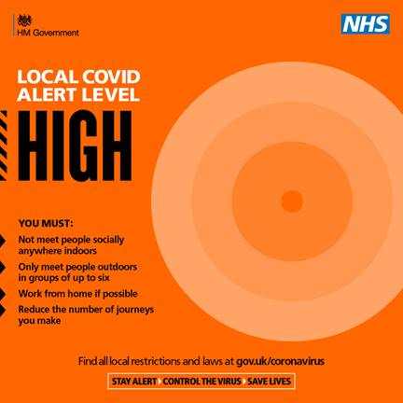
Nottinghamshire and Nottingham are still in the “high” alert level, announced by Government on October 12.

This means:

- People must not meet with anybody outside their household or support bubble in any indoor setting, whether at home or in a public place.
- People must not meet in a group of more than 6 outside, including in a garden or other space.
- People should aim to reduce the number of journeys they make where possible. If they need to travel, they should walk or cycle where possible, or to plan ahead and avoid busy times and routes on public transport.

Many common questions on the changes can be answered here: https://www.gov.uk/guidance/local-covid-alert-level-high

Please also continue to observe the following key behaviours:
- “Hands, Face, Space” which means:
Hands - wash your hands frequently for at least 20 seconds
Face - wear a face covering where required, unless you are exempt
Space - Maintain social distance of at least 2 metres from anyone you don’t live with or 1 metre plus additional precautions such as extra ventilation, screens or face coverings
- When eating out at a café, pub or restaurant everyone should provide full and accurate contact details of everyone in your group. This NHS Test and Trace Service is important for tracking and preventing the spread. The help play your part the NHS COVID-19 App is available to download.
- Only car share with those in your household or support bubble.
- If you have COVID symptoms, get a test and self-isolate. Symptoms include a fever, a new continuous cough, or loss of your sense of taste or smell. Call 119 to book your free test or book online via the NHS website
- Download the app. The free NHS Covid-19 app is the fastest way to see if you’re at risk from coronavirus. The faster you know, the quicker you can alert and protect your loved ones and community.
Go to the app store on your phone and search for the NHS Covid-19 app or visit COVID-19 app information

Increased compliance checks at pubs, bars and restaurants

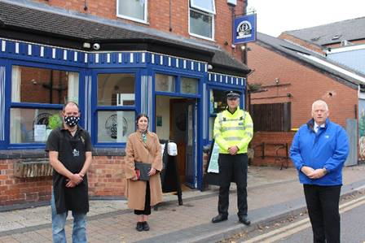
COVID-19 compliance checks at pubs, bars, restaurants and food and drink outlets were increased from last Friday across Greater Nottingham to further support business owners trading securely.

Our Environmental Health Officers and colleagues from Gedling Borough Council and Broxtowe Borough Council are continuing to provide support to business owners to maintain their secure practices with over 110 extra visits to premises across the three areas over the weekend, backed by Nottinghamshire Police.

The checks are building on the teams’ activity of recent weeks, helping owners and staff understand and apply the latest rule changes.

From socially distanced tables, table service and some outlets offering safe outdoor areas to accommodate rule of six, officers will offer advice and assistance to owners on how to maintain safe premises to maximise customer safety and encourage ‘Hands Face Space’ when not sat at a table.

Our Cabinet Portfolio Holder for Neighbourhoods Cllr Rob Inglis said: “We’re here to help hospitality businesses operate securely and the teams are committed to ensuring the business owners have all the latest advice available to implement the measures on their premises and communicate them effectively to staff.

“The vast majority of businesses are doing an incredible job in the circumstances and we thank them for their ongoing dedication to operate securely.

“We have taken action where we have needed to with some outlets but this has been required on a very few select occasions so you can be assured outlets have your safety in mind when you book a meal or pop in for your favourite drink.”

Nottinghamshire Police will also continue to have a presence in town and village centres to provide further reassurance to business owners and offer any advice around customers leaving premises safely at 10pm closing times.

High Street Ambassadors provide assurance in town and village centres

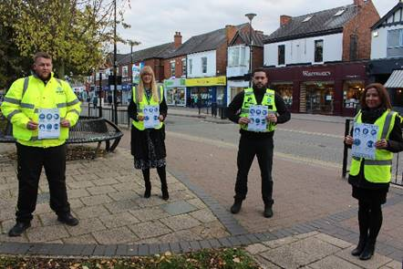
We have appointed a team of High Street Ambassadors to the Borough’s town centres to provide assurance and advice to residents and visitors in line with current COVID-19 restrictions, with funding provided by the European Regional Development Fund.
The friendly faces are now on hand to answer questions and provide useful advice and reminders to customers about staying safe whether out shopping, heading for a drink or bite to eat or enjoying a stroll in parks and open spaces.

Teams will be in Bingham, Radcliffe, Ruddington, Keyworth, East Leake, Cotgrave and West Bridgford in the coming days and weeks to provide the advice and support for local high streets reopening safely.

They will outline how retail, hospitality and venues with COVID-secure guidance are still safe to visit as everyone is encouraged to continue to Shop Local Shop Safe and support local economies.

Our Deputy Leader Cllr Andy Edyvean said: “As we continue with these new restrictions across the Borough and Nottinghamshire, it is important that our residents feel safe in their local town and village centres and that they understand how to visit safely within the new regulations.

“The High Street Ambassadors are a face you can trust to point you in the right direction for advice if you have any questions.

“They are not in place to enforce the restrictions but reassure residents help is available.

“Should you need to know for example where and when to wear a facemask, how outlets are accommodating rule of six in outdoor seating and social distancing and the other measures our great local businesses have in place, they are there to help.”

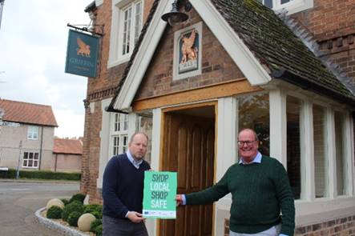
Continue to Shop Local Shop Safe and support your favourite outlets
Continue to Shop Local and Shop Safe and support local pubs, restaurants, shops and outlets with their COVID-19 secure practices.
That’s the message from our Deputy Leader Cllr Andy Edyvean who is asking residents to visit hospitality and retail outlets who are still trading safely in line with the latest COVID-19 ‘high’ tier 2 restrictions.
This means customers can continue to enjoy a bite to eat or drink at their favourite outlet in the Borough, with our Environmental Health team continuing to provide round the clock support and checks to business owners to adapt to secure COVID-19 practices.
From socially distanced tables, table service and some outlets offering safe outdoor areas to accommodate rule of six, there is still every opportunity to support your pub, bar, restaurant, tea and coffee shop or outlet.
Cllr Edyvean said: “The new restrictions should not stop us supporting our local economies and high streets and therefore please continue to Shop Local Shop Safe.
“Businesses are in the vast majority of cases doing a wonderful job adapting to the measures and we want everyone to feel they can still visit their favourite outlet with confidence.
“We have taken action where we have needed to ensure customers’ safety but so many businesses are rising to the challenge of the new rules brilliantly.
“As a Council we are here to support them in line with additional visits from our Environmental Health teams this weekend.
“You can be assured outlets have your safety in mind when you book a meal or pop in for your favourite drink.
“Don’t Forget Hands Face Space and ensure you stick to the rule of six outdoors.”
Volunteers needed to sustain vital community support
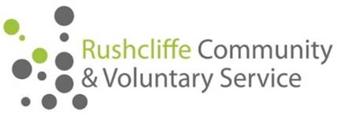
Rushcliffe Community and Voluntary Service (RCVS) is stepping up its urgent appeal for more volunteers, to counter the impact of COVID-19 in Nottinghamshire.
Almost 800 vulnerable people have been supported by RCVS since the coronavirus lockdown started in March.
Services include helping with shopping or collecting prescriptions, transport for those who would otherwise be stuck at home, housekeeping, and telephone befriending to counter social isolation.
Almost 5,900 individual pieces of support have been provided in the Borough, Gedling and Broxtowe.
However, around 100 more volunteers are needed to meet ongoing demand. This is because two thirds of the 145 successfully recruited by RCVS earlier in the pandemic are no longer available.
As a result, the charity’s voluntary transport scheme is providing essential journeys only, and there’s a waiting list for the telephone befriending service.
Operations Manager Carole Green said: “There are so many people who need our help. We heard about an elderly lady who got down on her knees to clean her floor. But she couldn’t get up again and was still on the floor when she was found.
“Our volunteers have been brilliant during the pandemic, but most have returned to work after being furloughed. With the new restrictions announced in our county, many clinically vulnerable people will be very anxious and needing our support to access essential services.
“We’re appealing for more volunteers so we have a flexible team able to respond to changing demands, and to provide support when and where people need it.”
Volunteering is open to people from all walks of life, who want to make a difference. Those recruited by RCVS have included teenagers, students, people in a wide range of trades and professions, those seeking work and people who have retired.
Anyone interested in volunteering should call RCVS on 0115 969 9060 or email volunteer@rushcliffecvs.org.uk.
Arena update

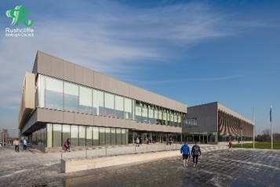
As we have moved into the “high” rating for Nottinghamshire, we are continuing to encourage staff to work from home when they can to minimise travel into the offices.

The Arena remains open for those staff who need to come in and to support our working arrangements.

With many schools sending children home to isolate for two weeks at a time we continue to be flexible in supporting staff deal with this situation whilst working from home. This is likely to continue for the foreseeable future.

If you need to come into the Arena, please inform Democratic Services democraticservices@rushcliffe.gov.uk in advance so that they can support you appropriately.

We will continue to do our best to support you with your work and community leadership roles in this difficult time.
NTU update on COVID measures

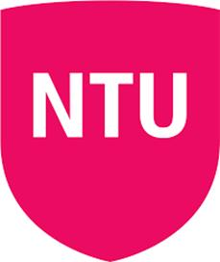
Nottingham Trent University have updated us on their COVID-19 approach.

Deputy Vice-Chancellor Nigel Wright said: “We continue to work closely with all local partners, including the City and County Councils including their Public Health teams, the Police, Public Health England and the University of Nottingham.

“We frequently liaise with community and neighbourhood groups and anyone who would like to be kept informed on all we are doing to keep students and the community safe can visit https://www.ntu.ac.uk/life-at-ntu/your-ntu-your-experience, where they are also welcome to sign up to our Stay Connected newsletter list for regular updates.

“The government is clear that universities should remain open. As a consequence, we are undertaking a mix of on-campus teaching and online learning; so-called blended learning. There are a range of comprehensive and robust safety measures in place across all our campuses.

“We will continue to communicate regularly with our students via email, social media and their online portal to inform and remind them of the new rules around socialising and mixing with other households, as well as providing health and wellbeing support.

“We are actively promoting the extra-curricular activities available to students for socialising on campus within their household. Parents and guardians have also been invited to join our mailing list to help them encourage the NTU students they know to check and adhere to the latest guidelines.

“We share the latest advice and guidance with students to ensure they understand that they – like all of us – have a crucial role to play in limiting the spread of this virus.

“Complying with the latest government instructions is part of our Student Code of Behaviour and for the small minority of students that breach this Code we have already taken disciplinary action and will continue to do so.”

Have your say on future electric car charging points in Rushcliffe

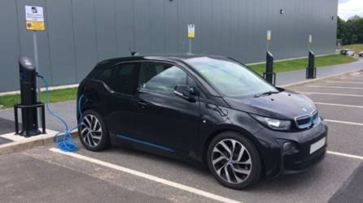
We’re inviting residents to have their say on the facilities for electric vehicles in Rushcliffe, including factors which would encourage them to own, charge and maintain a battery or plug-in hybrid vehicle.
Their views will help inform where the installation of charge points may be possible and help shape planning for potential facilities in line with local current or future capacity.
The survey takes just five minutes to complete, and gives residents the opportunity to comment more widely on car charging in the Borough: https://www.surveymonkey.co.uk/r/RBCevcharging

D2N2 board member roles advertised

The D2N2 Local Enterprise Partnership (LEP) has begun recruitment for two new private-sector board members who can help continue the growth of our region.

They are seeking an experienced senior leader or business owner with an outstanding ability to communicate, lead and influence to play a central role in deciding local economic priorities to drive economic growth and create local jobs across Derby, Derbyshire, Nottingham and Nottinghamshire.

Applications are welcome from across the LEP area and from all sectors of the economy to reflect our diverse business community.

The deadline for applications is Monday November 9 and more information on the role and application process is available on the D2N2 website.

Check your eligibility for this year’s flu vaccination

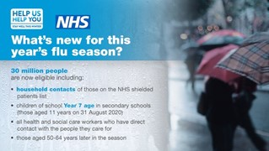
Public Health England are reminding everyone to check if they can get the flu vaccine this autumn, as an estimated 30 million people are eligible for the free vaccination.

There is a particular risk of severe illness from catching flu for:
- older people
- the very young
- pregnant women
- those with underlying disease, such as chronic respiratory or cardiac disease
- those who are immunosuppressed

This year you are also recommended to have the flu vaccine if you are the main carer of an older or disabled person, a household contact of someone on the Shielded Patients List for COVID-19 or a child aged 2 to 11 years old on 31 August 2020.

Flu vaccination is important because:
- if you're at higher risk from coronavirus, you're also more at risk of problems from flu
- if you get flu and coronavirus at the same time, research shows you're more likely to be seriously ill
- it'll help to reduce pressure on the NHS and social care staff who may be dealing with coronavirus

If you've had COVID-19, it's safe to have the flu vaccine. It'll be effective at helping to prevent flu.

Find out more about this year’s flu vaccinations on the NHS website.

Compliments

A business owner has praised our Environmental Health teams for their assistance in her application for a Premises Licence.
She said: “Simply a big thank you! In really difficult times because of the current pandemic, the help and support to get us up and running in a timely manner has been great.

“They were at the end of my calls and e-mails when I needed advice and guidance.

“Making the process for a complete first timer so much easier without compromise! Again, thank you!”

All the latest information for residents is available on the Coronavirus webpages or over the phone on 0115 981 99 11.

_________________________________________________________________________________

