Monday, August 17

New booking system at West Bridgford HWRC from September
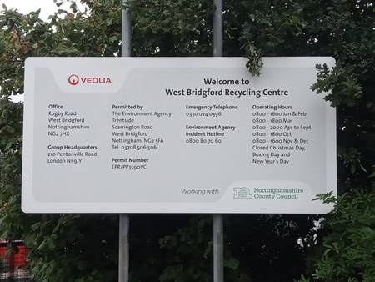
A new trial online booking system for the Household Waste and Recycling Centre (HWRC) in West Bridgford is to launch on September 1, Nottinghamshire County Council have announced.
The centre on Rugby Road will only be accepting pre-booked vehicles from next month, with 15-minute time slots available between 8.15am and 7.45pm every day during the summer opening hours. Up to five vehicles will be allowed on site at any one time.
Residents must already be registered to use Nottinghamshire County Council’s recycling centres before booking their timeslot easily through the authority’s website: www.nottinghamshire.gov.uk/booktorecycle
Sessions can be booked up to two weeks in advance but must be booked at least 24 hours before visiting the site as no same day slots will be available.
Visitors to the site will not be permitted entry without an electronic or paper copy of their emailed booking receipt.
Residents are requested not to make multiple bookings and use other sites where they need to visit more than once in any two-week period.
Only the West Bridgford recycling centre will need to be pre-booked, and residents can carry on using any of the Council’s 11 other sites around the County without an appointment.
Those who would like more information or to book their recycling visit over the phone should telephone Nottinghamshire County Council’s customer service centre on 0300 500 8080 between 8am and 6pm Monday to Friday.
Community Support Scheme grants to revert back to non-COVID projects from September

In April the Leader agreed in consultation with other Group Leaders to relax the arrangements for members to use their Community Support grants in light of COVID-19.

These funds were made available to reach local communities even quicker if they were needed for an urgent pandemic related cause and led to over £6,000 being allocated to great projects.

Now, subject to any local lockdown or national second wave of the pandemic, the normal operation of the scheme will resume from September 1 with applications again available for non-COVID projects.

COVID-related applications are still invited but it is anticipated with many community needs of the pandemic met through other specific local funds, the grant scheme can resume its role in supporting day to day community projects.

Applications for the allocated funding can continue to be made through the attached guidance and application form for each sum requested, all of which will also soon will be available via a digital form.

For more information email democraticservices@rushcliffe.gov.uk

Further action to deter rural fly-tipping
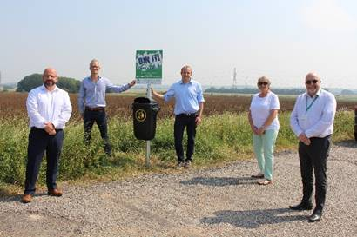
Further action is being taken to deter rogue fly-tippers from blighting landscapes in Gotham, Barton-in-Fabis and Thrumpton.
New bins and signage from us now instruct motorists to ‘bin it, don’t dump it’ at lay-bys in the area, backing up continued surveillance and monitoring at the sites to catch those who flout the rules.
The new features, installed by Streetwise on behalf of us, build on the work of a wider project which started last month, following an increase in fly-tipping in the area this year with trade waste and household items being dumped in laybys, roads and verges.
Nottinghamshire Police and Parish Council representatives joined us in July to stop vehicles on the nearby A453 Remembrance Way, Green Lane and Fox Covert Lane to make checks on trade waste and other drivers.
We are working together to combine resources and share information to support even more local action, including surveillance and fly-tip watch groups.
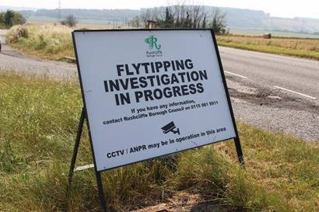
Residents and businesses are reminded to check that any company or individual they employ to dispose of their waste holds the relevant Trade Waste Carriers’ licence to avoid their unwanted goods contributing to fly-tips.
This can be completed by them showing the relevant licence in person and checking it with the Environment Agency’s listings of registered businesses here: https://bit.ly/1UFAWfn
Rushcliffe Borough Council’s ward councillor for the area Cllr Rex Walker joined Thrumpton Parish Meeting Chairman Ben Wilson, Gotham Parish Council Chairman Gill May and Streetwise’s Chairman Dave Mitchell and Managing Director Nigel Carter to view the new facilities at a lay by on Nottingham Road between Clifton and Gotham.
Our Cabinet Portfolio Holder for Neighbourhoods Cllr Rob Inglis said: “The new bins and signs complement the clear message that Rushcliffe Borough Council will not tolerate offenders dumping waste illegally in our picturesque and rural areas.
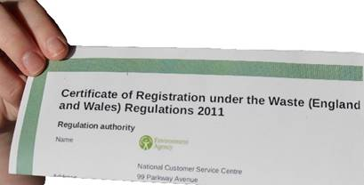
“Fly-tippers are warned that we are taking this very seriously and by our various monitoring means we will take positive action and prosecute from any evidence gathered and that includes seizing the vehicles involved.
“Residents have a huge part to play too by always checking that anyone they pay to take items away from their home is a registered waste carrier by requesting to view the appropriate Environment Agency licence.”
Cllr Walker added: “The Council’s engagement has been very positive so far since residents, the local parishes and I raised this issue and we’ll continue to look at further ways in which we can work together.
“From signage to surveillance, we are exploring what methods can deter fly-tippers from blighting our rural landscapes.”
Streetwise Chairman Dave Mitchell said: “We’re pleased to be able to support partners wherever we can to reduce fly-tipping across Rushcliffe.
“As we work across the Borough and the region, our teams continue to join communities in being extra eyes and ears in reporting information that can help the authorities take action against those who choose to not dispose of waste legally.”
Get our news direct to your inbox!

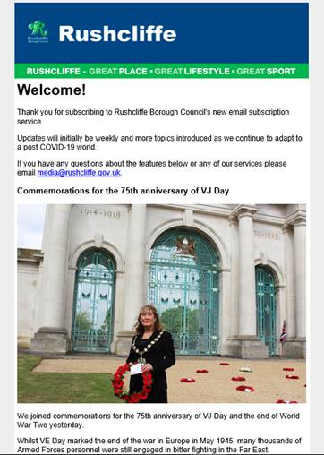
Yesterday (August 16) we launched a free email subscription service providing news and updates on our services direct to yours, residents’ and stakeholders’ inboxes.

To sign up now and receive the updates please subscribe here: https://bit.ly/RushcliffeSignUp

Whilst our website and social media pages are still a great place to find all our latest news and updates, these email bulletins are a new, no hassle channel that initially will provide a weekly digest on our great services.

Many local authorities use this as another way to connect with residents who are not on social media or may not be in the habit of visiting our website so we’re taking these further steps to give residents what they want, in the format they wish to receive it as our digital audiences continue to grow.

More topics will be introduced as we continue to adapt to a post COVID-19 world.

You will also see a subscription overlay on our website homepage that encourages all to enter their email address to sign up.

Advice on car sharing during COVID-19
Our Public Health partners are urging people in the City and County to take action to stop the spread of Covid-19, specifically when car sharing.
As well as continuing to wash hands, keeping socially distant and getting a free test for symptoms, people who have to share a car to get to work should be careful to use face coverings and to clean car surfaces at the end of the journey.
Those travelling by car should only do so with people from their household or within their support bubble, or if this is a work requirement. Outside of this, residents should avoid sharing cars with other people, but if people must then they need to make sure to:
- Share the transport with the same people each time
- Keep to small groups of people at any one time
- Open windows for ventilation
- Clean their car between journeys using standard cleaning products; making sure they clean door handles and other areas that people may touch
- Ask the driver and passengers to wear a face covering.

Commemorations for the 75th anniversary of VJ Day

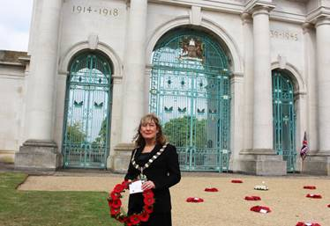
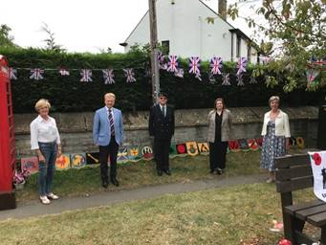
We joined commemorations for the 75th anniversary of VJ Day and the end of World War Two on Saturday.

Whilst VE Day marked the end of the war in Europe in May 1945, many thousands of Armed Forces personnel were still engaged in bitter fighting in the Far East.
Victory over Japan Day therefore marks the day Japan surrendered on August 15, 1945.
A wreath was laid on the Embankment War Memorial in Nottingham in a ceremony attended by our Mayor Cllr Sue Mallender on behalf of the Councillors and residents of the Borough.
Our Deputy Mayor Cllr Tina Combellack also attended VJ Day commemorations in the Parish of Langar cum Barnstone in part of her Ward and that of Cllr Sarah Bailey, also attended by Cllr Neil Clarke in his role as County Councillor and Ruth Edwards MP for Rushcliffe.
She met local resident Mr Chamberlin who displayed Burma Star Association memorabilia for those who attended including 28 plaques bearing the insignia of each of the divisions that took part in the War in the Far East in a very moving ceremony.
We also met with local resident and treasurer of the West Bridgford British Legion Pete Cunniff, whose father served in the Royal Navy in Asia until 1946 and was awarded the Burma Star for his services.
A video of the interview can be viewed here: https://youtu.be/4Ny8kFIWF9I

Risk management training available

A virtual risk management training session has been arranged for members of the Governance Scrutiny Group and all other Councillors on Wednesday, September 2 at 6pm.

The session will be for 45 minutes, with a questions section afterwards.

If you would like to attend, please email democraticservices@rushcliffe.gov.uk

Need to contact Metropolitan Housing?

Members are being reminded of the ways you can contact Metropolitan Thames Valley Housing to report new problems on behalf of your local residents.

By telephone they are available 24 hours a day, seven days a week, 365 days of the year on 0203 535 3535. Please note that due to data protection requirements verification will be required when you contact MTVH by phone.

For non-urgent calls please try to avoid calling in peak times between 8am to 10am and 4pm to 6pm.

Email enquiries for all routine issues should be sent to Service.Improvement@metropolitan.org.uk.

If however you wish to raise a formal Members’ enquiry, or are contacting Metropolitan about a Member’s enquiry or complaint that is already open, the address to use is customercare@metropolitan.org.uk.

Both of these mailboxes are monitored daily.

If the issue relates to a lack of progress on an existing complaint, Members may contact Chris Bull, Head of Housing North at chris.bull@mtvh.co.uk

And please remember all of these details are always available on the Extranet here.

New dates for HMRC webinars on self-employment, universal credit and child benefit

HM Revenue and Customs have added new dates for their webinar about the Self-Employment Income Support Scheme, Universal Credit and Child Benefit.
Businesses can also register for webinars on topics including the Coronavirus Job Retention Scheme and Eat Out to Help Out.
Businesses and residents can register here.

Make sure your vehicle is not an easy target
Our colleagues at Nottinghamshire Police are reminding us it’s important that vehicles are not an easy target for criminals.
Remember and please share with constituents:
• Make sure your vehicle is left with the doors locked and windows closed, as this will deter opportunist thieves
• Do not leave valuable items such as any electric devices, bags, clothing or cash on display
Criminals are not just targeting vehicles parked on the street, but also in driveways and in car parks.
For more advice, please visit: https://www.nottinghamshire.police.uk/advice/prevention/vehicle

Emergency fund to help Nottinghamshire groups support residents

A reminder that an emergency fund to help Nottinghamshire groups support residents who are struggling to afford essentials due to COVID-19 has been launched by Nottinghamshire County Council.

The Emergency Assistance Fund offers a share of £858,000 of emergency funding to groups and organisations already helping communities through the crisis.

Established local charities and community organisations who have been delivering essential COVID-19 related services can apply for grants towards the cost of getting food and other essentials to those who need it the most.

To apply and find out more, please direct applicants to: www.nottinghamshire.gov.uk/assistancefund

All the latest information for residents is available at www.rushcliffe.gov.uk/coronavirus or over the phone on 0115 981 99 11.

_________________________________________________________________________________

Thank you for contacting Rushcliffe Borough Council.

Please give feedback on your correspondence

