OFFICIAL

Monday, January 18

Meetings

Wednesday, January 20: Growth and Development Scrutiny Group will meet at 7pm. Find out more on our website. This meeting will be live streamed for the public to view on our YouTube channel.

Preparing our communities for potential flooding from tomorrow

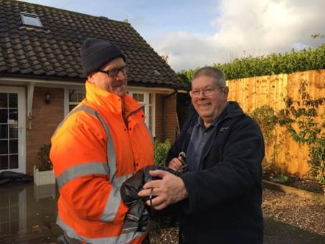
As you may have seen from this week’s weather forecasts, heavy rain is expected from Tuesday to Thursday that could impact with localised flooding in our communities.

Wednesday is the day we could receive the most significant rainfall with an amber warning for rain, building on the higher volumes we have received in the last 10 days.

In conjunction with the Local Resilience Forum and Nottinghamshire County Council, we are now preparing for flooding incidents.

We have contacted Parish Clerks and we’re asking you to help with messages to encourage local residents to deploy any local property resilience measures they may have.

These include flood gates, air brick covers or checking sandbag provisions to help reduce the possible impact. Please also ask them check any local water course infrastructure that they may have responsibility for to ensure it is free flowing.

As ever we will be ready to respond with support. We are available on 0115 981 9911 or on our out of hours number 0115 981 1143.

Our partners Streetwise will have teams on standby and will distribute sandbags with priority to households at imminent risk of internal flooding where requested but we ask for patience, as depending on the volume of rainfall, demand may be significant across the Borough.

For immediate assistance please call the numbers above or for any questions please email media@rushcliffe.gov.uk

Please continue to follow national lockdown measures

Thank you for continuing to play your part by staying at home, protecting the NHS and saving lives as the pandemic continues.

Please remember to keep informing residents of 'Hands, Face, Space' and to only leave their home for essential reasons.

All the latest can be found on our webpages www.rushcliffe.gov.uk/coronavirus

COVID-19 vaccine – please wait to be contacted and then respond promptly

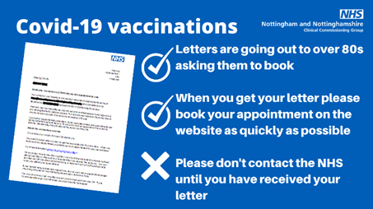
Across Nottingham and Nottinghamshire people over the age of 80 are continuing to be contacted to book their Covid-19 vaccination.

The NHS have now stated all over 80s, registered with a GP, should receive an appointment letter by this Tuesday, January 19.

No one should call their GP or turn up at A&E or a doctor’s surgery – the only way to get an appointment and the jab is to follow the instructions in the letter.

- Please don’t contact the NHS to seek a vaccine, they will send out a letter inviting individuals to book an appointment
- When they receive their letter, they should act quickly to book their appointment
- Please continue to follow all the guidance to stay at home, protect the NHS and save lives

For all enquiries on Vaccination appointments please visit Nottingham and Nottinghamshire’s CCG website.

Pub owners, staff and customers fined after flouting COVID rules
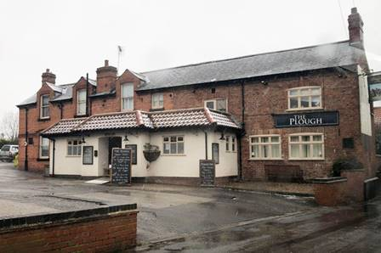
A pub in the Borough has been closed and its owners, staff and four customers fined after it was found to be serving alcohol inside the premises in breach of current national lockdown laws.

Nottinghamshire Police officers visited The Plough Inn in Cropwell Butler on January 13 to find four individuals sat around a table drinking and watching television with a member of staff.
Our Environmental Health and Licensing Officers have served its owners a fixed penalty notice of £1,000 in line with central government rules and Police have issued £200 fines to all customers and the three owners and staff present at the time of the breach.
The business has also received a prohibition notice ensuring it cannot allow individuals to enter the premises to consume food or drink.
Our Cabinet Portfolio Holder for Neighbourhoods, Cllr Rob Inglis said: “This is an exceptionally disheartening breach of the current lockdown restrictions when so many people are following the rules to protect lives and each other at the height of the pandemic to date.
“It is mindless, selfish and utterly irresponsible by all involved. We know businesses are facing an unprecedented trading situation but so many here in Rushcliffe have adapted brilliantly to offer takeaway and delivery safely instead of having to resort to flouting the rules.
"We always look to advise and educate business owners as to their responsibilities and we thank Rushcliffe business owners for their high compliance to date and for playing their part in keeping customers and staff safe.
“COVID restrictions are in place to protect everyone and we say to all business owners please do not place yourself in a position like this which is putting lives at risk. Contact us if you need support to trade.”

Vital national lockdown grants announced for eligible Rushcliffe businesses

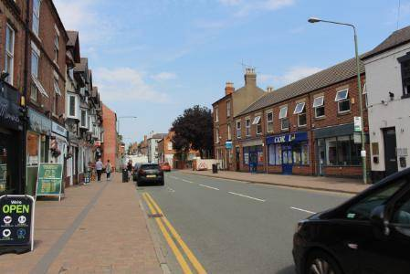
We have outlined our plans to ensure vital central government grants reach businesses affected by the current national lockdown restrictions.
Eligible businesses can now apply for the funding on our COVID-19 business support pages that is over and above any previous grant support.
To qualify for a grant, businesses must occupy a property listed as liable for national non-domestic rates and have been instructed to close in line with the current restrictions in the Borough from January 4, even if able to open for delivery or takeaway services.
Further discretionary support is set to be outlined as soon as possible.
We will contact those who previously applied for a grant in previous tier or lockdown restrictions with details of how to reapply.
Our teams are working to process all grants as quickly as possible with owners asked to ensure all supporting documents are included with any application.
This builds on our distribution of nearly £34m of previous central government grants since last March to over 1,500 eligible businesses.
Our Deputy Leader Cllr Andy Edyvean said: “This is very welcome news following the Chancellor’s announcement earlier this month, further grants are available and we will quickly distribute them.
“We’re very aware of our businesses’ outlook as this awful pandemic continues and this offers many in the hospitality sector and other industries vital support.
“We’ll continue to assist central government in managing the impacts of COVID-19 wherever we can.
“For all other business support for business owners please contact our Economic Growth team by emailing econdev@rushcliffe.gov.uk"

Tree planting continues across the Borough!

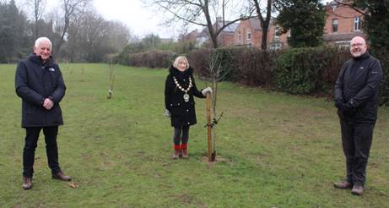
We’re continuing tree planting across the Borough, with Streetwise helping to plant field maple and crab apple trees on Bridge Field in West Bridgford over the weekend.

Our Mayor Cllr Sue Mallender was joined by Cllr Richard Mallender and Colin Gibson from Friends of Bridgford Park to view the latest green additions.

This builds on over 7,000 trees to have been planted across the Borough since our free tree scheme launched in December 2018.

Please consider support to the Grantham Canal Water Restoration Group

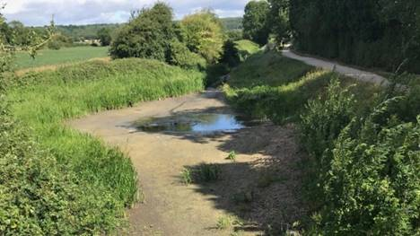
The Grantham Canal Water Restoration Group is appealing for further support and awareness of the plight facing parts of its waterway that continue to be dry during some parts of the year.

Group member Lesley Haig said: “Many people were very upset to see that the canal dried out locally last summer, despite it flooding at the same place in February last year.

“The August report about it on BBC East Midlands Today was the trigger for the formation of the Grantham Canal Water Restoration Group under the chairmanship of our Parish Council Chair, Peter Cadwallader.

“Six local councillors, including Tina Combellack, our local councillor, county councillor Neil Clarke, and Tony Osbond, General Manager of the Grantham Canal Society form the membership and myself.

“Between them all, the group has a very good knowledge of the canal and it’s problems. They know many of the local landowners who’s land is adjacent to the canal, and there is a lot of goodwill to get things done, the group also have the experience of navigating through the relevant bureaucracy.

“To summarise, the canals predicament and the causes of water loss are many, and they emanate from as far away as the Knipton Reservoir on the Belvoir estate to a large leak near to the Vimy Ridge Bridge.

“There are other leaks, and also the density of reeds in several places makes the reeds act as a dam, preventing the movement of both wildlife and water.

“The Canals and Rivers Trust are responsible for the maintenance of the canal. However their budget is overstretched, and they regard our disused canal as ‘a drain’ so it gets low priority.

“However they have promised some help, and you may have seen the plastic barrier marking the large leak near Vimy Ridge.

“The work started there was exploratory and has not yet fixed the leak, indicating that fixing it is not going to be an easy quick thing to do.

“Meanwhile all the early winter rain which had brought the canal to a decent level can be heard haemorrhaging out, and as I write on January 8, the water level is dropping again.

“The Canals and Rivers Trust have plans made to assist, with the thinning out and removal of some of the dense reed beds acting as dams along the watercourse.

“We need to keep public attention focused on our canal in any way that will bring the support and funding to address each issue, any help with any aspect of this will be welcomed by Tony Osbond’s team at the Grantham Canal Society, he can be contacted by email at lindyedge@aol.com

“Most people in Kinoulton will be aware of the massive popularity of our canal. During 2020 it has attracted a huge amount of people along its length to enjoy the beautiful scenery and the wildlife.

“We cannot take its continuation for granted however, it needs us, and our vocal and practical support to overcome its catalogue of accumulated maintenance needs if it and its wildlife populations are to be there for future generations.”

Support for disadvantaged children’s education at home

In response to the current restrictions preventing schools from opening, BT has introduced a connectivity support scheme which provides a range of support including help for disadvantaged children to continue their education at home.

The support scheme includes:

- Free unlimited mobile data for those families and carers supporting children with no internet access, to help access remote education, as part of DfE’s Get help with Technology programme.
- Free WiFi vouchers for schools and charity partners for access to the 5 million BT WiFi Hotspots across the UK. These can be accessed on the BT website.
- Zero rating of some of the most popular educational websites designed to support home learning, before the end of the month.
- Updated online educational resources, tech tips and digital skills with BT Skills for Tomorrow programme.

Full details are available on the BT website.

Grant available for elite Rushcliffe athletes

Elite athletes across the Borough are being invited to apply for grant funding to support their efforts in their chosen sport.
Our Elite Sports Grant is available with grants of up to £400 that aim to reduce some of the financial burden of competing at an advanced level that can often create a barrier to achievement.
Funds may help with costs such as travel, training, accommodation, competition fees and equipment, specialist coaching and other specialist support deemed appropriate by the National Governing Body over the next year.
The grant could be used when much elite sport fully resumes once Central Government announces it is safe to do so.
Applications to the grant scheme are being encouraged from athletes who are currently performing at international level within their sport with priority given to competitors in sports or disciplines represented at the Olympic and Paralympic Games or Commonwealth Games.
Applicants have until February 8 to apply at https://bit.ly/2sPw8ic and must be:
- a resident of Rushcliffe Borough or go to school within the Borough
- 14 years old or over
- competing in a Sport England recognised sport
- competing for their country/in the national training squad in their chosen sport
- have amateur status
- fully endorsed by their National Governing Body and National or International coach who must be suitably qualified and affiliated.
To accompany the application, a confirmation letter from their National Governing Body confirming an athlete’s level of performance is also required.

Climate Emergency online training available
The Local Government Association (LGA) have launched the following opportunities for elected members to receive climate change training.

All the webinars are hosted via Zoom to provide further insight into the climate challenges facing both the public and local authorities.

Digital solutions to the climate crisis
Tuesday February 9, 2.30pm to 4pm

Through a series of presentations - which brings together innovators, technologists, and local authorities - you’ll hear examples of how digital technologies are being deployed to support citizen engagement on climate action, and in supporting sustainable mobility and local energy initiatives.

Please secure your place via the LGA website.

Applying behavioural change techniques to the COVID-19 and climate emergency responses
Tuesday 23 February 2021, 10am to 11.30am

This online event will showcase councils which have used behavioural change techniques to tackle two of the biggest challenges of our day – tackling COVID-19 and climate change. The launch of a green behaviours online resource for councils to help tackle dangerous climate change with their communities will also be featured during the session.

Please secure your place via the LGA website.

New online courses for adults at Nottingham College

Nottingham College has recently launched a range of part-time courses delivered fully online.

They are designed for anyone aged over 19 to help them retrain for their future or improve their skills in their current career.
Many of the courses are free to adults who meet financial eligibility criteria, and others are short introductory options costing £28.50.

People can study from home at a time to suit them, and they are also suitable for local businesses to train their staff.
More details about courses and funding are available on Nottingham College’s online course pages on their website, or by calling the College on 0115 9100 100.

Warm Homes Hub winter grants for utility bill payments

Residents across the Borough affected by the pandemic can take steps to reduce their utility bill this winter, thanks to the Warm Homes Hub’s COVID Winter Grant Scheme, which offers grants of up to £178 per household.
Those who have experienced job loss, loss of income, increase in energy debt, increased fuel use, self-disconnection, or a detriment to health and wellbeing in Nottinghamshire could be eligible for the scheme.
We’re currently working alongside partners to refer any eligible residents to the Warm Homes Hub, but are encouraging anyone who’s experienced the circumstances listed above to contact our Customer Services team on 0115 981 99 11 or customerservices@rushcliffe.gov.uk if they feel they need additional support.
The Warm Homes Hub also offers a wide range of additional free and subsidised services to residents throughout the Borough, including financial support, energy efficiency advice and boiler repairs and replacements.
To find out more please visit the Warm Homes Hub website.

Gotham-Clifton road to close with diversions now in place

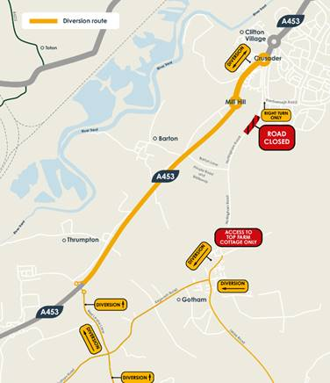
A reminder that Nottingham Road between Gotham and Clifton is now closed until Sunday, February 28 to allow for a new junction to be built as part of enabling works for the £800 million Fairham development.

Diversions are in place for Nottingham Road from Gotham in the south and Clifton in the north for all vehicles, cyclists and pedestrians, with signed diversions for cars, a designated cycle route and pedestrian access via the existing public right of way track through the fields to walk between Clifton and Gotham.

All motorised traffic will be re-routed via the A453 at the Gotham/Thrumpton junction coming from the south, east and west, and via the A453 at Crusader Island coming from the north.

Nottingham City Transport Bus Service 1 will be diverted during these works. All diversion plans are available to view and download at www.fairhamlife.co.uk

Have your say on our Planning Enforcement Policy

We are reviewing and amending our Planning Enforcement Policy. It allows us to intervene should a breach of planning control take place and assess any harm that is caused.

Have your say on how we apply this here before January 29: https://bit.ly/3myHv41

Compliments

A resident got in touch this week to share their praise for our garden waste collection service.

They said: “I’d like to send my highest regards to the council for being so fast and solving problems I had with our green bin/ disposal of Christmas tree!

“Thank you so much for getting it sorted and being fab via communication!”

Another resident got in touch on social media to thank our Streetwise team for their recent work in Compton Acres.

He said: “Just wanted to point out that you or your contractors had done a neat and tidy job of clearing all the overgrowth along the Lydney park pathways.”

Angela Mellor in our BSU team and Colin Offland in our Environmental Health Team were thanked by a resident for their recent work.

He said: “Hi Angela, thanks for arranging for Colin to visit this afternoon.

“Colin was extremely professional, knowledgeable and even though it was snowing heavily was happy to take the time to answer all of my questions regarding my pest problem. It's nice when you have people who go that little bit further to help the customer- a real asset to your department.”

All the latest information for residents is available on the Coronavirus webpages or over the phone on 0115 981 99 11.

_________________________________________________________________________________

Thank you for contacting Rushcliffe Borough Council.

Please give feedback on your correspondence with us today here: https://www.surveymonkey.co.uk/r/9LC6CXL

