Thursday, August 13

Council news and updates direct to yours and residents’ inboxes!
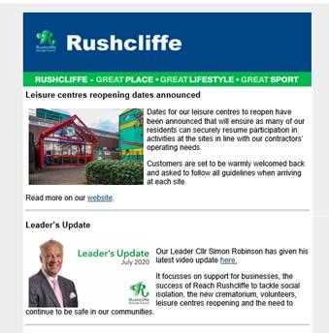
From this Sunday we are set to launch the GovDelivery email service, a free subscription service providing news and updates on our services direct to residents’ and stakeholders’ inboxes.
Many local authorities use this as another way to connect with residents who are not on social media or may not be in the habit of visiting our website.
This channel forms part of our external communications strategy 2018-21 that highlights taking further steps to giving residents the information they want, in the format they wish to receive it, as our digital audiences continue to grow.
Updates will initially be weekly and this will be reviewed with more topics introduced as we continue to adapt to a post COVID-19 world.
From tomorrow you will see a subscription overlay on our website homepage that encourages residents to enter their email address to sign up.
We’ll send this link to you tomorrow too so you can sign up.

Commemorations for the 75th anniversary of VJ Day

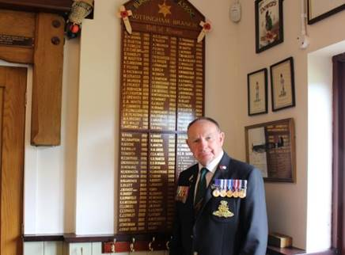
We are joining commemorations for the 75th anniversary of VJ Day and the end of World War Two.

Whilst VE Day marked the end of the war in Europe in May 1945, many thousands of Armed Forces personnel were still engaged in bitter fighting in the Far East.

Victory over Japan Day therefore marks the day Japan surrendered on August 15, 1945.

We are encouraging residents to join a national two-minute silence at 11am on Saturday led by His Royal Highness The Prince of Wales at the National Memorial Arboretum.

A wreath will also be laid on the Embankment War Memorial in Nottingham in a ceremony attended by our Mayor Cllr Sue Mallender on behalf of the residents of the Borough.

We are alerting residents to further information about the national commemorations at www.rushcliffe.gov.uj/vjday

We met with local resident and treasurer of the West Bridgford British Legion Pete Cunniff, pictured left, whose father served in the Royal Navy in Asia until 1946 and was awarded the Burma Star for his services. A video of the interview can be viewed here: https://youtu.be/4Ny8kFIWF9I

Mr Cunniff said: “It’s 75 years now since the end of the War and I think it’s important to acknowledge it wherever we can because there was a lot of brave men and women who risked their lives.

“They did a lot for us so we could have the freedom that we now enjoy.”

Our Deputy Leader and Armed Forces Champion Cllr Debbie Mason said: “Whilst Britain was celebrating VE Day in May 1945, there were still soldiers, sailors and airmen serving across the world and were amongst the last to be brought home.

“It is incredibly important to remember those who made a great sacrifice in the Far East and ended the War 75 years ago on August 15.

“Please take the time this weekend to reflect and commemorate those who lost their lives.”

Deputy Mayor attends veterinary opening in East Bridgford
Our Deputy Mayor, Cllr Tina Combellack, attended the opening of a new veterinary centre this week and was excited to welcome the business to the village.
She had the honour of cutting the red ribbon on the new Buttercross Veterinary centre, following a speech from Clinical Director Gemma Newbold.
Cllr Combellack also had a personal attachment to the new development and was pleased to be able to take part in celebrations.
She said: “I was delighted to go as my daughter is an Equine vet in Cheshire and started her small animal practice with Buttercross Veterinary at their base in Bingham.”

Email, planning and online form payments unavailable this Saturday from 9am to 5pm
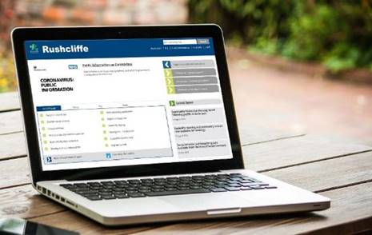
A reminder that our ICT team have a major project to replace the Council’s main storage devices which will affect access to council email, planning, online form payments and other web-based services this Saturday, August 15 from 9am to 5pm.
These storage devices hold 98% of all the Council’s systems and data stored in the Data Centre.
Some preliminary work is required to update the network infrastructure before this work can begin and this means shutting down these services temporarily.
Payments made via the website for invoices and council tax however will be unaffected.
If you have any concerns regarding this work, please email servicedesk@rushcliffe.gov.uk or call 0115 914 8333.

First secure Bingham ‘Summer on the Square’ sessions well received
Our Economic Growth, Environmental Health, Events and Licensing teams have been delighted to work with Bingham Community Events Group to help local bars, restaurants and outlets in the town centre expand their outdoor seating arrangements in line with secure COVID practices.
The teams have worked with the volunteer group and Bingham Town Council to secure the necessary licences for ‘Summer on the Square’ to safely welcome hundreds to the Buttercross in the town to enjoy a drink or bite to eat at weekends this month, accompanied by music from local bands, securely situated away from those socially distanced on tables.
The first sessions were held last Friday and Saturday in the town and continue tomorrow (August 14) and again on August 22, 23, 29 and 30.
We’ve also received thanks from Number Sixteen café in the town for helping them to secure a licence to serve customers safely in a wider area adjacent to their premises on the Buttercross.
Swimming pools reopen from September 1
A reminder that the Parkwood operated leisure centre at Keyworth and pools at Rushcliffe Arena, Bingham and Cotgrave will reopen on September 1.
In order to keep everyone safe, lane swimmers are asked to book their session in advance online or via the app.
Those going for a swim need to arrive changed and ready to go, and also need to make sure they shower before entering the pool.
Parkwood are also asking swimmers to ensure they have read the updated swim etiquette advice before entering the pool and take note of the directional signage for lane swimming.
More information is available here.

New dates for HMRC webinars on self-employment, universal credit and child benefit
HM Revenue and Customs have added new dates for their webinar about the Self-Employment Income Support Scheme, Universal Credit and Child Benefit.
Businesses can also register for webinars on topics including the Coronavirus Job Retention Scheme and Eat Out to Help Out.
Businesses and residents can register here.

Book a free place on our Business Support Programmes
Businesses can book their free place on a range of online workshops as part of our Business Support Programme, designed to provide free training, guidance and advice to help them reopen or continue to trade securely and successfully following COVID-19.
Each online workshop is completely free for high street businesses thanks to support from the European Regional Development Fund.
The sessions get started from next week on August 20, with a wide range of topics for business owners to choose from, including training on using Instagram for business use, advice on delivering an excellent customer experience during COVID-19 and discussion of the 10 steps to retail success from author and ‘retail champion’ Clare Bailey.
To view the full range of support available, please visit the Business Resources page on our website, where free spaces on any of the sessions can be booked via Eventbrite.

Call for residents to not endanger themselves in open water this summer
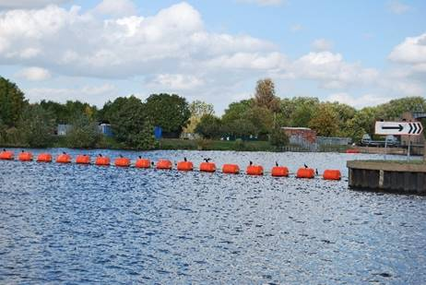
We’re supporting the Canal and Rivers Trust current campaign to remind residents to not endanger themselves by cooling down in open water this summer.
Last weekend, the Trust reported concerns of young people entering water in the River Trent at Holme Pierrepont and on the River Soar at Sutton Bonington.
With many risks that can’t be seen hidden below the surface, all residents are advised to enjoy our waterways from the safety of the towpath.
The advice to residents is:
Depth perception
- Canals are often shallow, which you can't tell from the surface. If you jump in you are likely to injure yourself, possibly seriously.
- However, don't be fooled by thinking that all canals are shallow. If you can't put your feet on the ground, it'll be much harder to get out. Rivers, reservoirs and docks are generally much deeper, and colder.
Hidden dangers under the water
- Canals are havens for wildlife. If you're in the water, reeds and other plant life could get tangled around your limbs and trap you in the water making it very difficult to climb out.
- Sadly, rubbish like shopping trolleys can be lurking below the surface of canals and rivers. If you're in the water you could injure yourself by cutting yourself on a rusty old bicycle or broken glass, or get trapped on a larger piece of rubbish, like a trolley or even a motorbike.
Disease
Waterborne diseases are extremely rare, but if you are swimming you're most exposed to them. If you are likely to come into contact with water it’s sensible to take a few precautions:
- If you’ve got any cuts or scratches, keep them covered
- If you fall in, take a shower and treat cuts with antiseptic and a sterile dressing
- Wash wet clothing before you wear it again
- If you develop flu-like symptoms within two weeks, see a doctor and mention that you fell in the water. Not all doctors will know to look for signs of Weil’s Disease, so do suggest it as a possibility.
Cold temperatures
Even on a hot day, inland waterways will be colder than you think, particularly reservoirs and docks as they're deeper. Low temperatures can cause your blood to rush away from your muscles to protect your organs and limbs and muscles may become fatigued quickly and this can lead to drowning.
For more information visit https://bit.ly/3fHzZ3u
Make sure your vehicle is not an easy target
As the warm weather continues, our colleagues at Nottinghamshire Police are reminding us it is important vehicles are not an easy target for criminals.
Remember and please share with constituents:
• Make sure your vehicle is left with the doors locked and windows closed, as this will deter opportunist thieves
• Do not leave valuable items such as any electric devices, bags, clothing or cash on display
Criminals are not just targeting vehicles parked on the street, but also in driveways and in car parks.
For more advice, please visit: https://www.nottinghamshire.police.uk/advice/prevention/vehicle

Domestic abuse support update
The guidance for the public on how to get help if they or someone they know is a victim of domestic abuse during COVID-19 has been updated by central government here.
It includes information on help for children and young people and also how those in need can call Refuge’s National Domestic Abuse Helpline for free and confidential advice, 24 hours a day on 0808 2000 247.

Emergency fund to help Nottinghamshire groups support residents

A reminder that an emergency fund to help Nottinghamshire groups support residents who are struggling to afford essentials due to COVID-19 has been launched by Nottinghamshire County Council.

The Emergency Assistance Fund offers a share of £858,000 of emergency funding to groups and organisations already helping communities through the crisis.

Established local charities and community organisations who have been delivering essential COVID-19 related services can apply for grants towards the cost of getting food and other essentials to those who need it the most.

To apply and find out more, please direct applicants to: www.nottinghamshire.gov.uk/assistancefund

Compliments
A resident has thanked our waste team who cover collections in Radcliffe on Trent for taking the time to engage with his children when on their round.
He said: “Every week the kids love to wave at the refuse collection team. Every week the team look out for the kids and wave enthusiastically.
“It makes the kids day and it means so much to them that they always look out for them. Thank you for all that you do and the manner in which you do it.”

All the latest information for residents is available at www.rushcliffe.gov.uk/coronavirus or over the phone on 0115 981 99 11.

_________________________________________________________________________________

Thank you for contacting Rushcliffe Borough Council.

Please give feedback on your correspondence with us today here: https://www.surveymonkey.co.uk/r/9LC6CXL

Follow us on Twitter https://twitter.com/Rushcliffe

Like us on Facebook - https://www.facebook.com/rushcliffeborough

Connect with us on LinkedIn - www.linkedin.com/company/rushcliffe-borough-council/

Sign up to receive our business newsletter - http://eepurl.com/dbczkn

Call us on 0115 981 9911 (8.30am to 5pm, Monday to Friday), email customerservices@rushcliffe.gov.uk or visit www.rushcliffe.gov.uk

Rushcliffe Borough Council
Finalist, Local Authority of the Year 2019

