

**Monday, November 9**

**Meetings**

**Tuesday, November 10 –** Cabinet meeting at 7pm. [Visit our website](https://democracy.rushcliffe.gov.uk/ieListDocuments.aspx?CId=137&MId=957) for further details.

**Thursday, November 12** – Planning Committee at 6.30pm. [Visit our website](https://democracy.rushcliffe.gov.uk/ieListDocuments.aspx?CId=140&MId=936) for further details.

**COVID-19 guidance on playgrounds and outdoor gyms**

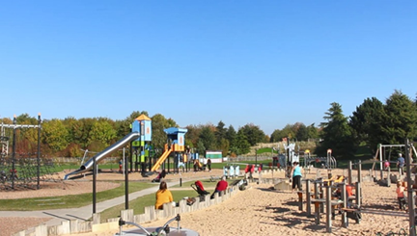New guidance from the Government means that outdoor gyms and fitness equipment across the Borough will be closed until December 2.

As a result, we have contacted our partners in towns and villages across the Borough and they are ensuring all outdoor spaces containing exercise fixtures and/or machines are temporarily closed.

Outdoor playgrounds can remain open during national COVID-19 measures.

Should you have any queries on this update, please email [media@rushcliffe.gov.uk](mailto:media@rushcliffe.gov.uk) or view the [Government guidance](https://www.gov.uk/government/publications/covid-19-guidance-for-managing-playgrounds-and-outdoor-gyms/covid-19-guidance-for-managing-playgrounds-and-outdoor-gyms) for further details.

**Latest COVID-19 update**

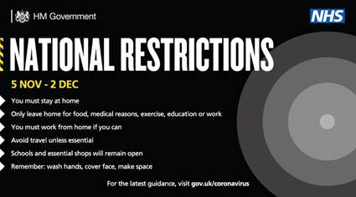Along with the rest of England, Rushcliffe is now under [national COVID-19 measures](https://www.gov.uk/guidance/new-national-restrictions-from-5-november).

The current national advice is:

**Stay at home**

This means you must not leave or be outside of your home except for specific purposes. These include:

* for childcare or education, where this is not provided online
* for work purposes, where your place of work remains open and where you cannot work from home (including if your job involves working in other people’s homes)
* to exercise outdoors or visit an outdoor public place - with the people you live with, with your support bubble or, when on your own, with one person from another household
* for any medical concerns, reasons, appointments and emergencies, or to avoid or escape risk of injury or harm - such as domestic abuse
* shopping for basic necessities, for example food and medicine, which should be as infrequent as possible
* to visit members of your [support bubble](https://www.gov.uk/guidance/making-a-support-bubble-with-another-household) or provide care for vulnerable people, or as a volunteer

**Stay safe outside the home**

You should minimise time spent outside your home and when around other people ensure that you are two metres apart from anyone not in your household or support bubble.

Remember - ‘Hands. Face. Space’:

* hands – wash your hands regularly and for 20 seconds
* face – wear a face covering in indoor settings where social distancing may be difficult, and where you will come into contact with people you do not normally meet
* space – stay 2 metres apart from people you do not live with where possible, or 1 metre with extra precautions in place (such as wearing face coverings or increasing ventilation indoors)

For further details on the national measures, please [visit our website](https://www.rushcliffe.gov.uk/environmentandwaste/emergencyplanning/coronavirus/" \l "d.en.52852).

**Reviewing the Ward Boundaries in Rushcliffe**

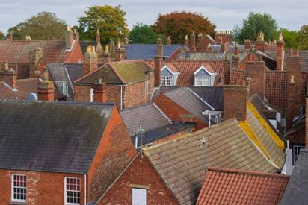A reminder to please complete the [Local Government Boundary Commission for England (LGBCE) survey](https://www.surveymonkey.co.uk/r/RBCmemberworkload) as soon as possible to help with the commissions’ review into electoral inequalities in Rushcliffe.

The review has been triggered by the LGBCE and will run from August 2020 to Summer 2022.

If you have any questions or comments about the survey or wider review, please contact Charlotte Caven-Atack at [CCaven-Atack@rushcliffe.gov.uk](mailto:CCaven-Atack@rushcliffe.gov.uk)

**Recognising Remembrance Sunday safely**

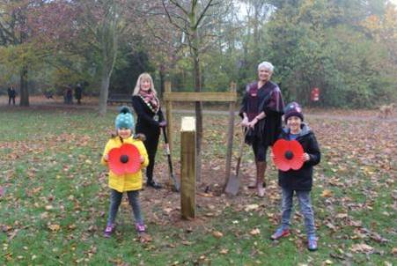Over the weekend, many councillors and residents took the time to recognise Remembrance Sunday safely with virtual celebrations, wreath laying and other COVID-secure activities.

Our Mayor Cllr Sue Mallender met with Cllr Abby Brennan and local school children to plant a commemorative tree and remember those lost in war from Rushcliffe and further signify 75 years since the end of World War II.

The tree, planted on Saturday, commemorates all those who paid the ultimate sacrifice from the Borough in all conflict and marked with a plaque to reflect the 75 years since VE Day.

Cllr Mallender said: "We know so many Remembrance events and reflections are sadly absent in many cases this year due to COVID-19.

"Therefore, we wished part of our commemorations this year to include planting this tree to remind residents we should never forget.

“Thank you to everyone who plays a part to remember those fallen at home this weekend.”

Cabinet Portfolio Holder for Community and The Environment Cllr Brennan was delighted a local park should be the focus of one of the Borough’s latest commemorations.

She said: “We know that so many residents love our parks, so what better way to mark this 75th Anniversary year than to provide a lasting monument to the sacrifice so many made in the second World War.

“We are living through difficult times for many now but it is important that we still take time to remember those who gave so much whether in world wars or conflict in more recent times.

“People can visit the tree safely under the COVID-19 restrictions as part of their daily walk or exercise."

Cllr Jen Walker also sent us some wonderful images from laying a wreath with Cllr Mike Gaunt at Holy Trinity church in Ratcliffe on Soar yesterday, as below.

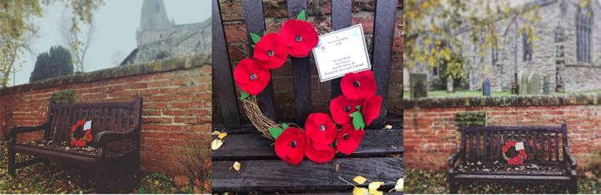

**National Careers Service Virtual Jobs Fair**

Residents can once again take part on a virtual jobs fair this month, featuring a live Q & A with a qualified advisor to address a wide range of queries.

The online session is available on Wednesday, November 18 from 9am to midday. Attendees are invited to check the [@CareersEMids](https://twitter.com/CareersEMids) channel on Twitter for more information on how to sign up in the coming days.

**Shortlisted nominees announced for the Celebrating Rushcliffe Awards**

The shortlisted nominees for this year’s Celebrating Rushcliffe Awards have been announced!

The awards this year are celebrating our wonderful volunteers, businesses and environmentalists, clubs, organisations, and the best of the health and wellbeing and food and drink sectors across the Borough, mindful of the impact COVID-19 has had on every part of the community and local enterprise.

Over 30 groups and individuals have been shortlisted for this year’s accolades and all will in due course be invited to a virtual ceremony taking place over three nights from December 1 to 3 to showcase their achievements.

[Visit our website to view the list of all our shortlisted nominees.](https://www.rushcliffe.gov.uk/aboutus/newsandpublications/latestnews/stories/name,55212,en.php)

**Items for Scrutiny**

The next Corporate Overview Group is on Tuesday, December 15. Each meeting of the Group considers items for scrutiny as submitted by Councillors and officers.

The deadline for submitting items for consideration is Friday, November 27. Items for consideration must be submitted using the Scrutiny Matrix which is available on the Extranet.

If you would like to discuss a topic before completing the matrix, please contact Service Manager – Finance and Corporate Services Charlotte Caven-Atack at [CCaven-Atack@rushcliffe.gov.uk](mailto:CCaven-Atack@rushcliffe.gov.uk)

**Volunteers needed to sustain vital community support**

Rushcliffe Community and Voluntary Service (RCVS) is stepping up its urgent appeal for more volunteers, to counter the impact of COVID-19 in Nottinghamshire.

Almost 800 vulnerable people have been supported by RCVS since the coronavirus lockdown started in March.

Services include helping with shopping or collecting prescriptions, transport for those who would otherwise be stuck at home, housekeeping, and telephone befriending to counter social isolation.

Almost 5,900 individual pieces of support have been provided in the Borough, Gedling and Broxtowe.

However, around 100 more volunteers are needed to meet ongoing demand. This is because two thirds of the 145 successfully recruited by RCVS earlier in the pandemic are no longer available.

As a result, the charity’s voluntary transport scheme is providing essential journeys only, and there’s a waiting list for the telephone befriending service.

Anyone interested in volunteering should call RCVS on 0115 969 9060 or email [volunteer@rushcliffecvs.org.uk](mailto:volunteer@rushcliffecvs.org.uk).

**Compliments**

**Customer Service Advisor Theresa Wilson received the below compliment from a resident for helping her to access the Meet, Greet and Eat service which delivers food packages to elderly and vulnerable residents.**

She said: “I would like to express my gratitude and say thank you to Theresa for the help she gave me.

“I would also like to give praise and recognition to the Customer Service Team as a whole and say thank you all for the hard work that you do.”

**A resident emailed to thank both our Customer Service Team and Waste Team for organising and delivering an additional blue bin to his property.**

He said: “I just wanted to say the bin has been delivered. Absolutely impeccable service; from raising a request and delivery of the new bin in less than 24hrs!

“Many thanks.”

**All the latest information for residents is available on the** [**Coronavirus webpages**](http://www.rushcliffe.gov.uk/coronavirus) **or over the phone on 0115 981 99 11.**

_________________________________________________________________________________

Thank you for contacting Rushcliffe Borough Council.

Please give feedback on your correspondence with us today here: <https://www.surveymonkey.co.uk/r/9LC6CXL>

Follow us on Twitter <https://twitter.com/Rushcliffe>