Thursday, January 7

Meetings

Tuesday, January 12: Cabinet will meet at 7pm. Find out more on our website.

Thursday, January 14: Planning Committee will meet at 6.30pm. Find out more on our website.

The meetings above will be live streamed for the public to view on our YouTube channel.

Vaccination service opens in Gamston
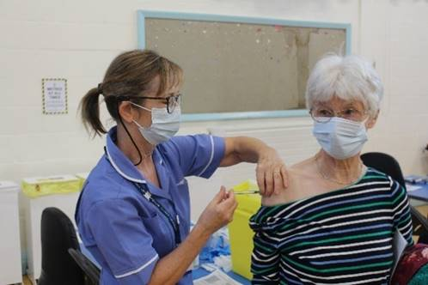
Our Leader Cllr Simon Robinson has welcomed the news Rushcliffe’s first COVID-19 vaccination service in is now live in Gamston.

We have been working with colleagues across the local health and care system to prepare for the opening of the first centre at our Gamston Community Hall located off Ambleside, close to the A52.

The site, which opened yesterday, opposite Morrisons, is open 8am to 8pm each day.

It will support the roll out of the national vaccination programme. In the coming weeks and months, other locations across Nottingham and Nottinghamshire will also open for vaccinations.

Recipients of the vaccine will be called forward in priority order as set out by the Joint Committee for Vaccination and Immunisation (JCVI).

The NHS are continuing to send letters to eligible people and vaccines will be by appointment only. First priority is for those over the age of 80 and frontline health and social care workers.

83-year-old Great Grandmother Wendy Wain (above) was among the first to receive the jab.

The former occupational therapist from West Bridgford said: “I am delighted to be receiving the vaccine if only for my two children, eight grandchildren and three great grandchildren who worry so much about me.

“I haven’t seen them all for such a long time and I hope this is the start of the road to being able to see them again safely.”

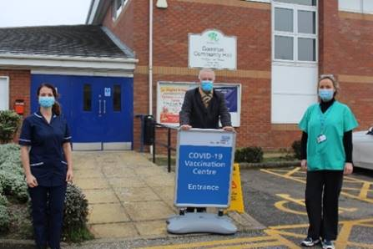
Cllr Robinson said: “This is a wonderful moment for Rushcliffe as we welcome the first vaccination site in the Borough, which will play a vital role in the biggest immunisation programme in NHS history.

“Although the rollout of the vaccine is exciting and we hope it will prove to be a pivotal moment in the fight against COVID-19, I ask people to be patient and wait until they are contacted to be vaccinated.

“The NHS will contact you when it’s your turn so please don’t turn up at this or any vaccination centre and don’t ring your GP or local hospital.

“I’d encourage everyone who receives a letter inviting them to have the vaccine, to get it. This will protect them from COVID-19 and hopefully help us all return to a more normal way of life as quickly as possible.

“I’m very proud of everyone who has worked hard to get to this stage. We will continue working with our partners to support the rollout in any way we can.”

It’s one of four sites in the County to have gone live this week at Ashfield Health Village, Richard Herrod Leisure Centre and Cripps Medical Centre at University Park with Newark Showground and the University of Nottingham’s King’s Meadow campus set to be operational next week.

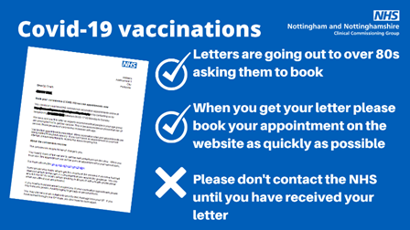
Please continue to reiterate to your constituents:
- Please don’t contact the NHS to seek a vaccine, they will send out a letter inviting individuals to book an appointment
- When they receive their letter, please act quickly to book your appointment
- Please continue to follow all the guidance to stay at home, protect the NHS and save lives

Leader calls on all to follow national lockdown measures

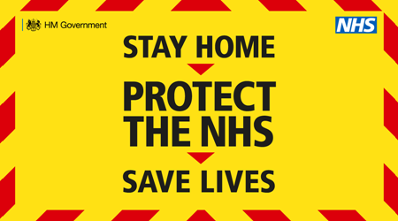
Our Leader Councillor Simon Robinson has responded to the latest announcement from Central Government on January 5 that England has now entered national lockdown measures.
He said: “We know these are yet more significant changes for everyone’s everyday life in Rushcliffe but it is absolutely necessary we follow these rules and stay at home, protect the NHS and save lives.
“The impact on residents, businesses, parents and individuals we understand is exceptional but we must do all we can to play our parts to fight this pandemic and ensure we help keep hospital admissions here in the County as low as possible.
“Thank you for your huge sacrifices to date and please keep visiting the Rushcliffe Coronavirus webpage for the latest, including on how you can help protect yours and your family’s mental health during these times.
“We’ll outline any further support for businesses as soon as possible.”
Colin to the cat rescue!

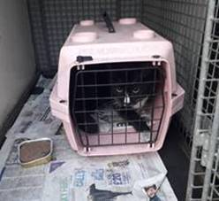
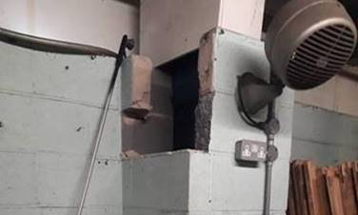
Hats off to our Environmental Assistant Colin Offland who came to the rescue of a cat at our Streetwise depot in Bingham on Monday.

Such was his dedication to saving the kitty, he even removed brickwork to gain access to where he had got trapped.

Colin said: “The cat had been setting off the alarms at the Streetwise unit for a few days and had got himself trapped at the bottom of one the block work columns.

“I was called by Barry Ingle there to rescue him and I had to remove a couple of blocks to get access. The cat was dehydrated and not microchipped but we soon got him to safety.”

Within 24 hours he had been reunited with his owners.

Customers reminded not to linger outside food and drink takeaway outlets

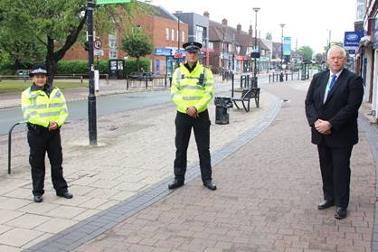
Residents in the Borough are being reminded to not linger outside food and drink takeaway services to help play their part in stopping the spread of COVID-19.
We’re also reminding all that a local Public Spaces Protection Order (PSPO) is in operation in West Bridgford for everyone’s benefit.
It means park users and town centre visitors must give up alcohol when asked to do so by an official and failure to comply can lead to a fixed penalty notice or prosecution at court and a fine of up to £1,000.
Under the national lockdown, businesses are able to continue a food and non-alcoholic beverage takeaway offering, or a food and beverage delivery service.

Gotham-Clifton road to close for six weeks with diversions in place

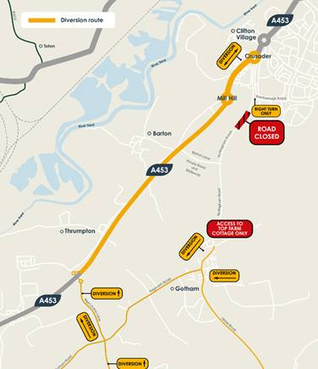
Nottingham Road between Gotham and Clifton will be closed for six weeks in January and February to allow for a new junction to be built as part of enabling works for the £800 million Fairham development.

The closure will take place from Monday January 18 to Sunday February 28 to enable the safe construction of a new staggered road junction to create access to the new development either side of the existing road and forms part of the longer term ambitions for traffic calming in the area.

There will be diversions in place for Nottingham Road from Gotham in the south and Clifton in the north for all vehicles, cyclists and pedestrians, with signed diversions for cars, a designated cycle route and pedestrian access via the existing public right of way track through the fields to walk between Clifton and Gotham.

All motorised traffic will be re-routed via the A453 at the Gotham/Thrumpton junction coming from the south, east and west, and via the A453 at Crusader Island coming from the north.

Nottingham City Transport Bus Service 1 will be diverted during these works. All diversion plans are available to view and download at www.fairhamlife.co.uk

Rushcliffe landlords invited to free webinar next week

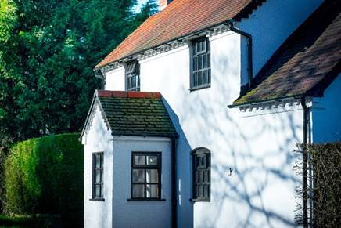
Landlords in Rushcliffe are being invited to join a free webinar next week, featuring local and national updates, in lieu of the usual in-person forum offered by South Nottinghamshire Councils.

We’re hosting the new online event at 10.30am on Wednesday, January 13 in partnership with Gedling Council, Broxtowe Council and DASH Services.

The National Residential Landlord Association will also be present to give an update.

Attendees can register their interest and find out more by visiting the Eventbrite page.

Natural England scheme to support Great Crested Newts launched in Rushcliffe
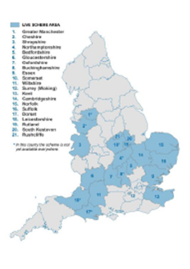
In December, we joined Leicestershire, Rutland and South Kesteven in the Natural England scheme to license Great Crested Newts.

District Level Licensing (DLL) is an innovative, strategic approach to supporting this protected species and is now being used by developers across more than 100 local authorities in England. Some of the live scheme areas are shown in the map on the left.

DLL means bigger, better and more joined up pond habitats and more resilient populations of Great Crested Newts, whilst saving developers time and providing them with certainty as they deliver new homes for local authorities.

To find out more, please visit the Natural England website.

Have your say on our Planning Enforcement Policy

We are reviewing and amending our Planning Enforcement Policy. It allows us to intervene should a breach of planning control take place and assess any harm that is caused.

Have your say on how we apply this here before January 29: https://bit.ly/3myHv41

Virtual communications training on January 25

A reminder that we have invited Keith Daniell from The Media Group to run an online Virtual Communications training session at 6pm on Monday, January 25 to help you make the most of your virtual communications.

The session is practical, interactive and fun. You will walk away with some very simple pointers to help improve the effectiveness of your virtual communications.

Hopefully Covid-19 isn’t here to stay, but technologies such as Zoom, Microsoft Teams and Skype may well be.

Learn how to make the most of a ‘fish’, a ‘Michelle’ and your smile by joining Keith and getting 2021 off to a cracking start.

To book your place or find out more about this session, please email Democraticservices@rushcliffe.gov.uk

COVID digital recovery grant to give businesses a further boost

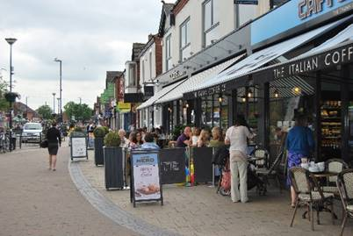
We are giving eligible high street businesses or established business groups another boost with a COVID Digital Recovery Grant that can further help them adapt and improve their online presence or sales.

Small to medium size retail, hospitality, personal care, leisure, tourism and other enterprises in the Borough can now access up to £1,000 over and above existing central government grant support by visiting https://bit.ly/3lQWfuG

Part of our recovery plan on the pandemic, the funds allow businesses to create or improve a website, seek advice and support on improving their social media presence or create greater online transactional capability.

It can also aid local retail groups or traders’ associations supporting or enhancing the development of, for example, an online market place for their town or village.

Applicants must be a High Street business who pay their business rates to the Council or receive small business rate relief with between 1.5 and 30 employees.

All appropriate licences and permissions must be in place and full criteria is available on the webpage.

Census 2021 roles available

This year will see the Census 2021 take place and there's set to be lots of temporary job roles available for residents at http://orlo.uk/U4o5s.

Application windows are open now too for Census Area Managers, team leader and officers amongst others with many more going live soon.

Compliments

A resident in West Bridgford emailed to thank our Customer Services Team and Waste Team for replacing his blue bin.

He said: “The bin has just been delivered. This really is exemplary service, please pass my thanks to everyone involved.”

Another resident emailed their thanks to our Customer Services Team and Waste Team for quickly organising the collection of his bin.

He said: “I would like to say thank you for the quick response to my bin not being emptied yesterday as it was emptied just less than a couple of hours after I emailed you about it.”

All the latest information for residents is available on the Coronavirus webpages or over the phone on 0115 981 99 11.

_________________________________________________________________________________

