COVID-19 update

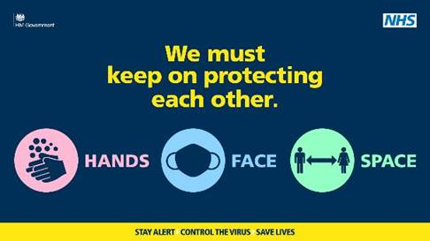
The situation in Rushcliffe as of Thursday, September 17:
During the most recent 14 days for which we have complete data there were 58 confirmed cases in Rushcliffe.

The official headline seven-day incidence rate for Rushcliffe stands at 27.3. This has increased from 21.3 since the previous seven-day period. Rushcliffe daily figures have not increased recently, the district is rated as green on PHE Exceedance reports as a result.

Cotgrave, West Bridgford and Ruddington are neighbourhoods with a high density of recent cases. Cases are also in other areas of the district, but these are more sporadic.

Are there particular groups/settings on which we should focus attention?
Analysis of recent cases identifies a range of settings where there is evidence of community transmission. This includes several clusters of cases in households, several cases related to returning travellers, and cases linked to three care home settings, with several more cases who are contacts of the above.

Cases are distributed quite widely across the different age groups. Most cases are amongst people of working age, reaching into the 60 to 69 year age group.

This is consistent with a situation in which there is transmission of COVID-19 right across the community. There is no single setting or group on which action should be exclusively focussed.

It is important that everyone understands the need for adhering to all of the government guidance in full. There are no proper grounds for individuals to unilaterally exempt themselves, except where government guidance specifically allows for that.

What measures are in place?
Testing of symptomatic people and identification of contacts takes place through the NHS Test & Trace system.

Additional measures include follow-up of cases and work with an identified business associated with transmission.

Media work has emphasised the importance of everyone following all of the guidance in full, as below.

How can I play my part in this?
HANDS
- wash hands regularly for at least 20 seconds

FACE
- wear face coverings in enclosed spaces where you can’t keep your distance

SPACE
- observe social distancing of 2 metres (or 1 metre with additional precautions where 2m is not possible) – this includes at home if you are mixing with others
- stick to the ‘rule of 6’ for gatherings indoors or outdoors

It’s also important to:
- follow guidelines about car sharing
- self-isolate and quickly getting a free test if you have symptoms: www.nhs.uk/coronavirus or phone 119

How can businesses in Rushcliffe play their part?
- Control the number of people in premises and ensure social distancing is maintained
- Maintain adequate track and trace information
- Provide adequate hygiene of premises – hand sanitising points for staff and customers and extra cleaning
- Where possible, implement measures to minimise contact – table service, use of apps, pre booking of customers, contactless payments
- Ensure staff who are ill or have been in contact with people who are ill stay at home and get tested
- Follow the latest Government rules on being Covid-secure: https://www.gov.uk/guidance/working-safely-during-coronavirus-covid-19

If you have any queries on this update, please contact media@rushcliffe.gov.uk
_________________________________________________________________________________

Thank you for contacting Rushcliffe Borough Council.

Please give feedback on your correspondence with us today here: https://www.surveymonkey.co.uk/r/9LC6CXL

Follow us on Twitter https://twitter.com/Rushcliffe

Like us on Facebook - https://www.facebook.com/rushcliffeborough

Connect with us on LinkedIn - www.linkedin.com/company/rushcliffe-borough-council/

Sign up to receive our business newsletter - http://eepurl.com/dbczkn

Call us on 0115 981 9911 (8.30am to 5pm, Monday to Friday), email customerservices@rushcliffe.gov.uk or visit www.rushcliffe.gov.uk

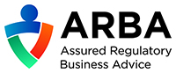

Rushcliffe Borough Council
Finalist, Local Authority of the Year 2019

