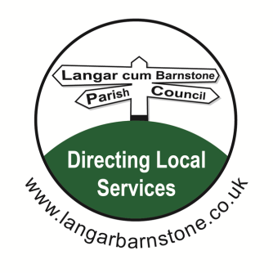**Langar cum Barnstone Parish Council**

Parish Clerk:

Mrs Sharon Ellis

22 Brownes Road

Bingham

Nottingham

NG13 8EF

Tel: 07984 075016

Email: [langarbarnstoneclerk@gmail.com](mailto:langarbarnstoneclerk@gmail.com)

Website: [www.langarbarnstone.co.uk](http://www.langarbarnstone.co.uk)

**PLEASE NOTE:**

**Following the recent introduction of new legislation:**

(The Local Authorities and Police and Crime Panels (Coronavirus) (Flexibility of Local Authority and Police and Crime Panel Meetings) (England and Wales) Regulations 2020)

**The Parish Council has taken the decision to hold the Parish Council meeting via video conference. If you would like to attend this Parish Meeting via Zoom or make a comment on any of the agenda items listed below, or have a question on another matter, please contact the Clerk - Sharon Ellis prior to the meeting.**

Dear Councillor,

21-04-21

You are hereby summoned to attend the **Annual Parish Council meeting** to be held Wednesday 5th May

**19.30 by video conference,**

*Sharon Ellis*

Sharon Ellis Parish Clerk Dated: Wednesday 21-04-21

**A G E N D A**

1.Election of Chairman & signing of declaration of Acceptance of Office

2. Declarations of Interests.

3. Apologies for absence.

4. Election of Vice Chairman & Signing of Declaration of Acceptance of Office

5. Receipt of Declaration of Acceptance of Office and Register of Interest Forms from all Councillors

6. Approval of Minutes of the Meeting held on Wednesday 7th April 2021

**7. Clerks report (for information only)**

(a) Online Calendar now operational.

(b) Photographs taken at the Crossroads Langar- Barnstone and of the Main Road. These have been

forwarded on to Cllr. Clarke.

( c ) Wildflower seeds received from RBC have been distributed

(d) Clerk qualification ILCA has been completed

**8**. **Confirmation of Committee appointments:**

(a) Village Hall Committee – Parish Council representative

(b) HR Committee members

( c )Village Hall Development Committee

**9. Public Open Session**

**10.** **New Village Hall including:**

Public Works Loan

**11. Borough & County Council reports**

**12. Police reports**

**13. Planning Applications:**

**Reference Number: 21/01108/FUL**

Applicant: Mr Richard King

Development: Erection of Timber Garden Shed

Location: 5 The Brambles Main Road Barnstone Nottinghamshire NG13 9JU

[**http://www.nottinghamshire.gov.uk/planningsearch/plandisp.aspx?AppNo=F/4267**](http://www.nottinghamshire.gov.uk/planningsearch/plandisp.aspx?AppNo=F/4267)

Langar North Trading Estate, Harby Road, Nottinghamshire, Langar, NG13 9HY

Construction of a Car Parts/Spares Storage Building and a Vehicle De-pollution Building

(retrospective) at the existing End of Life Vehicle (ELV) operation located at Langar North

Trading Estate, Harby Road, Langar, Nottinghamshire,

**14**. **Planning Notifications:**

**21/00161/FUL**

Stokes Bungalow Main Road Barnstone

Single Storey extension and open porch

**GRANT PLANNING PERMISSION**

|  |
| --- |
|  |

**15**. **Finance for Parish Council:.**

* 1. Financial Statement and bank reconciliation 30-04-2021*(reports attached at Appendices 1&2)*
  2. Accounts Paid prior to meeting: Appendix 3 attached
  3. Accounts for Payment at meeting: Appendix 4 attached
  4. End of Year Accounts 2020-2021 closed using Scribe software

balanced to £92107.96

**e**. Village Hall donations below (for information only)

**f**. Payments received

Precept £19758.00

HMRC Vat £1330.70

.

.

|  |  |
| --- | --- |
|  |  |
| |  |  | | --- | --- | | **Donations/Grants/Payments received up to 11-03-21 for the new Village Hall** |  | |  |  | | 30-01-21 Vale Market Café - Donation | £500 | |  |  | |  |  | |  |  | |  |  | | **Total** | £500 | |  |
| **14.16**. **Finance for Village Hall:**  a. Bank Reconciliation 30-04-2021 attached at appendix 5 ( Accounts to follow)  b. Accounts paid and for payment for report only (attached at Appendices 6 & 7) (Accounts to follow)  c. End of year Accounts 2020/2021 closed using Scribe software, balanced to £33645.36    **Matters for consideration**  **17**. Sports & Recreation Amenities Committee & terms of reference.  **18** Proposed Telecommunications Installation (emailed prior to meeting)  **19**. ILCA enhanced knowledge  **20**. To receive the Chairman’s Annual report ( emailed prior to the meeting)  **21**. Councillors’ Comments  **22**. Date of next meeting?  Members of the public are welcome to attend all Parish Council meetings. There is a 15 minute Open Session at the start of each meeting, for residents to raise items of interest or ask questions. A full set of meeting papers is available on application to the Clerk, above, or at www.langarbarnstone.co.uk |  |
|  |  |
| **Private & Confidential**  Employees  Taxi Vouchers  Appendix 1 |  |
|  |  |
|  |  |
|  |  |
|  |  |
| Appendix 2 |  |
|  |  |
|  |  |
|  |  |
|  |  |

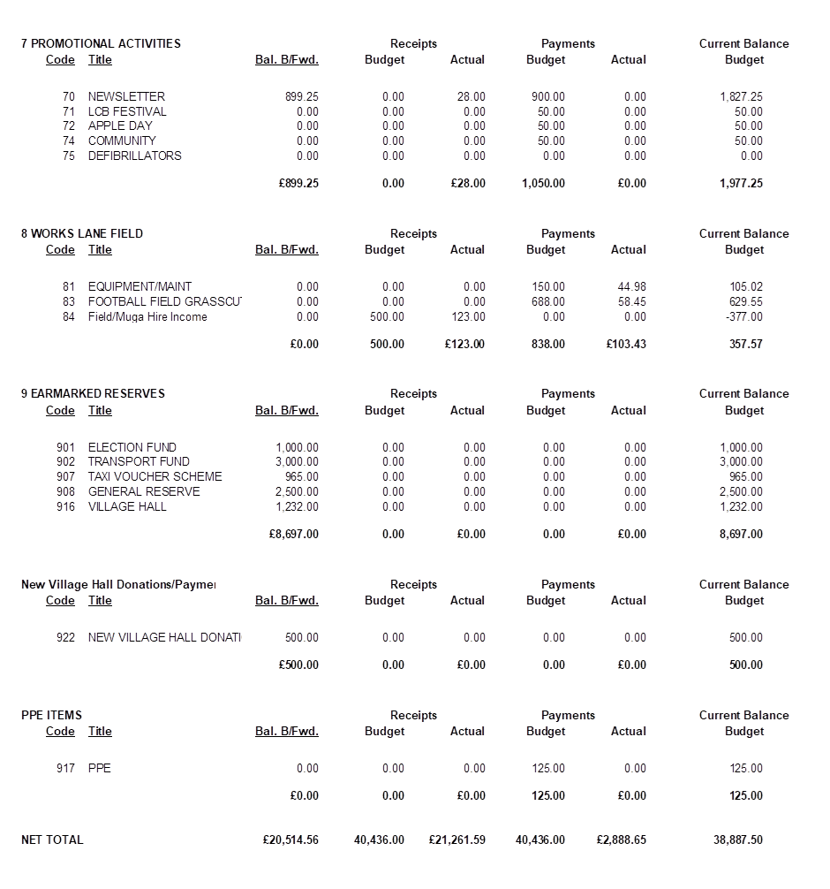

**Appendices 3 & 4**



**Appendix 5**



**Appendices 6 & 7**

