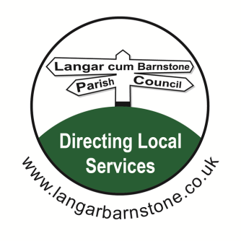**Langar cum Barnstone Parish Council**

Parish Clerk:

Mrs Sharon Ellis

22 Brownes Road

Bingham

Nottingham

NG13 8EF

Tel: 07984 075016

Email: [langarbarnstoneclerk@gmail.com](mailto:langarbarnstoneclerk@gmail.com)

Dear Councillors,

You are hereby summoned to attend the Parish Council meeting to be held on Thursday 17th June 2021 at

**19.30 at Barnstone Village Hall, Main Road, Barnstone.**

Sharon Ellis Parish Clerk Dated: Friday 11th June 2021

**A G E N D A**

**1**. Declarations of Interests.

**2.** Apologies for absence**.**

**3.** Approval of Parish Council Minutes held on Wednesday 5th May 2021

**4.** Clerk’s report

**5.** Public open session.

**6** New Village Hall including:

**7**. Police reports.

Circulated prior to the meeting

**8.** Borough & County Council reports.

**9**. Planning Applications:

There are no new planning applications to date

**10**. Planning Notifications

21/01108/FUL

**Grant Planning Permission**

**11.** Finance for Parish Council

**a**. Financial Statement and bank reconciliation 31-05-2021 *(reports attached at Appendices 1&2)*

**b**. Accounts Paid prior to meeting: Appendix 3 attached

**c.** Accounts for Payment at meeting: Appendix 4 attached

**d**. **Annual Return 2020/2021 including:** *(documents emailed prior to meeting)*

Approval of Section 1 - Annual Governance Statement

Approval of Section 2 - Accounting Statement

Report of Internal Auditor

**12.** Finance for Village Hall:(for information only)

a. Bank Reconciliation 31-05-2021 (attached at Appendix 5)

b. Accounts paid and for payment for report only (attached at Appendices 6 & 7)

**Matters for consideration**

**13.** Encroachment on to Parish Council-owned land by a resident’s fence

**14.** Defibrillator Training

**15.** C28 Footpath

**16.** Dates/days for future Parish meetings

**17.** Correspondence including:

Dog Laws -RBC

Remote meetings – NALC

Parliamentary Constituency Boundary Changes

**18.** Councillors’ Comments

**19.** Date of next meeting: tbc

Members of the public are welcome to attend all Parish Council meetings. There is a 15 minute Open Session at the start of each meeting, for residents to raise items of interest or ask questions. A full set of meeting papers is available on application to the Clerk, above, or at www.langarbarnstone.co.uk

**Private and Confidential Business**

In accordance with Section 1(2) of the Public Bodies Admissions to Meetings Act 1960 it is resolved that, due to the confidential nature of the business to be transacted, the public and press are asked to leave the meeting during consideration of:

**20.** Employees

**21.** Taxi voucher application

**Appendix 1**



**Appendix 2**

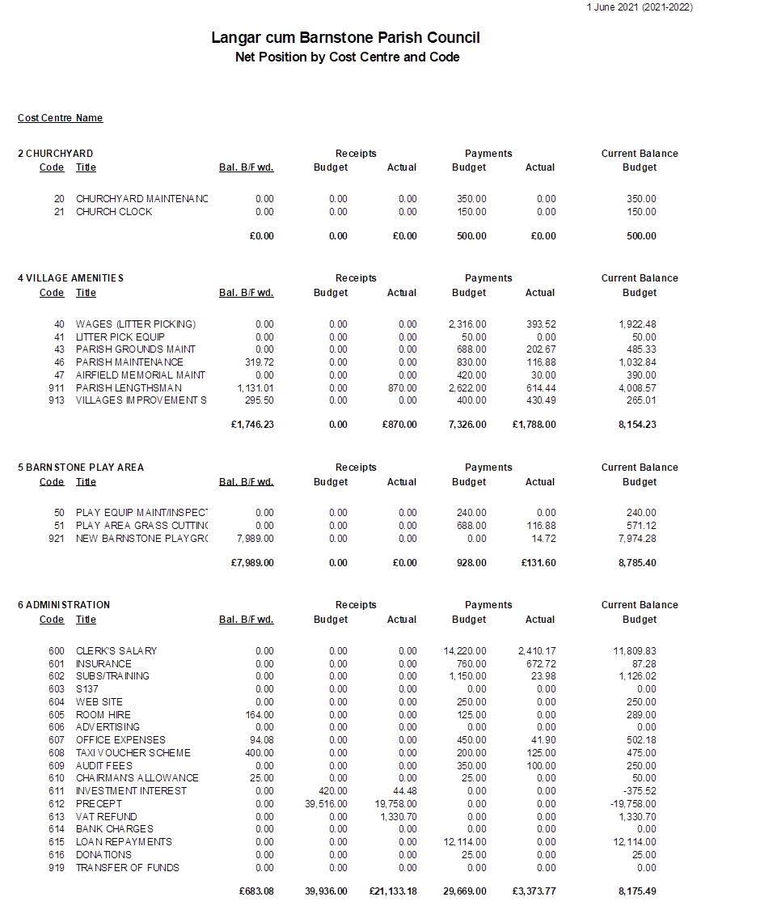

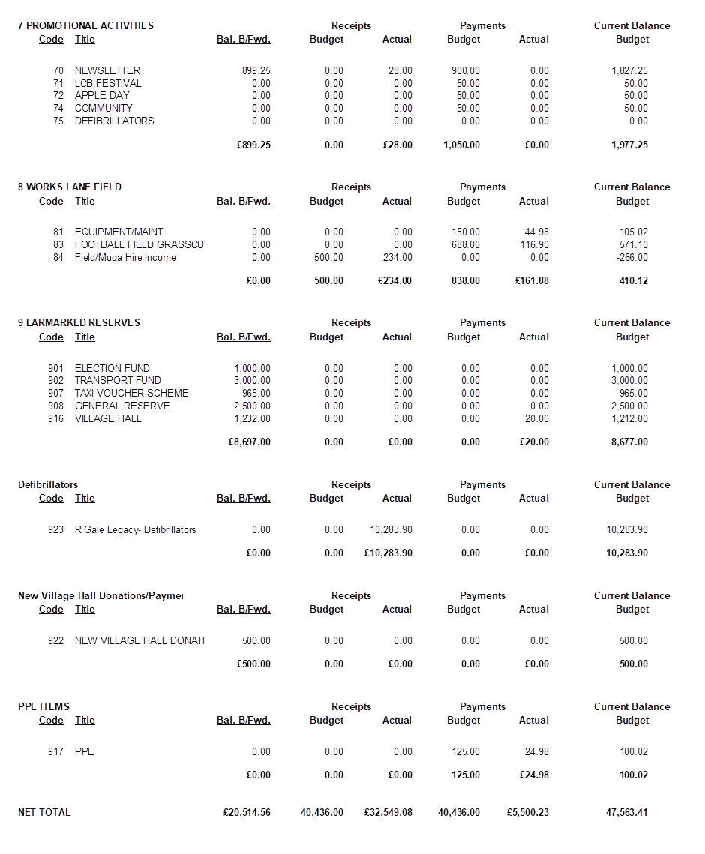

**Appendices 3 and 4**

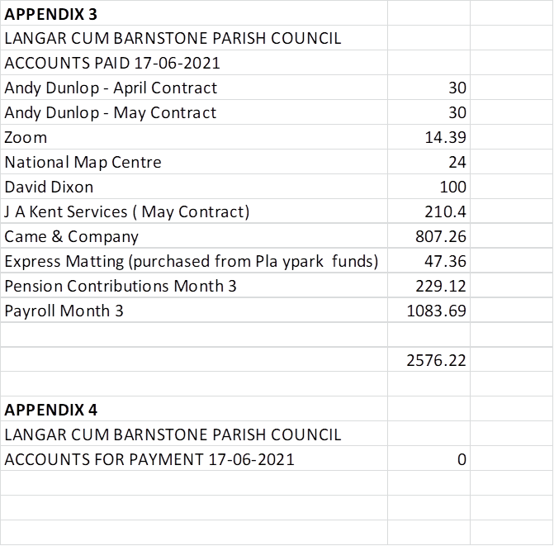

**Appendix 5**

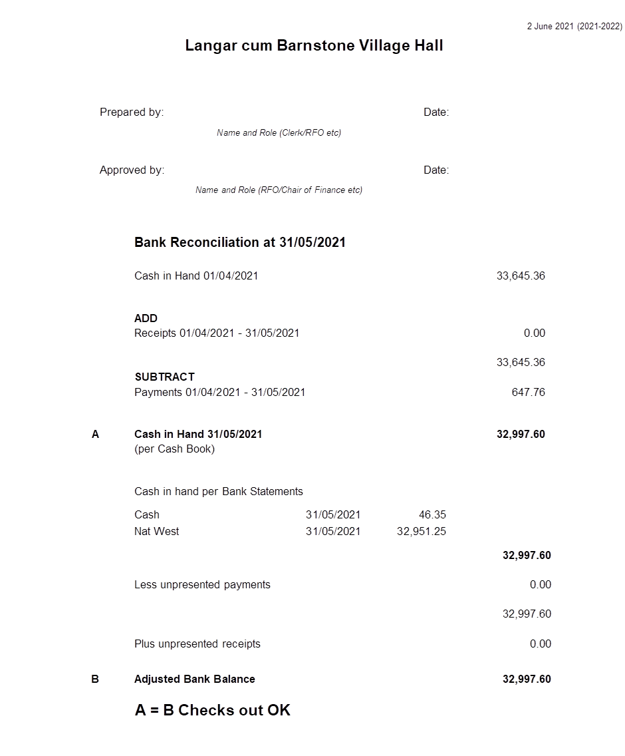

**Appendices 6 & 7**

