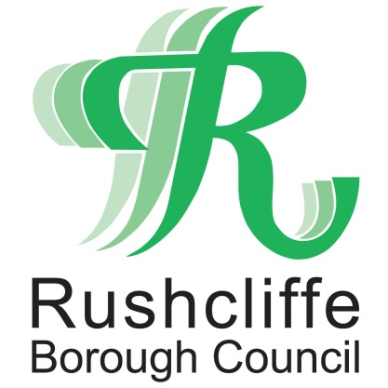 | Press Release

FOR IMMEDIATE RELEASE REF. GATHERING
31.12.20

Do not linger outside food and drink takeaway outlets after your purchase to help stop COVID-19

Residents in Rushcliffe are being reminded to not linger outside food and drink takeaway services this New Year and beyond to play their part in stopping the spread of COVID-19.

As positive cases hit their highest figure to date nationally this week, over 100 people were witnessed congregating outside bars on Central Avenue in West Bridgford on Christmas Eve.

They had in many cases purchased food and drink from local outlets but were not following the rules to consume the items away from the businesses and were not sufficiently socially distanced.

Officers from Nottinghamshire Police dispersed the groups, understanding those wishing to support local businesses but highlighted local COVID-19 restrictions should be followed at all times.

Rushcliffe Borough Council has now worked with and reiterated to the business owners in the area on how to implement the restrictions to customers, as Tier 4 restrictions in Nottinghamshire from today (December 31) see hospitality businesses still able to continue a takeaway offering.

It’s also reminding all a local Public Spaces Protection Order (PSPO) is in operation in West Bridgford for everyone’s benefit.

It means park users and town centre visitors must give up alcohol when asked to do so by an official and failure to comply can lead to a fixed penalty notice or prosecution at court and a fine of up to £1,000.

The Council’s High Street Ambassadors are continuing to provide advice and reassurance at sites across the Borough, highlighting signage that reiterates the measures to follow at each location.

Rushcliffe Borough Council’s Cabinet Portfolio Holder for Neighbourhoods Cllr Rob Inglis said: “It’s great that many want to support local businesses great takeaway services but it’s vital we all follow the rules at yet another pivotal time for this awful pandemic.

“If you purchase takeaway food or drink anywhere in Rushcliffe please ensure you move away from the premises and consume it elsewhere, not forming gatherings or lingering and following the restrictions on the number of people you can meet outdoors.

“Stay at home this New Year and make sure you follow all the Tier 4 restrictions.”

Neighbourhood Policing Inspector for Rushcliffe Craig Berry said: "We need to all remember Covid has not gone away. In fact it is even more prevalent with the new variant currently sweeping the country.
“That is why we have to all take responsibility for our actions to stop this spreading and causing even more issues for the NHS, which is breaking under the strain.
“Therefore any pub which allows people to gather outside after serving takeaway alcoholic drinks is in serious breach of the rules and as a result we will take action as a partnership.
“It is the responsibility of pub owners to ensure that no one’s health is inadvertently put in danger due to actions they have taken. The pubs in Rushcliffe are in a dispersal zone and as a result no one should be gathering at all, with or without Covid. Pubs and licensed premises need to take action to ensure this doesn’t happen.
"A number of pubs and other establishments in the area have already been warned about not complying, and we would remind them of their individual responsibility to ensure they are adhering to the restrictions and that people are not congregating outside.
"We are pleased with the partnership approach that is being taken to tackle Covid-19 and we will take appropriate action towards those flouting the rules."
ENDS

NOTE TO EDITORS

For information please contact the Rushcliffe press office on 0115 9148 555 or media@rushcliffe.gov.uk

For the latest news and events, follow @rushcliffe on Twitter or Rushcliffe on Facebook or go to the council's website.

