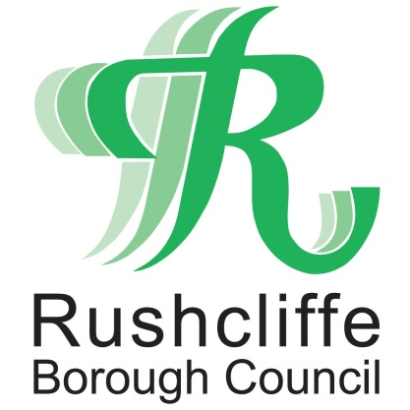 | Press Release

FOR IMMEDIATE RELEASE REF. TIER
30.12.20

Rushcliffe and Nottinghamshire to enter Tier 4 COVID-19 restrictions from December 31

Central Government has decided that the whole of Nottinghamshire will move to Tier 4 COVID-19 restrictions from 00.01 on December 31.

From tomorrow you cannot leave or be outside of the place you are living unless you have a reasonable excuse. The Government has provided guidance on when it is reasonable to leave the place where you are living.

You cannot meet other people indoors, including over the New Year period, unless you live with them, or they are part of your support bubble.

Outdoors, you can only meet one person from another household.

Another example of when you can leave home is to buy things at shops or obtain services from a business which is permitted to open.

Parents can still take their children to school, and people can continue existing arrangements for contact between parents and children where they live apart. This includes childcare bubbles.

All the restrictions can be found at Tier 4: Stay at Home - GOV.UK (www.gov.uk)
The next review date of this tier is set to be January 13.

Leader of Rushcliffe Borough Council Cllr Simon Robinson said: “We know these further changes impact so many residents and businesses again but we must do all we can to protect the NHS and save lives.

“This is especially in light of the volume of hospital admissions here in the County continuing to rise rapidly day on day currently.

“Please follow the rules so you can do all you can to relieve the pressure the service is facing.

“Thank you to residents who have already sacrificed so much this year but we must now stay at home and remember hands face space.

“We’ll outline any further support for businesses as soon as possible.”

Dawn Jenkin, Public Health Consultant at Nottinghamshire County Council said: “Remember that the Christmas Bubble arrangements only applied on Christmas Day so you must only spend New Year at home with your own household or bubble.

“The rates of infection in our communities across the county are continuing to grow at a concerning rate.

“The impact this is having on our hospitals and the rate of infection in those aged over 60 are some of the key factors which determine how the government decides what tier to place each area into.

“We appreciate how hard the new restrictions will be for many but what is important now is that we all observe the new regulations in place, understand what they mean and explain the rules to those around us.

“Whilst it is really positive news that the vaccine is starting to roll out across the county it will a while before it has the desired impact on infection rates, so now is not the time to let our guard down.

“Remember that around 1 in 3 people who have coronavirus have no symptoms and could be spreading it without realising it.

“So, the very best thing you can do now to help us overcome the virus is to continue to follow the rules of Hands, Face, Space.

“Make your New Year’s Resolution to protect yourself, your family and your friends by sticking to these simple rules. In addition, if you develop any symptoms, it remains critically important that you self-isolate and get a test as soon as possible.

“It is these actions by each of us that will stop the spread of the virus in our communities.”

- ENDS -

NOTE TO EDITORS

For information please contact the Rushcliffe press office on 0115 9148 555 or media@rushcliffe.gov.uk

For the latest news and events, follow @rushcliffe on Twitter or Rushcliffe on Facebook or go to the council's website.

