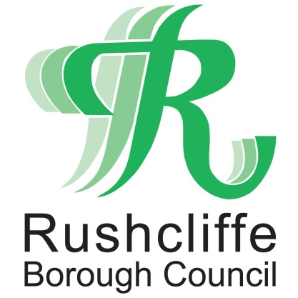 | Press Release

FOR IMMEDIATE RELEASE REF CREM
30.09.21

Find out the latest on new
Rushcliffe Oaks crematorium

Residents and businesses have another chance to view plans for Rushcliffe’s new crematorium, Rushcliffe Oaks.

Further information about the new facility and community space in Stragglethorpe near Cotgrave can now be found on its dedicated website www.rushcliffeoaks.co.uk or by picking up a leaflet from the Cotgrave Hub, NG12 3UQ, during operating hours.

Many residents and stakeholders, including local funeral directors, attended the recent information event on September 23 hosted by Rushcliffe Borough Council to learn more about the project and share their thoughts.

The Council is seeking to be carbon neutral in its operations by 2030 and this is reflected at the heart of the design and thought process for the new facility.

An extensive landscape management plan has been developed for the project which focuses on retaining and enhancing boundary planting and a living roof on the single-storey building aims to reduce the visual impact from the surrounding area. Rushcliffe Oaks development will focus on reflecting a connection back to nature and wildlife.

Through the use of innovative technologies and renewable energy sources, there are plans for a greener electric powered cremator rather than the more traditional use of gas, lowering CO2 emissions by up to 90 per cent. Rushcliffe Oaks will be one of the first in the country to invest in this new technology.

Development is due to commence on site soon and it is anticipated it could open in Autumn 2022.

Rushcliffe Oaks will be operated and managed directly by the Council with potential opening hours of 9.30am to 4.30pm Monday to Friday.

ENDS

NOTE TO EDITORS

For information please contact the Rushcliffe press office on 0115 9148 555 or media@rushcliffe.gov.uk

For the latest news and events, follow @rushcliffe on Twitter or Rushcliffe on Facebook or go to the council's website.

