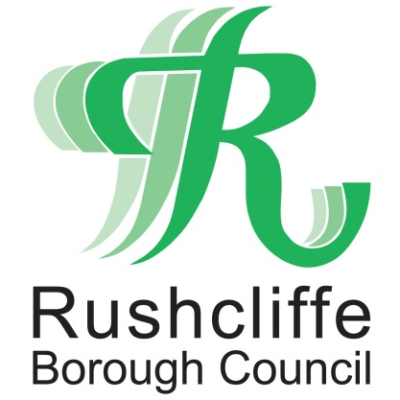 | Press Release

FOR IMMEDIATE RELEASE REF AWARDS
30.09.20
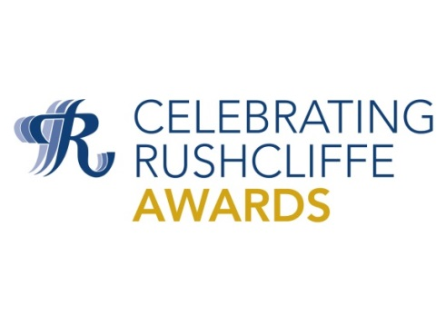

Nominate your community, volunteer or business hero for a Celebrating Rushcliffe Award

Residents and groups in Rushcliffe have just a few days left to acknowledge their unsung community, business and health heroes in the Borough Council’s community accolades, the Celebrating Rushcliffe Awards.

In conjunction with media partner West Bridgford Wire, the Borough’s wonderful volunteers, businesses, clubs, organisations, environmentalists and the best of its health and wellbeing and food and drink sectors are being sought to be recognised, mindful of the impact COVID-19 has had on every part of the community and local enterprise.

Nominations for the 10 awards are now open at https://www.surveymonkey.co.uk/r/CRAs2020 until this Monday, October 5.

Winners will be announced and celebrated in a ceremony to be confirmed later this year.

Last year Nottinghamshire Wildlife Trust’s Keeping it Wild scooped the Young Environmentalist or Group of the Year accolade at the awards for its fantastic work with 13 to 25 year-olds at Skylarks Nature Reserve in Holme Pierrepont and across the County.

People and Nature Officer Laura Bacon from the Trust said: “Winning the award last year was a wonderful acknowledgement of all the hard work our young people and teams have dedicated to our sites in conserving our natural habitats.

“I would encourage everyone to nominate their community hero for a Celebrating Rushcliffe Award so they too can honour those who spread such warmth and community spirit to people through local projects and efforts.”

The award categories are:

- Volunteer of the Year
This award recognises the countless hours and dedication that volunteers make to the community of Rushcliffe. They may be an individual or group and those who have stepped forward to assist others before or during COVID-19.

- Business of the Year
This award is to recognise a Rushcliffe business that helps to support the local community.
This could be through employing local people, growing their business, employing apprentices or work experience or putting profit back into the Borough.
In recent times, this business may have gone the extra mile to help their community during COVID-19 or those who have adapted their business to deliver a local service.

- Young Person/Group of the Year
An individual or group who sets an example to others in their community or being an excellent role model for other young people to emulate.

- Community Group of the Year
This award recognises a new or established group who has stepped up and supported their local community during the Coronavirus pandemic.

- Get Active Award
An individual, group or organisation who has supported people to become or stay active during the Coronavirus pandemic.

- Food and Drink Establishment of the Year
Recognising a fantastic outlet who provide quality, provenance, and presentation as well as being the best place for a cuppa, sandwich, pint, pizza, or pie.

- Health and Well-Being Award
Celebrating an individual’s or group’s tireless dedication in improving the health and wellbeing of members of their local community whether before or during COVID.

- Environmental Group or Project of the Year
Acknowledging individuals, organisations or projects that have an impact in making Rushcliffe a ‘greener’ place. This could include promoting nature conservation, reducing waste, improving energy efficiency, water conservation or improving quality of life for the people of the Borough.

- Young Environmentalist of the Year
Celebrating an individual under 25 or group who has provided an outstanding contribution to environment or carried out an environmental project to make Rushcliffe a ‘greener’ place.

- The Pride of Rushcliffe Award
An individual or organisation who makes others proud to live in Rushcliffe. This could be an inspirational leader, public figure, or head of a community or voluntary group who leads by example to make the Borough a better place to live and work.

- ENDS -

NOTE TO EDITORS

For information please contact the Rushcliffe press office on 0115 9148 555 or media@rushcliffe.gov.uk

For the latest news and events, follow @rushcliffe on Twitter or Rushcliffe on Facebook or go to the council's website.

