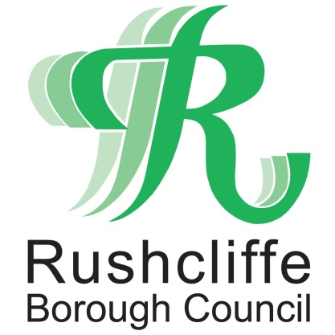 | Press Release

FOR IMMEDIATE RELEASE REF. BAR
30.09.20

Bar, restaurant and hospitality owners reminded to follow all track and trace and government guidelines
Rushcliffe Borough Council is reminding bar, restaurant and hospitality business owners to continue stringently following all central government guidelines to operate in a COVID secure environment including collecting customer details for track and trace purposes.
The authority has visited over 200 hospitality businesses to provide support and advice on how to comply with the requirements so owners can continue to adapt to new laws and have queries answered. Following the most recent changes the Council is also writing to all of its licensed businesses.
The call comes after issuing a fixed penalty notice to a West Bridgford bar for its latest breach of coronavirus regulations.
Council officers issued the £1,000 fine to Zinc bar on Central Avenue on September 25 for failing to put measures in place to record customer details in accordance with statutory requirements.
The regulations include a requirement for businesses to record and retain details of all customers entering the premises.
Businesses can do so in writing, or by using a designated NHS QR poster available on the Government website: https://www.gov.uk/create-coronavirus-qr-poster and wider support for all business owners is continually updated at www.rushcliffe.gov.uk
Rushcliffe Borough Council’s Cabinet Portfolio Holder for Environment and Safety Cllr Rob Inglis said: “We thank the vast majority of business owners who take their responsibilities around COVID operating very seriously and as a Council we are supporting them wherever we can.

“Our Environmental Health teams continue to visit businesses to ensure they’re keeping a record of their customer’s details to help the national effort to track and trace cases and we cannot stress enough the importance that all rules are strictly followed.

“We know it’s incredibly tough times for businesses but we will not tolerate complacency when it comes to regulations that are designed to protect the health of our residents.

“Nor will we allow unacceptable behaviour towards Council staff when undertaking their role who are checking government rules and keeping consumers safe.

“It’s hugely important that businesses remain diligent and implement all necessary measures to keep their premises secure for customers and help tackle the rising number of cases.”

The information being recorded at each site should include:
- name of each person in the party
- contact number
- date of visit
- arrival time
- departure time, if possible

The Council are asking residents to play their part by ensuring a member of staff at each premise always asks for details, or if they are not requested, to inform the authority by emailing envhealth@rushcliffe.gov.uk

The latest government advice for residents and consumers on COVID-19 rules can be viewed at https://bit.ly/30kyqDD

- ENDS -

NOTE TO EDITORS
For information please contact the Rushcliffe press office on 0115 9148 555 or media@rushcliffe.gov.uk

For the latest news and events, follow @rushcliffe on Twitter or Rushcliffe on Facebook or go to the council's website.

