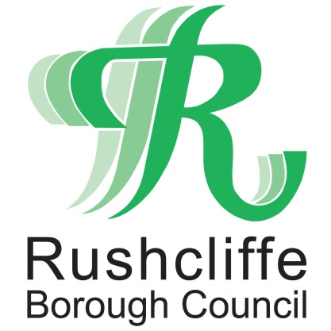 | Press Release

FOR IMMEDIATE RELEASE REF BIKE
27.08.20
Free bike security marking session
at Ruddington Village Market

Cyclists can get their bikes security marked and registered with BikeRegister for free at Ruddington Village Market on Saturday September 5.

Rushcliffe Borough Council’s Community Safety team and Nottinghamshire Police will host a stall at the event on the Green in the village from 9am to 12pm on the day which will also provide advice on crime prevention advice for burglary and vehicle crime.

BikeRegister is the UK’s national cycle database and the preferred bike marking system of Nottinghamshire Police.

Bike marking is a permanent visible deterrent from bike theft and registering a bike makes it traceable and therefore more difficult to sell on. The true owners’ identity is marked and can help cyclists be reunited with their bike if retrieved.

Security of a bike starts with a strong lock and a limited supply of free ‘D’ locks will be available on a first come first served basis at the stall.

The authority is set to have a similar presence at Bingham Farmers’ Market on September 19.

Rushcliffe Borough Council’s Cabinet Portfolio Holder for Neighbourhoods Cllr Rob Inglis said: “It’s pleasing to continue our work with Nottinghamshire Police to deliver these important sessions that can make such a big difference in preventing bike, house and vehicle crime in our communities.

“Thank you to co-ordinators at Ruddington Centre Village Partnership for welcoming us aboard to the market and we invite cyclists and residents alike to visit the stall and find out more.”

Ruddington Centre Village Partnership’s Chairman Mike Ader said: “This is a great initiative which will help all bike owners in the village. I’m delighted they can join us at our Ruddington Village Market on September 5 which promises to be another highly successful event with over 40 fantastic stalls.”

- ENDS -
NOTE TO EDITORS

For information please contact the Rushcliffe press office on 0115 9148 555 or media@rushcliffe.gov.uk

For the latest news and events, follow @rushcliffe on Twitter or Rushcliffe on Facebook or go to the council's website.

