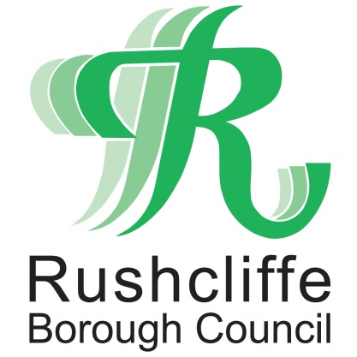 | Press Release

FOR IMMEDIATE RELEASE REF. MARKET
27.05.20

West Bridgford Farmers’ Market to reopen safely on Saturday May 30

West Bridgford Farmers’ Market is set to safely reopen on Saturday May 30.

The popular feature will relaunch with an initial seven stalls observing secure social distancing measures including a marked out queuing system for customers at each trader.

There will be extended space between each stall with hand-washing facilities on site for all traders, who will also follow central government advice on masks and gloves as appropriate.

Traders at the market will feature those currently in the government’s essential category and are set to include Grasmere Farm selling meat products and Scarborough Fayre offering fish, eggs, bison and venison.

Goachers fresh fruit, jams and juices, Lincolnshire Poacher Cheese, Tuxford Windmill, Eden Farm’s organic vegetables and Rushcliffe based Turners Bakery’s sumptuous bread and cakes complete the list.

The Council thanks residents in advance for those who wish to attend and support local businesses and asks where possible for payment to be made by card for further safe trading.

All visitors to the sites are asked to ensure social distancing is maintained at all times.

Rushcliffe Borough Council’s Cabinet Portfolio Holder for Transformation and Business Cllr Andy Edyvean said: “We’re incredibly pleased to see the Farmers’ Market reopen, allowing residents and visitors alike to support local businesses whilst shopping for essential items.

“The changes made to the market are paramount to ensure the safety of both stall holders and their valued customers.

“We will continue to adapt services where possible whilst prioritising residents’ safety and doing all we can to support local businesses in line with government advice.”

- ENDS -

NOTE TO EDITORS
For information please contact the Rushcliffe press office on 0115 9148 555 or media@rushcliffe.gov.uk

For the latest news and events, follow @rushcliffe on Twitter or Rushcliffe on Facebook or go to the council's website.

