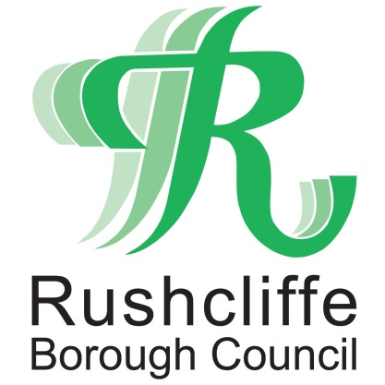 | Press Release

FOR IMMEDIATE RELEASE REF. LANGAR
27.05.20

Residents reassured Langar fire debris does not pose health risk
Residents in the Langar and Bingham area and surrounding villages in Rushcliffe are being reassured that debris from a recent fire close to Langar Airfield does not present any ongoing health risk.

Rushcliffe Borough Council is working with partners including Notts Fire and Rescue and Public Heath England as well as other stakeholders and is not aware of any health risk associated with any debris or pollution emanating from the fire.

Therefore any debris can be cleared safely from residents’ properties.

- ENDS -

NOTE TO EDITORS
For information please contact the Rushcliffe press office on 0115 9148 555 or media@rushcliffe.gov.uk

For the latest news and events, follow @rushcliffe on Twitter or Rushcliffe on Facebook or go to the council's website.

