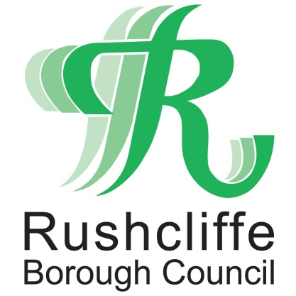 | Press Release

FOR IMMEDIATE RELEASE REF. TIER
26.11.20

Rushcliffe and Nottinghamshire to enter Tier 3 COVID-19 restrictions
Nottinghamshire will enter Tier 3 for Covid-19 restrictions from Wednesday 2 December.
The move is part of the Government’s Winter Plan to reduce the spread of the virus following the end of the four-week national lockdown.
Tier 3 means:
- No mixing of households indoors or outdoors apart from support bubbles. Maximum of six in some outdoor public places, for example parks and public gardens
- Hospitality will close except for sales by takeaway, drive-through or delivery
- Retail, entertainment and personal care businesses can all open
- Places of worship are open but people cannot interact with anyone outside household or support bubble
- Avoid travelling out of the area, other than where necessary for work, education, youth services, medical attention or because of caring responsibilities
- No overnight stays outside of local area, unless necessary for work, education or similar reasons
- 15 guests for weddings, civil partnerships and wakes; 30 for funerals. Wedding receptions not permitted
- Exercise classes and organised adult sport can take place outdoors, but should avoid contact. Organised activities for elite athletes, under-18s and disabled people can continue
The new Tiers have been strengthened to reduce the infection rate as part of a strategy to save lives, protect health and care services, and keep our economy and schools open.
As well as the new Tiers, the Government has also announced specific ‘Christmas bubbles’ that will allow people from three households to mix in homes between 23-27 December, to enable them to celebrate Christmas together.
Nottinghamshire councils have pledged to work together to help communities to adapt to the new restrictions. The Government will review this every 14 days.
Director of Public Health for Nottinghamshire Jonathan Gribbin said: “People across Nottinghamshire have achieved a reduction in rates over recent weeks and I welcome the move out of lockdown, and a set of arrangements from December 2 which are clear and consistent.
“We will support our communities and businesses to adapt to the new rules.
“The Government has also announced an easement of the rules for a few days covering the Christmas holiday period to enable family members or friends to meet up.
“As in the rest of the UK people in Nottinghamshire are urged to exercise caution and to take care to work within the guidance about how to do this safely. In this way, we can maintain our momentum in lowering infection rates.
“The regulations are here to protect us all and are designed to keep the rates low; and the lower the number of cases get the more likely we are to move down through the tiers and start to feel like things can return to normal again.
“It is important that we all follow the new rules and work together to slow the spread of the virus in our communities. People in Nottingham have worked hard to reduce rates of Covid-19 and we have seen cases in the city fall below the national average.
“There is good news about the rollout of vaccines but it’s going to be a while before whole populations are protected from the virus. In the meantime, our local health and care services continue to experience severe pressures.
“I would urge people to continue to follow the best practice around ‘Hands, Face, Space’ and reduce contact with people from other households as much as possible. In particular, anyone who has symptoms of Covid-19 – such as a fever, continuous cough or loss of taste or smell – should isolate immediately and book a test by calling 119.”
The current legislation for the tiering approach is due to end in March 2021.
Leader of Rushcliffe Borough Council Cllr Simon Robinson said: “These new restrictions again call on all residents to play their part to do all they can to stop the transmission of the virus, with cases and deaths at the existing levels, it is vital you continue to follow these rules.

“We know this tiered system is still so tough for so many but it is designed to protect us all.

“Business grants continue to be distributed to hundreds of eligible businesses across the Borough and more on support for owners can be found at www.rushcliffe.gov.uk

“Please continue to stay safe and follow the rules so we can all look forward to a brighter 2021.”

For further information about the guidance visit www.rushcliffe.gov.uk

- ENDS -

NOTE TO EDITORS

For information please contact the Rushcliffe press office on 0115 9148 555 or media@rushcliffe.gov.uk

For the latest news and events, follow @rushcliffe on Twitter or Rushcliffe on Facebook or go to the council's website.

