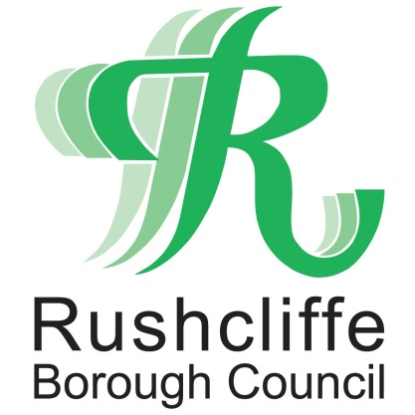 | Press Release

FOR IMMEDIATE RELEASE REF.GRANT
26.11.20

Over £1.7m COVID-19 support grants distributed to Rushcliffe businesses

Rushcliffe Borough Council has now distributed over £1.7m of further vital central government grants to nearly 500 eligible businesses in the Borough who were affected when they entered former tier and current national lockdown restrictions.

Tomorrow (Friday) is the last chance for businesses to apply for this discretionary Local Business Support Grant Scheme at www.rushcliffe.gov.uk/businesscoronavirus

However there is expected to be further new Tier 3 mandatory business grant support to those still affected by closures in Rushcliffe under the new restrictions after December 2 announced by central government today.

Continue to visit the webpage for more updates.

All grants continue to be processed as quickly as possible with business owners asked to ensure all supporting documents are included with any application.

Nottinghamshire Councils worked together earlier this month to create a consistent scheme across the County seeking to support those in the non-essential retail, hospitality, leisure and accommodation sectors and those who directly supply them.

Rushcliffe Borough Council’s Deputy Leader Cllr Andy Edyvean said: “Our teams are responding quickly to distribute this vital support to eligible businesses as we assist central government in managing the impacts of COVID-19.

“We know so many businesses everywhere are facing incredible pressures and with Tier 3 restrictions announced today in Rushcliffe we’ll continue to act rapidly as soon as further new Tier 3 grants become available to those affected, such as in the hospitality industry.”

- ENDS -

NOTE TO EDITORS

For information please contact the Rushcliffe press office on 0115 9148 555 or media@rushcliffe.gov.uk

For the latest news and events, follow @rushcliffe on Twitter or Rushcliffe on Facebook or go to the council's website.

