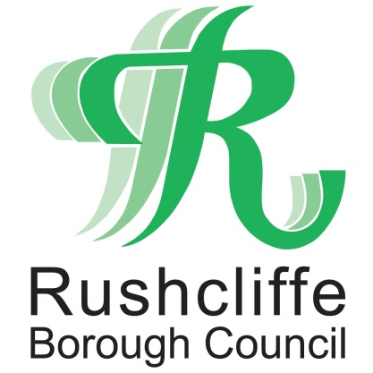 | Press Release

FOR IMMEDIATE RELEASE REF. REACH
25.06.20

Music cafe to continue to combat social isolation with help of Reach Rushcliffe fund

A local charity that provides virtual music cafes to combat social isolation and loneliness is the latest group to receive vital funding from Reach Rushcliffe.

Musicworks is receiving funds as part of Rushcliffe Borough Council’s initiative which was launched in May aiming to tackle the issues.

The charity will use the funds to hold weekly virtual Heron Music Cafes, online musical sessions to help residents who are socially isolated, have disabilities or mental health conditions including those with dementia to stay in touch with their communities.

The project is one of four successful applications that have benefitted from over £6,000 to help those in need.

During the sessions those attending are encouraged to communicate with each other while the singing is taking place and the words of the songs are also streamed allowing participants to sing along.

Deputy Leader of the Council Cllr Debbie Mason met Director of Musicworks John Osborne at the charity’s base in Lady Bay.

Cllr Mason said: “We are so pleased to have awarded funding to another local charity, which will help them increase the number of online musical sessions they can provide to help the wellbeing of our communities.

“We understand that those who are vulnerable or have health conditions may have found the lockdown restrictions particularly difficult, so the continued support Musicworks can provide will be highly valued.
“We would encourage any organisations also looking to reduce social isolation in their part of Rushcliffe to apply for funding through Reach Rushcliffe by visiting www.rushcliffe.gov.uk/health/reachrushcliffe/.”

Mr Osborne said: “It is brilliant to receive funding through Reach Rushcliffe and the Borough Council.

“We know it is incredibly important to maintain the links our Music Cafes have developed throughout the community.

“We will now be able to hold a live virtual session once a week which will help maintain the momentum of the café and ensure that connections are not lost for members of the group.”

- ENDS -

NOTE TO EDITORS
For information please contact the Rushcliffe press office on 0115 9148 555 or media@rushcliffe.gov.uk

For the latest news and events, follow @rushcliffe on Twitter or Rushcliffe on Facebook or go to the council's website.

