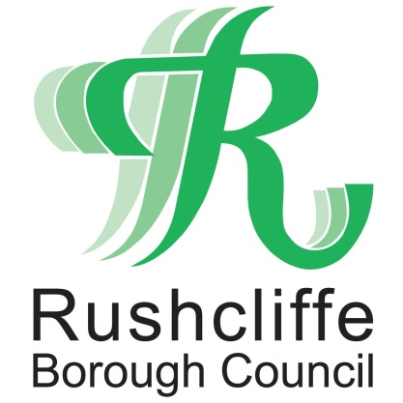 | Press Release

FOR IMMEDIATE RELEASE REF. SECURITY
25.06.20

Increased enforcement patrols at Bridgford Park and Bridgfield to reassure park users

Increased enforcement patrols will continue at Bridgford Park and Bridgfield in West Bridgford to further reassure residents and visitors the open spaces can be enjoyed responsibly.

Rushcliffe Borough Council has secured further enforcement support to complement work with Nottinghamshire Police to decrease instances of litter and anti-social behaviour at the parks and other public spaces with local rules.

All officials and Police have powers to enforce Public Spaces Protection Order (PSPO) rules which means park users and town centre visitors must give up alcohol when asked to do so by an official.

Failure to comply can lead to a fixed penalty notice or prosecution at court and a fine of up to £1,000.

On Monday (June 22) it was announced the parks will have earlier evening closing times to alleviate the issues.

The sites will continue to be closed from 7pm at Bridgfield and 9pm at the Bridgford Park, instead of 9.30pm each evening, until further notice.

Extra security fencing was also installed around their entrances and perimeters to prevent unauthorised access when closed and access to Bridgfield will continue to be through a single controlled access point.

The number of park users will be monitored so the areas can still be used safely in conjunction with government advice and all park users will be requested to leave the areas at the stated closing times.

Park users and town centre visitors are advised to approach officials or call Nottinghamshire Police on 101 should they need to raise any future concerns.
Leader of the Council Cllr Simon Robinson said: “Further security is now in place in addition to the measures we announced at the parks earlier this week to ensure it can continue to be a place for all to enjoy.
“We know the overriding majority of park users enjoy the areas responsibly and we thank them for taking pride in their local area by always binning their rubbish or taking it home.
“Park users’ and local residents’ safety is exceptionally important to us and the scenes of recent weeks where a minority have left high volumes of litter and reports of anti-social behaviour have been received is totally unacceptable.
“This mirrors an unfortunate picture nationally but we will do all we can to protect those who use and enjoy our parks and adjoining neighbourhoods.”
Extra temporary yellow event bins and toilets will remain in place and Streetwise teams will continue their regular clearance of bins across the park and town centre.
Outlets in the town that are currently licensed to serve off-sales food and drink continue to display signage at their premises reminding customers to follow the PSPO guidelines.
The Council’s Environmental Health and Licensing teams and Police are continuing unannounced high-profile visits to all licensed premises in the town to further check arrangements in line with their current licences.
- ENDS -

NOTE TO EDITORS
For information please contact the Rushcliffe press office on 0115 9148 555 or media@rushcliffe.gov.uk

For the latest news and events, follow @rushcliffe on Twitter or Rushcliffe on Facebook or go to the council's website.

