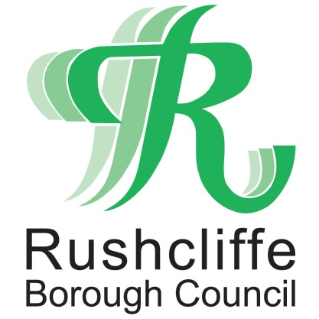 | Press Release

FOR IMMEDIATE RELEASE REF PLANNING
25.06.20
Extension for planning applications due to expire during COVID-19 restrictions

Central government have confirmed planning application’s expiry dates in Rushcliffe will be extended to April 1 next year in line with national guidelines.

The Ministry of Housing, Communities and Local Government confirmed the new timeframes in place for all applications given consent in the last three years set to that lapse between March 23 and December 31 this year will now receive the extension.

The new guidance introduced will mean that residents and businesses with applications recently expired or due to expire, do not have to re-submit their plans.

Rushcliffe Borough Council’s Cabinet Portfolio Holder for Housing Cllr Roger Upton said: “It is great to see this confirmed by the government, which will reassure many residents and businesses in the Borough who often need to work through complex planning rules.

“The extension of planning applications’ expiry dates will mean that those unable to begin work during COVID-19 lockdown restrictions will not be required to re-apply.”

For more information regarding the planning process in Rushcliffe, visit the authority’s website at: https://www.rushcliffe.gov.uk/planningandbuilding/

- ENDS -
NOTE TO EDITORS

For information please contact the Rushcliffe press office on 0115 9148 555 or media@rushcliffe.gov.uk

For the latest news and events, follow @rushcliffe on Twitter or Rushcliffe on Facebook or go to the council's website.

