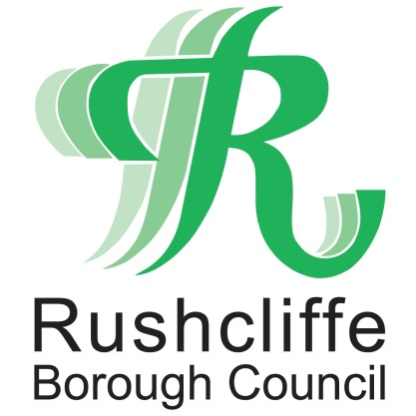 | Press Release

FOR IMMEDIATE RELEASE REF. GAMSTON
24.11.20

Council requires masterplan before considering Gamston housing applications

Rushcliffe Borough Council is requiring developers considering planning applications for 4,000 homes and employment on land at Gamston to agree with it a Masterplan for the whole site, to make sure that the right infrastructure needed to support the development is provided.

In 2014, as part of its Local Plan, it allocated land to the East of Gamston and North of Tollerton for the new homes, employment space and necessary infrastructure, including new schools, and other community facilities.

In the six years since the site was allocated for development, no detailed plans have been submitted by any of the site’s landowners, meaning no new homes have been built.

Until building starts, this site won’t help the Borough Council reach its target for new housing and may increase pressure for housing elsewhere in Rushcliffe.

It is therefore essential that a Masterplan is agreed to help speed up the development of this site and reduce the need for development in other locations.

Rushcliffe Borough Council’s Cabinet Portfolio Holder for Housing, Cllr. Roger Upton said: “The Authority is keen to see detailed proposals for the site come forward in order for new homes to finally be built on this site, but it is critical that it is developed in accordance with an agreed comprehensive and co-ordinated Masterplan.

“This is to ensure that all new development is supported by the right infrastructure, including new roads, community facilities and schools as soon as they are needed.

“We are concerned that if proposals for different parts of the site come forward separately and at different times this might not happen.

“More detailed planning guidance, including a site-wide Masterplan should be put in place for the site’s development and the Council will endeavour to make this happen.

“This will set out what development the Authority expects to see on the different parts of the site and what supporting infrastructure is required, where and when.

“All proposals to develop the whole or parts of this site will be expected to comply with this guidance and Masterplan before any planning permissions are granted for new housing development on the site.”

The process of preparing planning guidance and a Masterplan for the whole site will include consultation with the local community, the developers, and others on a draft of the guidance and Masterplan. It is expected that this will happen during the first half of 2021.

In the meantime, the developers are currently separately consulting with the local community on their latest proposals which can be commented on at https://consultwithyou.co.uk/gamstonfields/consultation

- ENDS -

NOTE TO EDITORS

- The Rushcliffe Local Plan Part 1: Core Strategy was adopted in December 2014 and allocates land to the east of Gamston/north of Tollerton for large scale housing and employment development – www.rushcliffe.gov.uk/planningpolicy/localplan/localplanpart1corestrategy (see Policy 25).
- The guidance referred to will be a Supplementary Planning Document (SPD). SPDs provide more detailed advice or guidance on policies in an adopted local plan, but cannot introduce new planning policies. They are a material consideration when deciding relevant planning applications.

For information please contact the Rushcliffe press office on 0115 9148 555 or media@rushcliffe.gov.uk

For the latest news and events, follow @rushcliffe on Twitter or Rushcliffe on Facebook or go to the council's website.

