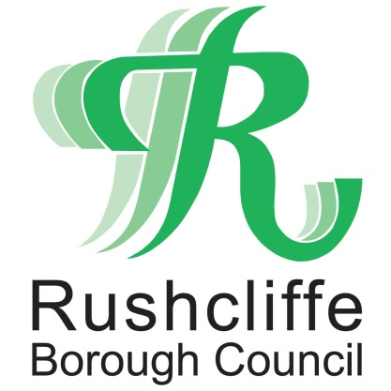 | Press Release

FOR IMMEDIATE RELEASE REF. GRANT
24.06.21

£400,000 boost to COVID-19 grant funding for Rushcliffe pubs, bars and restaurants

Rushcliffe based pubs, bars, restaurants and other businesses in the hospitality trade are set to receive a boost with nearly £400,000 of COVID-19 support grants being further allocated to the industry.

Eligible businesses will now be contacted directly from later this week by Rushcliffe Borough Council for further discretionary funding of Additional Restrictions Grants of up £6,000 each, following previous grant payments.

The authority has decided to attribute the funding to the sector due to the ongoing disruption of current COVID-19 restrictions that see outlets not able to operate at full capacity due to social distancing and other measures.

All of the Council’s support for businesses during the pandemic is available at www.rushcliffe.gov.uk/businesscoronavirus

It follows news earlier this month of its Finance and Revenues teams being shortlisted for a national award for reaching out to local businesses quickly and effectively during the pandemic to distribute all grant funding.

The authority will now be in the running for a CCLA/Room151 Impact Award that has seen thousands of the grants administered with speed and accuracy.

Rushcliffe Borough Council’s Cabinet Portfolio Holder for Finance and Customer Access Cllr Gordon Moore said: “We’re very pleased to be able to direct further funding to many businesses in the hospitality sector who are working tirelessly as COVID-19 restrictions continue.

“We recognise businesses need support now and our approach from the moment grants were made available from central government was to waste no time and make payment distribution a priority.

“We know businesses are facing big pressures and we’re committed to helping them wherever we can. We would encourage all business owners to look at what assistance is also available through our business support programmes.

“Our Environmental Health and Licensing teams continue to offer support on trading securely in line with restrictions. Please email envhealth@rushcliffe.gov.uk for assistance.”

Business owners with any COVID-19 grant questions should email econdev@rushcliffe.gov.uk for more information. Those who have breached operating rules since March 2020 may not be eligible for the funding.

Eligible high street businesses or established business groups can also apply for a COVID Digital Recovery Grant that can further help them adapt and improve their online presence or sales.
Small to medium size retail, hospitality, personal care, leisure, tourism and other enterprises in the Borough can now access up to £1,000 over and above existing central government grant support by visiting https://bit.ly/3lQWfuG.
This allows businesses to create or improve a website, seek advice and support on the improving their social media presence or create greater online transactional capability.
It can also aid local retail groups or traders’ associations supporting or enhancing the development of, for example, an online market place for their town or village.

- ENDS -

NOTE TO EDITORS

For information please contact the Rushcliffe press office on 0115 9148 555 or media@rushcliffe.gov.uk

For the latest news and events, follow @rushcliffe on Twitter or Rushcliffe on Facebook or go to the council's website.

