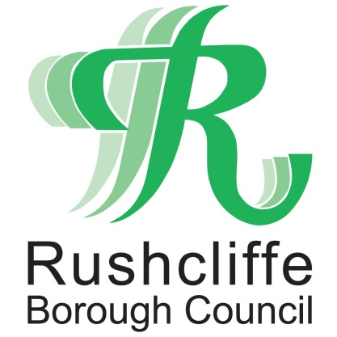 | Press Release

FOR IMMEDIATE RELEASE REF. TESTING
24.03.21

Rapid COVID-19 home tests available for collection in East Leake

Households with primary school, secondary school and college age children, including childcare and support bubbles can now collect two free rapid COVID-19 tests per person, per week on selected days in East Leake from March 25.

A community collect station will be in place at Gotham Road car park in the village on the following dates:

- Thursday March 25, 9am to 3pm
- Friday March 26, 9am to 3pm
- Wednesday March 31, 9am to 3pm
- Thursday April 1, 9am to 3pm

Further possible dates are being assessed and will be publicised once confirmed.

Testing will continue to be a vital part of the response to COVID-19, supporting the roadmap set out by the Prime Minister and although cases in Rushcliffe and nationally are declining, everyone needs to play their part to keep the virus under control while keeping children and young people in school.

As set out in the roadmap, secondary school and college students are moving to this twice-weekly home testing routine but the tests are free to all families and households with primary, secondary school and college aged children and young people, including childcare and support bubbles, to help find more Covid-19 cases and break chains of transmission.

With about a third of individuals with coronavirus showing no symptoms and potentially spreading it without knowing, targeted regular testing will mean more positive cases within households are found and prevented from entering schools and colleges, helping to keep educational settings safe.

Rapid testing detects cases quickly –in under 30 minutes –meaning positive cases can isolate immediately. This can be the difference between children being able to stay in school, or a class being sent home due to an outbreak. It could also be the difference between a workplace having to close for a period or being able to stay open and running.

Jonathan Gribbin, Director of Public Health at Nottinghamshire County Council said: “Getting tested regularly, twice a week, will help us to identify cases early and break the chain of transmission. Each positive case identified can help prevent additional people from becoming infected over time.

“Regular testing will help to find cases that would otherwise have gone undetected. Testing, alongside staying at home, following the Hands, Face, Space rules, getting a test if you have symptoms and self-isolating if your test is positive all remain critical to keep reducing the rate of infection and protect each other.

“I would strongly encourage everyone to take advantage of the testing facilities that are now widely available across the county.”

Rapid Testing is also available via:
- through your employer if they offer testing to employees
- at a local community testing site – Cotgrave Hub on Wednesdays and Saturdays or a full list County wide is available at https://bit.ly/2ORuo3j
- by ordering a home test kit online - https://www.gov.uk/order-coronavirus-rapid-lateral-flow-tests

Anyone with symptoms of Covid-19 should book a test online at www.gov.uk/get-coronavirus-test or by calling 119.

- ENDS -

NOTE TO EDITORS
For information please contact the Rushcliffe press office on 0115 9148 555 or media@rushcliffe.gov.uk

For the latest news and events, follow @rushcliffe on Twitter or Rushcliffe on Facebook or go to the council's website.

