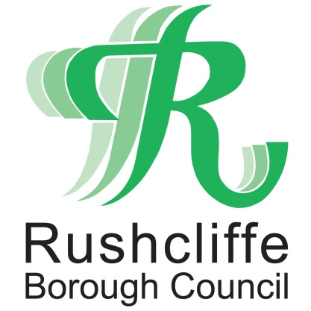 | Press Release

FOR IMMEDIATE RELEASE REF. RESIDENTS
23.06.21

Have your say on life in Rushcliffe
through residents’ survey

Rushcliffe Borough Council has launched its latest residents’ survey, inviting all who reside in Borough to have their say on Council services and life in the area.

The survey can be completed online at https://bit.ly/3xulnO7 or in Rushcliffe Reports magazine which is delivered to every home in the Borough, arriving through letter boxes this week.

Carried out every three years, the survey asks residents to answer questions about their satisfaction with a range of services that the Council offers, their feeling of being safe in their community and where they feel the Borough can improve to be a better place to live and work.

Surveys should be completed before the deadline of 5pm on Monday August 2.

Leader of the Council Cllr Simon Robinson said “Please complete the survey to have your say so you can help shape our services going forward.

“It is essential residents of the Borough have the opportunity to be able to inform their local Council on the items that matter to them.

“We’re aware this is just one snapshot of gauging people’s opinions of our services and life here in the Borough and we encourage residents to continually feedback their thoughts to us at www.rushcliffe.gov.uk

“Given the impact of COVID-19 on us all, we are keen to hear too if you have felt, and continue to feel, informed and connected to the latest advice on the pandemic.”

- ENDS -

NOTE TO EDITORS
For information please contact the Rushcliffe press office on 0115 9148 555 or media@rushcliffe.gov.uk

For the latest news and events, follow @rushcliffe on Twitter or Rushcliffe on Facebook or go to the council's website.

