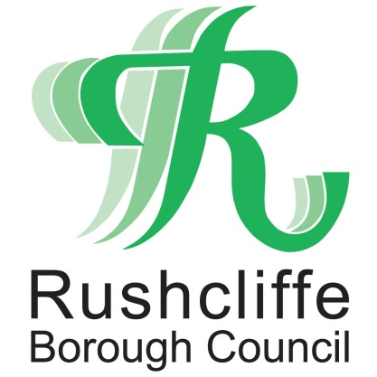 | Press Release

FOR IMMEDIATE RELEASE REF FLY-TIP
23.04.21
Resident fined £300 for not checking waste carrier that led to huge fly-tip

A resident has been issued a fine of £300 after failing to check who was disposing of his house clearance waste that led to an irresponsible waste carrier dumping hundreds of items on the footpath completely blocking its use.

Rushcliffe Borough Council has issued the fixed penalty notice to the householder after finding evidence belonging to the property owner in the waste at a bridge adjacent to the Grantham Canal at Fosse Locks under the A46 near Cropwell Butler, a popular location for walkers.

A huge pile of cardboard boxes, electrical and households items was found by the authority on April 6 following a number of reports from local residents, a further investigation into an individual operator connected with the fly-tip is ongoing.

Householders who employ individuals or companies to dispose of their waste must make the necessary checks or face a potential penalty if it is linked with a fly-tipping case. This is known as the householder’s duty of care.

Residents can check whether a waste carrier is registered online at https://bit.ly/3sIgmil or by calling 03708 506 506.

Powers put in place since 2019 can see Borough and District Councils impose the penalty should a householder’s domestic waste be found dumped in any part of Nottinghamshire.

If the penalty is not paid householders can still be taken to court for alleged offences and face a potential £5,000 fine if convicted.
This fine system means individuals can receive the bill as an alternative to court action as the Council seeks to clamp down on cases of fly-tipping, littering and dog fouling across the Borough in its partnership with Waste Investigations Support & Enforcement (WISE).

The Council’s Executive Manager for Neighbourhoods and Deputy Chief Executive Dave Banks said: “Householders looking to get rid of waste from their property must ensure they check the licence of the waste carrier they choose to employ, as if items from your property are linked to fly-tipping we could be knocking on your door with a fixed penalty notice.
“We continue to have zero tolerance for anyone that blights our landscape by dumping rubbish and it is vital householders take the responsibility to carry out the necessary checks.

“Our work with WISE is seeing an increase in fixed penalty notices for fly-tipping and we will not hesitate to take action on waste carriers and householders flouting the rules as necessary.”

WISE’s environmental enforcement service operates across the Borough clamping down on dumped domestic and commercial waste seven days a week.

The authority encourages reporting of any other fly-tipping in Rushcliffe at https://bit.ly/3rUE4rt.

The webpage includes a facility to pinpoint the location of the fly-tip on a map which can help the Council locate items and aid their swift removal.
The authority and its partner Streetwise also offer collections of large unwanted items for £18.50 for the first item and any other item thereafter will be £9. To make a booking or for more information visit the Council’s website at https://bit.ly/32vaFtf

- ENDS -

NOTE TO EDITORS

For information please contact the Rushcliffe press office on 0115 9148 555 or media@rushcliffe.gov.uk

For the latest news and events, follow @rushcliffe on Twitter or Rushcliffe on Facebook or go to the council's website.

