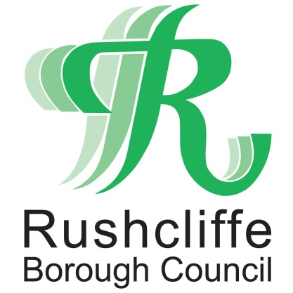 | Press Release

FOR IMMEDIATE RELEASE REF HEALTHY
22.08.20
Try a healthier, fresher and more nutritious takeaway in Rushcliffe

Rushcliffe Borough Council’s Environmental Health team are reminding residents of the wide range of healthy options available at local Healthier Options Takeaways (HOT) across the Borough.

Outlets that have achieved a HOT merit offer a variety of food items, which are clearly displayed on their menus to enable customers to make informed choices that will help support a healthy lifestyle.

Residents can quickly find a list of participating establishments in their area by visiting www.rushcliffe.gov.uk/hot or by looking out for the heart-shaped ‘HOT sticker’ displayed in qualifying venues.

Takeaways that have achieved the merit pledge to offer healthier options to their customers, such as introducing new menu items, improved cooking methods or campaigns that promote nutritious items to customers as they order.

Rushcliffe Borough Council Cabinet Portfolio Holder for Neighbourhoods Cllr Rob Inglis said: “The HOT scheme provides a fantastic opportunity for businesses to celebrate all the healthy food options available across their menus.

“Residents can access a wide range of fantastic fresh food in Rushcliffe, so it’s great to be able to access a list of outlets offering healthier choices easily and online.

“If you’re not sure where your local Healthier Options Takeaway is located, simply head to our website and check out what’s available in your area, you might just be surprised by the range of options!”

The reminder comes as the Government launched its new obesity strategy last month to get the nation fit and healthy, protect themselves against COVID-19 and help protect the NHS.

CHEFF in West Bridgford is one local venue to have been awarded the HOT merit and has recently introduced a new healthy menu for children in line with its pledges to the scheme.

Owner Adam Sinnott said: “Our focus is on clean, healthy, energising fast food, so it made perfect sense to join the HOT scheme and promote the range of healthy foods and snacks we make available for our customers.

“As part of our pledge, we’ve introduced a children’s menu, featuring our incredibly popular ‘CHEFF boxes’ which enable customers to build their own box meal, based on a range of healthy choices.

“I’d encourage everyone to find their local HOT establishment and discover that healthy food can be fast, local and delicious.”

Find CHEFF and lots of other HOT establishments online at www.rushcliffe.gov.uk/hot or discover further outlets in Nottinghamshire on the County Council website at www.nottinghamshire.gov.uk/care/health-and-wellbeing/healthier-options-takeaways

If you’d like to find out more about the scheme for you or your business, please contact Rushcliffe Borough Council’s Environmental Health team at Environmentalhealth@rushcliffe.gov.uk or call 0115 981 9911.

- ENDS -

NOTE TO EDITORS

For information please contact the Rushcliffe press office on 0115 9148 555 or media@rushcliffe.gov.uk

For the latest news and events, follow @rushcliffe on Twitter or Rushcliffe on Facebook or go to the council's website.

