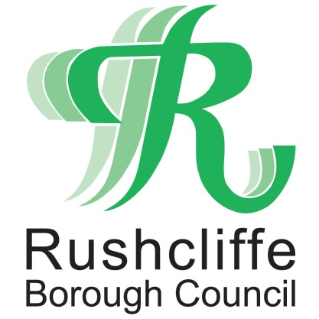 | Press Release

FOR IMMEDIATE RELEASE REF ARMED FORCES
22.06.21
Rushcliffe Borough Council raises a flag
in support of Armed Forces Week

Rushcliffe Borough Council has joined organisations across the country to raise a flag to commemorate Armed Forces Week.

Councillors and local dignitaries gathered at Rushcliffe Arena to watch the ceremonial flag raising in line with current Government guidelines.

Mayor of Rushcliffe Cllr Sue Mallender was joined by fellow members of the Council, members of local Armed Forces organisations including those from Ruddington, Gotham, Radcliffe on Trent, Colston Bassett, Owthorpe and Cotgrave and Council staff.

Armed Forces Week is an opportunity for everyone to show their support for those defending the UK and its interests as part of the Armed Forces community, which includes current servicepeople, veterans, cadets, and their families.

Madam Mayor said: “I was delighted to raise the flag to officially commence a week of celebration in honour of our Armed Forces.

“Our Armed Forces and Veterans rightly deserve the nation’s support and recognition. They, and their families, have made and continue to make huge personal sacrifices to ensure the interests of our country are defended and this day is our chance to say thank you.

“During this week what our veterans have already achieved, what our current personnel continue to achieve and the opportunities the Armed Forces offer future generations, will be celebrated.”

Celebrations to mark Armed Forces Day take place each year on the final Saturday in June to help boost morale for service members and as a chance for communities to show their recognition.

Following the government’s COVID-19 roadmap update on June 14, the authority’s annual Proms in the Park event is now set to take place later this summer on Saturday September 18.

It is hoped this will mean being able to accommodate a greater number of people and safely offer food and drink outlets and fringe stalls and attractions and welcome local Armed Forces representatives, not possible under the current COVID restrictions.

Madam Mayor added: “In line with the government roadmap, we look forward to our Proms in the Park event in September where we can further acknowledge their contribution to all our lives.”

ENDS

NOTE TO EDITORS

For information please contact the Rushcliffe press office on 0115 9148 555 or media@rushcliffe.gov.uk

For the latest news and events, follow @rushcliffe on Twitter or Rushcliffe on Facebook or go to the council's website.

