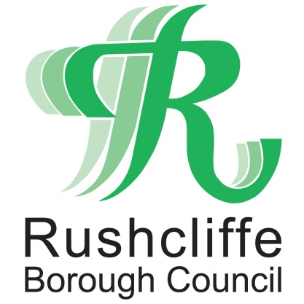 | Press Release

FOR IMMEDIATE RELEASE REF. VOTE
22.04.21

Make sure you’re ready to have your say on May 6
With just two weeks left until voters in Rushcliffe go to the polls on May 6, Rushcliffe Borough Council is urging voters to get ready to vote.
There are Police and Crime Commissioner and County Council elections taking place on the day.
Polling stations will be safe places to vote and people voting in person are encouraged to keep themselves and others safe by:

wearing a face covering
bringing their own pen or pencil
cleaning their hands when entering and leaving the polling station
keeping a safe distance
Voters should not attend the polling station if they have symptoms of COVID-19, or if they have been asked to self-isolate.
Anyone who develops symptoms or is asked to self-isolate shortly before polling day, has up to 5pm on polling day to apply for an emergency proxy vote. This allows them to nominate someone they trust to vote on their behalf.

Kath Marriott, Deputy Returning Officer for Rushcliffe Borough Council said: “Your poll card will tell you where to find your polling station.

“Make sure you check the information on your polling card, as your polling station might have changed since the last elections.

“You do not need your poll card to vote, however, we encourage you to bring it with you to make the process quicker and more efficient.
“Polling stations will be open from 7am to 10pm on Thursday May 6. Voters who have opted to vote by post must return their postal ballot pack by 10pm and can hand it in at their polling station if they don’t have time to return it by post.”

Ailsa Irvine, Director of Electoral Administration and Guidance at the Electoral Commission, said: “If you are voting in person, make sure you remember to bring your face covering and a pen or pencil with you.

“At the polling station, help keep yourself and others safe by following the safety measures, including sanitising your hands and keeping a safe distance from others.
“If you are self-isolating or become unwell as a result of Covid-19, you don’t need to lose your vote. You will be able to apply for an emergency proxy vote so that someone you trust can vote on your behalf.”
For further information on how to apply for an emergency proxy, voters should contact the electoral registration team at the Council by emailing elections@rushclifffe.gov.uk or calling 0115 981 9911.
For further information on elections in their area, voters can visit www.electoralcommission.org.uk/voter. This page will continue to be updated ahead of the polls.
- ENDS -

NOTE TO EDITORS
For information please contact the Rushcliffe press office on 0115 9148 555 or media@rushcliffe.gov.uk

For the latest news and events, follow @rushcliffe on Twitter or Rushcliffe on Facebook or go to the council's website.
The Electoral Commission is the independent body which oversees elections and regulates political finance in the UK. We work to promote public confidence in the democratic process and ensure its integrity by:
- enabling the delivery of free and fair elections and referendums, focusing on the needs of electors and addressing the changing environment to ensure every vote remains secure and accessible
- regulating political finance – taking proactive steps to increase transparency, ensure compliance and pursue breaches
- using our expertise to make and advocate for changes to our democracy, aiming to improve fairness, transparency and efficiency
The Commission was set up in 2000 and reports to the UK, Scottish and Welsh parliaments.
Elections taking place in England on 6 May 2021:
- English local government elections (includes polls postponed from May 2020), including elections to county, district and parish councils
- Police and Crime Commissioners (polls postponed from May 2020)
- Combined Authority Mayoral (includes polls postponed from May 2020)
- Local Mayoral (includes polls postponed from May 2020)
- Mayor of London and London Assembly (polls postponed from May 2020)

