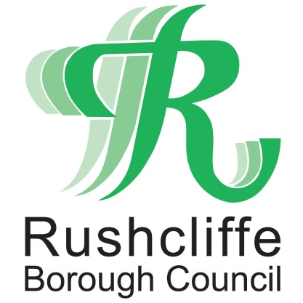 | Press Release

FOR IMMEDIATE RELEASE REF TREE
21.07.22
Free tree scheme returns for Rushcliffe residents!

Rushcliffe residents can make their properties even greener by applying for free trees for a fifth year running.

Over 9,000 trees have been distributed since the start of the campaign in 2018 and now a further 1,600 field maple and hazel trees are available without charge for those who live in the Borough.

It’s part of Rushcliffe Borough Council’s strategy to provide sustainable environments in line with the Borough’s significant housing and employment growth in the coming years.

Householders are encouraged to apply as soon as possible given anticipated high demand and can apply for up to two trees by visiting https://www.surveymonkey.co.uk/r/trees2022 and submitting an application before September 30.

The Council’s Cabinet Portfolio Holder for Communities and Climate Change Cllr Abby Brennan said: “We are delighted to be running the free tree scheme again, after a wonderful response from residents since the scheme was launched in 2018.

“They have shown great enthusiasm in collecting and planting thousands of these free trees and we thank them for their continued support to making Rushcliffe a great and greener place to live.

“We hope that by increasing the number of trees in the Borough, our green environments will grow alongside our communities, improving the quality of life for both current and future residents.”

Among the sites to have benefitted include, Oldershaw Trust land in East Leake.

Village tree warden Wendy Thompson said: “East Leake has benefitted hugely from this free tree scheme, we’ve added to our tree nursery for children to use in the future as a nature walk to supplement our natural play scheme.

“I’d encourage residents to take advantage of Rushcliffe Borough Council’s free tree scheme. Not only are trees important for nature and wildlife, but they are also important for the local community breathing life and oxygen into where we live.”

Successful applicants will have trees delivered direct to their door by Streetwise with the volume of delivery trips minimised by the firm to make its carbon footprint as low as possible.

The field maple or acer campestre can grow to 20m tall, with flowers in spring and winged papery fruit in late summer and autumn colour. Grow in fertile, moist but well-drained soil in full sun or part shade.

The hazel or corylus avellana can grow to 12m tall, it has yellow male catkins in early spring, followed by edible nuts in autumn. Grow in moist but well-drained soil in full sun or part shade.

All the trees are two years old and approximately 60-90 cm (2-3 feet) high on delivery. Trees will be delivered to addresses in Rushcliffe from December 2022 to February 2023.

- ENDS –

NOTE TO EDITORS

For information please contact the Rushcliffe press office on 0115 9148 555 or media@rushcliffe.gov.uk

For the latest news and events, follow @rushcliffe on Twitter or Rushcliffe on Facebook or go to the council's website.

