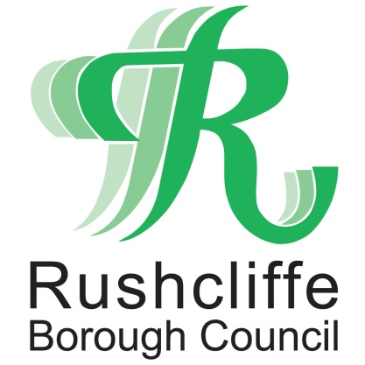 | Press Release

FOR IMMEDIATE RELEASE REF. REACH
21.01.21

Reach Rushcliffe connects group and restaurant to provide meals
to vulnerable residents

Reach Rushcliffe has connected a volunteer group with a West Bridgford restaurant to provide hot meals as a vital food package for vulnerable Rushcliffe residents.

The Meet, Greet and Eat project and Portello Lounge in West Bridgford worked together to provide the home delivered meals for individuals across the Borough.

The group previously received funds from the Rushcliffe Borough Council initiative which was launched last year aiming to tackle social isolation and loneliness.

Staff at the Portello Lounge kindly offered to cook the meals to safely put their professional kitchen to good use during current lockdown restrictions.

It has allowed the Meet, Greet and Eat group’s dedicated volunteer chefs a valuable breather to their weekly cooking sessions which have continued throughout COVID-19 at their base at Welbeck Hall in West Bridgford.

The authority’s Cabinet Portfolio Holder for Community and the Environment Cllr Abby Brennan met with Project Coordinator Farah Jamil, project volunteers and Portello Lounge Manager Bobby Holmes at the restaurant to see the partnership in action.

Cllr Brennan said: “It is brilliant to see the Portello Lounge and Meet, Greet and Eat Project working together to provide these vital meals to vulnerable or elderly residents and families who may be at risk of social isolation.

“From our work with partners throughout this pandemic we know that there are many groups and individuals who really benefit from projects like this and we know that it goes beyond the important job of providing nutritious hot meals.
“It also helps tackle loneliness and makes sure people have regular contact with the outside world - we are delighted to be able to connect people and enable them to support one another.

“We would encourage any organisations also looking to safely reduce social isolation in their part of Rushcliffe to apply for funding through Reach Rushcliffe by visiting www.rushcliffe.gov.uk/health/reachrushcliffe/.”

Farah said: “We are so pleased that the Portello Lounge have been able to assist with making 40 meals that were delivered to our residents in need, whilst giving some of our volunteers a well-earned rest.

“A big thank you to Bobby and all the staff at the restaurant for safely preparing, donating and helping to deliver the food packages that means we can reach out again and help those who really need our support.”

Bobby added: “The work that the Meet, Greet and Eat project do in the local community is fantastic and as soon as we heard some assistance would help them cook their meals this week we were really keen to get involved.

“We know the volunteers work so hard each week to prepare the meals so we’re so happy to be able to give them a break and put our kitchen to good use at the same time."

Town and parish councils, local groups and organisations can access funding from Reach Rushcliffe to apply for proposals to create, sustain or expand projects that could help reach out with a friendly face to those in need.

It should aim to take steps to make contact and engage individuals or groups in Rushcliffe communities who may have little or no social contact.

Email communitydevelopment@rushcliffe.gov.uk for more information.

- ENDS -

NOTE TO EDITORS

For information please contact the Rushcliffe press office on 0115 9148 555 or media@rushcliffe.gov.uk

For the latest news and events, follow @rushcliffe on Twitter or Rushcliffe on Facebook or go to the council's website.

