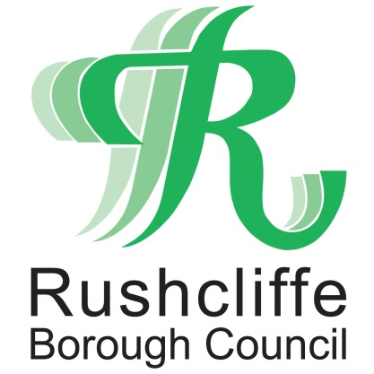 | Press Release

FOR IMMEDIATE RELEASE REF GRANTS
21.01.21

Local Business Support Grant now available for eligible business owners

Rushcliffe Borough Council is now inviting applications for the Local Business Support Grant, designed for those currently impacted by reduced trading conditions operating in specific sectors.

Businesses in the hospitality, accommodation, beauty and leisure sectors, as well as non-essential retail and their supply chains can consider applying to support them in meeting operational costs, or to help maintain the necessary COVID secure measures during and after lockdown.

Applications for eligible business owners who have not previously applied can be completed at www.rushcliffe.gov.uk/businesscoronavirus
Eligible businesses could receive a one-time payment if occupying a property with an annual property charge as below:
- £2,250 if rent is up to £15,000
- £6,000 if rent is over £15,001
Businesses that are not liable for business rates and don’t pay a rental charge may be entitled to a fixed grant of up to £1,500 if they have been forced to close business due to COVID restrictions and temporarily ceased trading, or £750 if they are still operating.
Rushcliffe Borough Council’s Deputy Leader Cllr Andy Edyvean said: “The Local Business Support Grant offers yet another essential channel of funding to businesses during the pandemic.
“We remain committed to processing all applications quickly and considerately to ensure we can support as many businesses as possible with the funding available.
“Eligible businesses will be able to submit an application until the Government funding is exhausted. Previous applicants will be contacted if they are now eligible under the new guidelines.”

ENDS

NOTE TO EDITORS

For information please contact the Rushcliffe press office on 0115 9148 555 or media@rushcliffe.gov.uk

For the latest news and events, follow @rushcliffe on Twitter or Rushcliffe on Facebook or go to the council's website.

