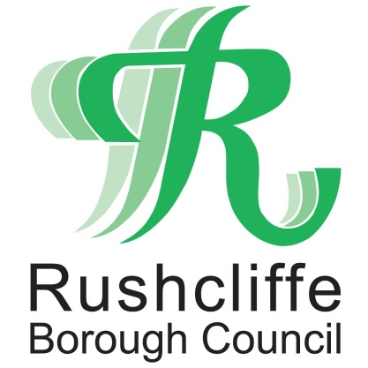 | Press Release

FOR IMMEDIATE RELEASE REF. BUBBLE
20.12.20

Follow the latest advice on forming a Christmas Day bubble

Following the government announcement on December 19, Rushcliffe and Nottinghamshire residents are being urged to adhere to the latest advice about forming a Christmas Bubble.

The new regulations mean that Christmas Bubbles can now only be formed on Christmas Day, Friday 25 December.

The government has confirmed the new arrangements as they announced new Tier 4 restrictions for London, the South East and parts of the East of England to help combat a new variant of COVID-19.
Nottinghamshire will remain in Tier 3 which means very high alert restrictions will remain in place throughout December. The next review date is Wednesday 30 December.
Leader of Rushcliffe Borough Council Cllr Simon Robinson said: “We know it’s hugely disappointing for everyone that Christmas plans have now changed but we must continue to show the strength and resilience we have this year to beat this virus.
“It’s vital we follow these restrictions and as tough as it is, it will ultimately save lives and protect health and care services.
“Please continue to stay safe and remember ‘hands face space’, don’t travel outside of Nottinghamshire wherever possible and follow the rules so we can all look forward to a brighter 2021.”
Jonathan Gribbin, Director of Public Health for Nottinghamshire said: “Sadly, the new restrictions also mean that you should stay local even if you do form a bubble for Christmas Day. That means avoiding any unnecessary travel outside of Nottinghamshire.

“It is a concern to hear that the new variant of COVID-19 is passed on more easily.

“But it is important to remember that we already know exactly how to stop its spread. It still comes down to frequent hand washing, use of face coverings in enclosed spaces, and complying with social distancing measures such as maintaining a 2-metre distance from others.

“What is important now is that we follow these rules with even greater attention and rigour than before. That is what is needed because when we do it, that is what breaks the chain of transmission.”

Apart from on Friday 25 December, Tier 3 restrictions mean you must avoid mixing indoors with any other households and the rule of six applies in public outdoor settings.

Full details on the measures are available at www.rushcliffe.gov.uk/coronavirus

The new Tier 4 restrictions announced by government in other parts of the country also means people who live in those areas are not allowed to mix with any other households at all. People in Tier 4 areas cannot form a Christmas Bubble. Only essential travel to Tier 4 areas – such as for work purposes is allowed.
The rules about bubbles:
- Bubbles can only be formed on Friday 25 December.
- you can form an exclusive ‘Christmas bubble’ of people from no more than three households.
- you can only be in one Christmas bubble
- you cannot change your Christmas bubble
- you can only meet your Christmas bubble in private homes or in your garden, places of worship, or public outdoor spaces
- if you form a Christmas bubble, you should not meet socially with friends and family that you do not live with in your home or garden unless they are part of your Christmas bubble
- you can continue to meet people who are not in your Christmas bubble outside your home according to the rules in the tier you are meeting in
- people in Tier 4 areas are not allowed to form bubbles with any other households.

Jonathan Gribbin continued: “The announcement on Saturday 19 December illustrates that further effort is required from everyone to keep Nottinghamshire safe. Unfortunately, it means that many of us now need to come to terms with the prospect of a different Christmas to the one we had planned.
“I urge people in Nottinghamshire people to take care to stick to the rules because this is what will curb transmission, save lives, and protect local services.
“The best tools for achieving this are in our hands already. We must avoid mixing with other people indoors, maintain focus on the hands, face and space principles, and get a test, and isolate immediately if we develop any COVID-19 symptoms. It really is that simple.
“The best gift we can give one another is to play our part to stop the spread.”
The latest government announcement can be seen in full including the new Christmas Bubble guidance:
- https://www.gov.uk/government/speeches/prime-ministers-statement-on-coronavirus-covid-19-19-december-2020
- the very latest Tiers information can be seen here: https://www.gov.uk/guidance/full-list-of-local-restriction-tiers-by-area

- ENDS -

NOTE TO EDITORS

For information please contact the Rushcliffe press office on 0115 9148 555 or media@rushcliffe.gov.uk

For the latest news and events, follow @rushcliffe on Twitter or Rushcliffe on Facebook or go to the council's website.

