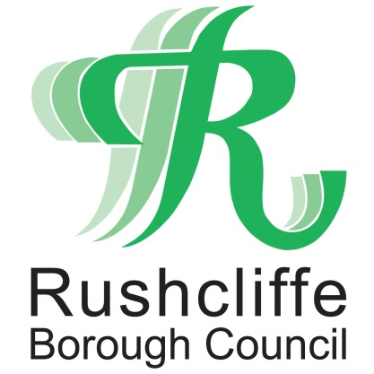 | Press Release

FOR IMMEDIATE RELEASE REF COUNTRY
20.10.20
Rushcliffe Country Park receives fourteenth consecutive Green Flag Award!

Rushcliffe Country Park has received its fourteenth consecutive Green Flag Award, acknowledging the green space as one of the very best parks in the UK.

In October, the outdoor area was again named among a record-breaking 2,061 UK parks and green spaces that have received the award which is the mark of a quality park or green space.

Rushcliffe Borough Council’s Portfolio Holder for Community and the Environment Cllr Abby Brennan visited the Country Park to watch the flag raising in a COVID-19 secure ceremony and hear more about the work of local stakeholders.

Cllr Brennan said: “It is brilliant that the Country Park has received the Green Flag Award for another year running, highlighting the hard work and dedication of our staff and great volunteers.

“The importance of green space has been highlighted even more so during COVID-19 and parks such as this allow thousands of residents and visitors to visit and enjoy the fresh air.

“It is also a celebration of the great work the volunteers carry out so we would like to thank them again in their help to receive this prestigious accreditation once more.”

Chair of Friends of Rushcliffe Country Park Dorothy Pearson said: “We’re really pleased to be able to raise the Green Flag at the park for yet another year.

“This year we were not able to do as much work as we’d hoped due to COVID-19, but safe work is now starting to pick up again. It’s great to receive the award for the fourteenth year and shows all of our efforts don’t go unnoticed.”

The international award is a sign to the public that the space boasts the highest possible environmental standards, is beautifully maintained and has excellent visitor facilities.

For more information about Rushcliffe Country Park and details on how to plan your next visit, please go to www.rushcliffe.gov.uk/rushcliffecountrypark/

- ENDS -

NOTE TO EDITORS

For information please contact the Rushcliffe press office on 0115 9148 555 or media@rushcliffe.gov.uk

For the latest news and events, follow @rushcliffe on Twitter or Rushcliffe on Facebook or go to the council's website.

