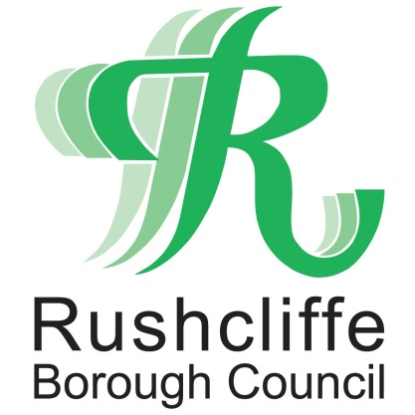 | Press Release

FOR IMMEDIATE RELEASE REF. ELECTION
20.01.21

Voting safely at this year’s elections

Residents in Rushcliffe will go to the polls on Thursday May 6, 2021 to have their say on who represents them at the Police and Crime Commissioner and County Council elections.
While the elections are some time away, we’re already making plans to help you stay safe while casting your votes.
There are a number of ways to have your say in the elections - you can vote in a polling station, by post, or by appointing someone you trust to vote on your behalf, which is known as a proxy vote.

Kath Marriott, Returning Officer for Rushcliffe Borough Council, said: “The elections are very important, they’re an opportunity to make your voice heard and have a say on who represents you on issues that directly affect day-to-day life here in Rushcliffe.
“We’re thinking about these elections now so that, however you choose to cast your vote in May, you can do so safely.
“We’re putting arrangements in place to help you stay safe at the polling station; you can expect many of the measures you’ve become used to in shops and banks over recent months, such as hand sanitiser, social distancing signs and face masks. But you also have the option to apply to vote by post or by proxy.”

Ailsa Irvine, Director of Electoral Administration and Guidance at the Electoral Commission said: “The choice on how to vote at this May’s elections is yours – you can have your say in person, by post or by proxy.
“If you’re thinking about voting by post, you can apply now. This will make sure your application is processed early, and your postal vote can be sent to you more quickly. It’s easy to apply and you can find out how by visiting the Electoral Commission website.
“You need to be registered to vote in order to have a say at the elections – the easiest way to register is online at www.gov.uk/register-to-vote”

Residents can visit the Elections 2021 page on the website at https://www.rushcliffe.gov.uk/elections/ to find out more about the elections on 6 May 2021. The page will be updated with new information as it becomes available.

Any residents who have questions can also contact their local elections team at the Council at elections@rushcliffe.gov.uk

- ENDS -

NOTE TO EDITORS

For information please contact the Rushcliffe press office on 0115 9148 555 or media@rushcliffe.gov.uk
The Electoral Commission is the independent body which oversees elections and regulates political finance in the UK. We work to promote public confidence in the democratic process and ensure its integrity by:
- enabling the delivery of free and fair elections and referendums, focusing on the needs of electors and addressing the changing environment to ensure every vote remains secure and accessible
- regulating political finance – taking proactive steps to increase transparency, ensure compliance and pursue breaches
- using our expertise to make and advocate for changes to our democracy, aiming to improve fairness, transparency and efficiency
For further information on elections in their area, how to register to vote, or how to apply to vote by post or by proxy, voters can visit www.electoralcommission.org.uk/i-am-a/voter. This page will continue to be updated ahead of the polls.
The Commission was set up in 2000 and reports to the UK, Scottish and Welsh Parliaments.
Elections taking place in England, Scotland and Wales on 6 May 2021:
- Senedd Cymru / Welsh Parliamentary
- Scottish Parliamentary
- English local government elections (includes polls postponed from May 2020), including elections to county, district and parish councils
- Police and Crime Commissioners (polls postponed from May 2020)
- Combined Authority Mayoral (includes polls postponed from May 2020)
- Local Mayoral (includes polls postponed from May 2020)
- Mayor of London and London Assembly (polls postponed from May 2020)

For the latest news and events, follow @rushcliffe on Twitter or Rushcliffe on Facebook or go to the council's website.

