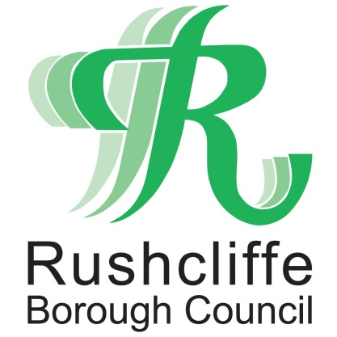 | Press Release

FOR IMMEDIATE RELEASE REF MARKET
19.08.20

Twilight taster market to visit East Leake
this September

A new taster twilight food, drinks and craft market is to securely visit East Leake next month, thanks to funding from Rushcliffe Borough Council’s Strategic Growth Board and the dedication of the Trader’s Association, parish councillors and local volunteers.

East Leake Market will be trialled at Gotham Road playing fields from 3pm to 8pm on Friday, September 11 with a wide array of stalls offering local, fresh and homemade products, following a four month delay due to COVID-19.

In line with current Government guidance, the site will feature stalls that aid social distancing and provide visitors with opportunities to browse an eclectic range of goods and produce in a COVID secure environment.

Rushcliffe Borough Council’s Cabinet Portfolio Holder for Finance and Chair of the East Leake Growth Board Cllr Gordon Moore is delighted the event is being developed, and that despite the challenges of COVID-19, that local groups have enthusiastically driven on the project.

He said: “It’s brilliant that this market can now be trialled in East Leake, after the pandemic sadly delayed plans for this concept back in May, and that the organisers have found ways to innovate and provide local residents with a taster twilight market next month.

“I’m so pleased that we as a Growth Board have been able to provide funding for this incredibly exciting venture, particularly when so many residents already appear keen to welcome a market to their local village centre.

“I would encourage all East Leake villagers and people from across the region to visit the playing fields next month and discover what a regular twilight market could look like in this part of the Borough.”

The market is set to visit the village on September 11 in line with COVID secure guidelines and organisers are keen to assess levels of demand so that they can explore further opportunities for a regular monthly event in 2021.

Hayley Masom of photography studio Captcha in East Leake has been at the forefront of efforts to coordinate the market for local people, serving on both the market committee and as a member of the Trader’s Association.

She said: “It’s so exciting to be hosting this trial of East Leake Market next month and we can’t wait to find out what local residents think of the concept and consider whether we could launch a more regular market in the village next year.

“We’ve invited local producers, traders and artisans to register and we’re confident that the market will offer something for everyone, with operating hours designed to make it easier for those visiting after work.

“Our sincere thanks go to all those who’ve contributed towards this market, especially Cllr Kevin Shaw who has very generously donated essential funds to this project in his role as our local ward councillor.

“Visit our taster market in September to find out more. You can find us online at www.eastleakemarket.org.uk, or on social media by typing @eastleakemarket on Facebook and Instagram for the latest updates ahead of next month’s taster market.”

-ENDS -

NOTE TO EDITORS

For information please contact the Rushcliffe press office on 0115 9148 555 or media@rushcliffe.gov.uk

For the latest news and events, follow @rushcliffe on Twitter or Rushcliffe on Facebook or go to the council's website.

