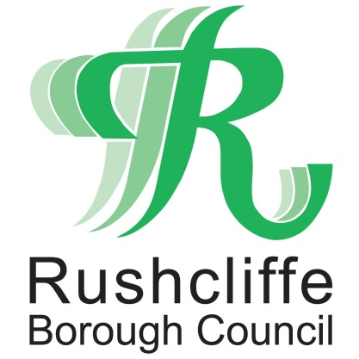 | Press Release

FOR IMMEDIATE RELEASE REF. PARKS
18.12.20

Simple steps to stay safe at Rushcliffe parks, open spaces and play areas this Christmas

Residents and visitors to Rushcliffe Borough Council owned parks and play areas are being reminded to follow simple steps to have fun safely this festive season.

It is anticipated many sites including Rushcliffe Country Park and Bridgford Park will be among those to remain very popular across the Borough over the holiday season.

The authority understands the continued need to get regular exercise and fresh air to assist everyone’s mental and physical health, especially as those based in the County are still only able to meet in wider open spaces in line with current Tier 3 restrictions.

Therefore given the expected higher footfall at its parks and open spaces, it is asking all to follow these tips to ensure everyone can enjoy a safer experience when visiting the locations.

- Follow the on-site signage and remember to socially distance from others at all times
- Wash your hands before and immediately after visiting
- Only one parent or support bubble member should accompany a child at any play area.
- No one should visit a site if they feel unwell
- Consider returning at a quieter time should you arrive to find parks or facilities already busy
- Follow current guidance to use open skate parks in line with Skate England advice at https://bit.ly/3r4WQN0
- Follow the above points if using the 4X Bike Track at Rushcliffe Country Park
- Outdoor gym equipment remains open in line with the latest government guidance.

The Council’s High Street Ambassadors are continuing to provide advice and reassurance at sites across the Borough, highlighting signage that reiterates the measures to follow at each location.

Sanitisation of facilities at all play parks takes place routinely and any feedback on the sites is requested to be sent to facilities@rushcliffe.gov.uk

- ENDS -

NOTE TO EDITORS

For information please contact the Rushcliffe press office on 0115 9148 555 or media@rushcliffe.gov.uk

For the latest news and events, follow @rushcliffe on Twitter or Rushcliffe on Facebook or go to the council's website.

